**Feb**

2023

**The AED Model Assessment, Reporting, and Visualisation Library (MARVL) v1**

**User Instruction**

**(DRAFT)**

****

**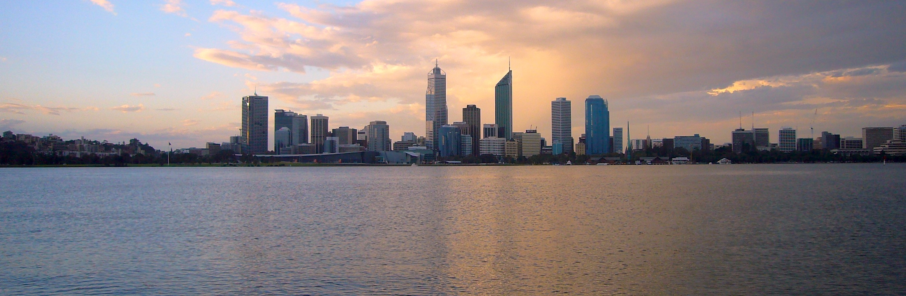**

# About This Instruction

This document is a User Instruction for the AED Model Assessment, Reporting, and Visualisation Library (MARVL) package. The MARVL package is an integrated software package for visualizing the model outputs and observational datasets, and evaluating the model performance. One of the key challenges for water quality modelling is to assess the model performance against field observations that typically include plenty of biogeochemical variables, exist at multiple sites, and are provided by multiple agencies in different formats. To handle this challenge, the AED research group has developed a series of data processing framework to store the data in a uniform format that is compatible to the AED outputs. At the same time, the group has developed a series of model assessment methods and scripts that were specifically designed to be compatible with the AED data repository and model outputs. The package is a collection of the past AED in-house scripts, and has been refined with uniform and easier user interfaces. This instruction provides guidance for using the MARVL package for visualizing the model outputs and/or data. For the AED variables, units, and science the readers are referred to the AED Science Manual (<https://aquaticecodynamics.github.io/aed-science/>, Hipsey et al., 2022).

****

## CONTRIBUTORS

*Peisheng Huang a*

*Brendan D. Busch a*

*Matthew R Hipsey a*

a Aquatic Ecodynamics, School of Earth and Environment, The University of Western Australia, Crawley WA 6009, Australia.

## ACKNOWLEDGEMENTS

The authors would like to acknowledge technical support for AED development by Casper Boon. Some functions used in MARVL for processing TUFLOW and AED outputs are originally developed by BMT.

## REVISION AND DISTRIBUTION HISTORY

|  |  |  |  |  |  |
| --- | --- | --- | --- | --- | --- |
| Issue | Issued to | Qty | Date | Reviewed | Approved |
| *V1 (prelim)* |  | *e* | *25 Feb 2023* | *Matt Hipsey* |  |
|  |  |  |  |  |  |
|  |  |  |  |  |  |

## RELEASE STATUS:

Confidential: No

**DRAFT – UNDER REVIEW**

## DOCUMENT DETAILS

# Citing this report: Huang, P., Busch B., Hipsey, M.R., 2023. The AED Model Assessment, Reporting, and Visualisation Library (MARVL) v1, User Instruction. AED Report #R\*\*, The University of Western Australia, Perth, Australia. 39pp.

# Copyright © 2016. The University of Western Australia, WA Department of Water (DoW) & WA Department of Parks and Wildlife (DPaW).

# Contents

Executive Summary 3

Contents 7

1. Introduction & Objectives 10

2. Methods 10

2.1 Estuary water quality model 10

Model Set Up 10

Model Performance Analysis Methods 13

2.2 Tracer Modelling Method 13

Model Set Up 13

Analysis Method 13

3. Model Performance Assessment 14

3.1 Time series of model output against measurements at representative stations 14

Salinity 15

Temperature 16

Dissolved Oxygen (DO) 17

Phosphorus: Total Phosphorus (TP) 18

Phosphorus: Phosphate (PO4) 19

Nitrogen: Total Nitrogen (TN) 20

Nitrogen: Ammonium (NH4) 21

Nitrogen: Nitrate (NOx) 22

Nitrogen: Dissolved Organic Nitrogen (DON) 23

Silica: Reactive Silica (RSi) 24

Phytoplankton: Chlorophyll-a (TCHLA) 25

3.2 Transect thalweg (whole river view) of selected variables 26

Transect thalweg plots of surface waters 26

Transect thalweg plots of bottom waters 27

3.3 Error assessment by region 28

Lower Swan – include sites of ARM, HEA, BLA, RIV 28

Middle Swan – include sites of MAY, NAR, NIL, STJ 29

Upper Swan – include sites of KIN, MSB, RON, SUC 30

Summary 31

4. Hotspot analysis: tracer model assessment 32

4.1 Hotspot in dry season (February 2015) 32

4.2 Hotspot in wet season (August 2015) 33

5. Assessing Monitoring Data Worth 34

5.1 Is the current monitoring program capturing areas in the domain that are more biogeochemically active? 34

5.2 Are there strong cross-stream gradients that are not picked up? – Needs for transect monitoring 34

5.3 Does the regular monitoring adequately capture events and daily variations? - Needs for dynamic monitoring and high-frequency monitoring 35

5.4 Do we adequately monitor what is coming into the estuary? - Need to improve boundary monitoring 36

5.5 Would reducing sampling frequency affect the model validation? 37

6. Real-time Model Operation 38

SCEVO model automation framework 38

Example outputs, and link to website 38

7. Key Points and Recommendations 39

Model Performance 39

Recommendations to water quality monitoring from a modelling point-of-view 39

References 39

# 1. Introduction

## 1.1 Overview

MARVL is an integrated software package for visualizing the model outputs and observational datasets, and evaluating the model performance. It is also able to carry out high-level system assessment such and environmental response functions and nutrient budgeting analysis, though certain pre-processing steps are required to prepare the data for the high-level system assessment. The current MARVL repository is a collection of AED in-house scripts that have been developed during previous research projects for model assessment, and has been refined with uniform and easier user interfaces. At the moment, the AED-MARVL was designed with the following features:

* Multiple visualizing options such as time-series, transect view, curtain view, site profiling;
* Standard and advanced performance evaluating methods;
* One configuration file for all visualizing functions;
* Uniform outlook (e.g. font style and size, figure resolution) of the figures and animations;
* Option to use YAML style of configurations that can be shared with other plotting software such as R and python;

Following visualizing functions are available in MARVL:

* Time series (with options to show observational data and perform model skill assessment);
* Transect (with options to show observational data on the same transect);
* Transect stacked area for comparing water quality compositions;
* Transect exceedance for comparing water quality levels against guidelines;
* Site profiling of selected water quality variables;
* Sheet plotting and animations;
* Curtain plotting and animations;

High-level systematic assessment of water quality response of to environmental factors and nutrient budgeting analysis have been developed using many of the basic functions of MARVL. However, these high level assessments require several pre-processing steps to prepare data for the assessment, and the configurations and pre-processing varied in different case studies. Therefore, there is still no straightforward script for these high level assessments. We have included the workflow in this document and examples scripts/outputs of the high-level assessments in the MARVL repository. Users of MARVL can follow the workflow and modify the scripts to produce the assessment outcomes of their studies.

The plotting functions have been tested within several case studies, including Coorong Lagoon, Cockburn Sound, and Lake Erie, and examples are included in the current repository. However, MARVL is still in its developing phase. We are expecting feedbacks for us to improve the user experience, as well as functionalities.

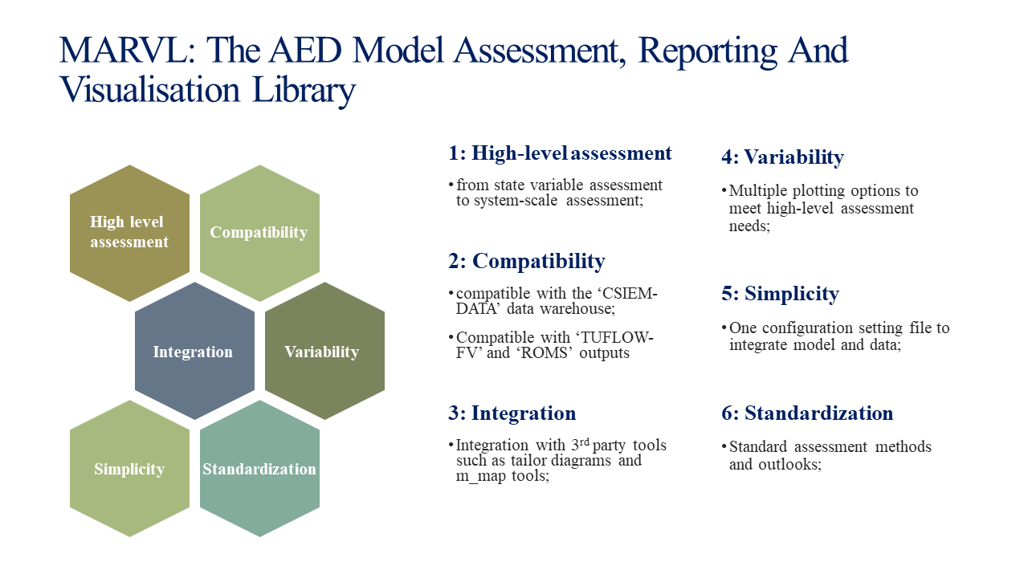

## 1.2 Repository Organisation

The repository is organized as followed:

* `Common`: place holder for common files such as unit conversion and agency information;
* `Matlab`: matlab plotting scripts and libraries for MARVL;
* `Project`: site-specific configurations and recommended place for plotting results;
* `R`: place holder for future development in R environment;
* `Documents`: place holder for documenting MARVL science and user instructions;

## 1.3 Execution Instruction

Step 1: Colone the `csiem-marvl` repository onto local computer

Step 2: Open Matlab (version 2020 or later versions), go to the local `csiem-marvl` folder and add the paths to tools/libraries by entering

addpath(genpath('./'))

Step 3: Go to `csiem-marvl/{your project}/` folder, edit the `MARVL.m` to configure the plots (use the 'MARVL.m' under other project folder as templates);

Step 4: Under the `csiem-marvl/{your project}/` path, start the plotting by entering

run\_AEDmarvl('./MARVL.m','matlab')

or if you wish to use YAML style configuration

run\_AEDmarvl('./MARVL.m','yaml')

# 2. Configurations

## 2.1 master module

## Model Set Up

The estuary is simulated using the TUFLOW-FV hydrodynamic model that is dynamically coupled with the AED2 water quality model. A brief description of the model settings is given below. For more information of the models refer to the recent report of Hipsey et al. (2016a).

The modelling domain spans the full extent of the estuary from Fremantle to Great Northern Highway (Figure 1). The final mesh used was determined from previous grid sensitivity assessment to satisfy model accuracy but also compromise for model run-time ration. AED2 version 1.1 was used for water quality simulation. Boundary condition data used to force the model are summarized in Table 1.



Figure 1. Model domain, inflow locations, and selected validation sites.

Variables simulated within the models are summarised in Table 2. In total, 23 state (transportable) variables were simulated from the “aed2\_tracer”, “aed2\_oxygen”, “aed2\_nitrogen”, “aed2\_phosphorus”, “aed2\_organic\_matter”, “aed2\_phytoplankton” and “aed2\_macrophyte” modules, and 42 diagnostic variables were output (of which only several key outputs are presented here). For detailed overview of these variables and how they are computed the reader is referred to the recent report of Hipsey et al. (2016a).

Table 1. Summary of the boundary condition data used for the developed model domain.

|  |  |  |
| --- | --- | --- |
| **Boundary Condition** | **Full domain** | **Upper Swan domain** |
| ***Tidal forcing*** | Data from the Fremantle tide gauge from the DOT is applied at Fremantle, also using data from the DOW Fremantle (FREO) sampling point | Data from the Barrack St Jetty gauge from the DOT is applied at the Narrows, also using data from the DOW Narrows (NAR) sampling point. |
| ***Upper Swan River*** | DOW 616076 | DOW 616076 |
| *Ellen Brook* | DOW 616189 | DOW 616189 |
| *Jane Brook* | DOW 616178 | DOW 616178 |
| *Susannah Brook* | DOW 616099 | DOW 616099 |
| *Helena River* | DOW 616086 | DOW 616086 |
| *Bennet Brook* | DOW 616084 | DOW 616084 |
| *Bayswater Drain* | DOW 616082 | DOW 616082 |
| *Canning River* | DOW 616082 | N/A |
| *Guildford Oxy Plant* | As described in Hipsey et al. (2014) | As described in Hipsey et al. (2014) |
| *Caversham Oxy Plant* | As described in Hipsey et al. (2014) | As described in Hipsey et al. (2014) |
| *Meteorological data* | DAFWA South Perth Meteorological Station Data | DAFWA South Perth Meteorological Station Data |

Table 2: Variables simulated within the models. Bold indicate variables being presented in the current model validation and assessment.

|  |  |  |  |  |  |
| --- | --- | --- | --- | --- | --- |
| **Variable** | | **Units \*** | **Common Name** | | **Process Description** |
| Physical variables | | | | | |
| ***T*** | °C | | Temperature | Temperature modelled by hydrodynamic model, subject to surface heating and cooling processes | |
| ***S*** | psu | | Salinity | Salinity simulated by the hydrodynamics model, impacting density. Subject to tributary, drain and groundwater inputs, and evapo-concentration | |
| *EC* | uS cm-1 | | Electrical conductivity | Derived from salinity variable | |
| *IPAR* | mE m-2 s-1 | | Shortwave light intensity | The PAR fraction of incident light, I0, is attenuated as a function of depth | |
| *IUV* | mE m-2 s-1 | | UV light intensity | The UV fraction of incident light, I0, is attenuated as a function of depth | |
| *ηPAR* | m-1 | | PAR extinction coefficient | Bandwidth specific extinction coefficient computed based on organic matter and suspended material | |
| *ηUV* | m-1 | | UV extinction coefficient |
| Core biogeochemical variables | | | | | |
| ***DO*** | mmol O2 m-3 | | Dissolved oxygen | Impacted by photosynthesis, organic decomposition, nitrification, surface exchange, and sediment oxygen demand | |
| ***RSi*** | mmol Si m-3 | | Reactive Silica | Algal uptake and subsequent sedimentation, sediment flux | |
| ***FRP*** | mmol P m-3 | | Filterable reactive phosphorus | Algal uptake, organic mineralization, sediment flux; adsoprtion/desorption to/from particles | |
| *FRP-ADS* | mmol P m-3 | | Particulate inorganic phosphorus | Adsoprtion/desorption of/to free FRP | |
| ***NH4+*** | mmol N m-3 | | Ammonium | Algal uptake, nitrification, organic mineralization, sediment flux | |
| ***NO3-*** | mmol N m-3 | | Nitrate | Algal uptake, nitrification, denitrification, sediment flux | |
| *CPOM* | mmol C m-3 | | Coarse particulate organic matter | Breakdown to POM by macroinvertebrates | |
| *DOC-R* | mmol C m-3 | | Refractory DOC | Enzymatic hydrolysis to more labile DOM, sediment flux, photolysis | |
| *DON-R* | mmol C m-3 | | Refractory DON |
| *DOP-R* | mmol C m-3 | | Refractory DOP |
| *DOC* | mmol C m-3 | | Dissolved organic carbon | Mineralization, algal excretion | |
| ***DON*** | mmol N m-3 | | Dissolved organic nitrogen |
| *DOP* | mmol P m-3 | | Dissolved organic phosphorus |
| *POC* | mmol C m-3 | | Particulate organic carbon | Enzymatic hydrolysis (breakdown) to DOM, settling, algal mortality, and loss to grazing | |
| *PON* | mmol N m-3 | | Particulate organic nitrogen |
| *POP* | mmol P m-3 | | Particulate organic phosphorus |
| ***TP*** | mmol P m-3 | | Total Phosphorus | Sum of all P state variables | |
| ***TN*** | mmol N m-3 | | Total Nitrogen | Sum of all N state variables | |
| *TKN* | mmol N m-3 | | Total Kjedahl Nitrogen | Sum of relevant N state variables | |
| *CDOM* | mmol C m-3 | | Chromophoric Dissolved Organic Matter | Related from DOC-R and DOC concentrations | |
| Plankton groups | | | | | |
| *BGA* | mmol C m-3 | | Cyanobacteria | | Growth based on photosynthesis, respiration, excretion and mortality, and loss to grazing |
| *CRYPT* | mmol C m-3 | | Cryptophytes | |
| *DIATOM* | mmol C m-3 | | Diatoms | |
| *DINO* | mmol C m-3 | | Karlodinium/Dinoflagellate group | |
| *GRN* | mmol C m-3 | | Chlorophytes | |
| ***TCHLA*** | ug Chla L-1 | | Total Chlorophyll-a | | Sum of the algal groups, converted to pigment concentration |
| Benthic groups | | | | | |
| *HALO* | mmol C m-2 | | Halophila biomass | |  |
| Suspended sediment and related properties | | | | | |
| *SSs* | g SS m-3 | | Suspended solids groups | | Settling, resuspension |
| *Turbidity* | NTU | | Turbidity | | Computed based on SS, TCHLA, CPOM and POM |
|  |  | |  | |  |

## Model Performance Analysis Methods

Various methods are used to validate and evaluate the model performance, include:

* Time series of model output against measurements at representative stations, annotated with statistics and error metrics of
  + r: regression coefficient, Varies between -1 and 1, with a score of 1 indicating the model varies perfectly with the observations and a negative score indicating the model varies inversely with the observations. A consistent bias may be present even when high score of r is obtained.
  + RMSE: root mean squared error, Measures the mean magnitude, but not direction, of the difference between model data and observations, and hence can be used to measure bias. Values near zero are desirable. This method is not affected by cancellation of negative and positive errors, but squaring the data may cause bias towards large events.
  + MAE: mean absolute error: Similar to RMSE except absolute value is used. This reduces the bias towards large events. Values near zero indicate good model skill.
  + MEF: modelling efficiency, measures the mean magnitude of the difference between model data and observations. This method compares the performance of the model to that only uses the mean of the observed data. A value of 1 would indicate a perfect model, while a value of zero indicates performance similar to simply using the mean of observed data.
* Transect (whole river) thalweg medians of selected variables
  + Transect view of measured data range against model performance from estuary mouth to upper Swan (spatial assessment)
* Error assessment by region
  + Scatter plots showing r, RMSE, MAE, and MEF of three regions
    - Lower Swan
    - Middle Swan
    - Upper Swan
  + Summary Table (colour coded by performance of variables an regions)

## 2.2 Tracer Modelling Method

A ‘Tracer Model’ was set up aiming at identifying the biogeochemical ‘hotspots’ within the estuary domain. This model is identical to the above water quality estuary model, except all the biogeochemical activities were “turned off”. E.g., all the state variables, including nutrients and phytoplankton, were treated as idle tracers. They were not involved in any biogeochemical reactions but only being physically transported and mixed. After the models were run for a certain period, spatial distributions of key state variable were compared between the water quality model and the tracer model. The degrees of differences between the water quality model and the tracer model indicate how intensive the biogeochemical activities occurred.

## Model Set Up

The settings of the tracer model were identical to the water quality estuary model, except all the biogeochemical reactions within the AED2 model were turned off. That means the change of spatial distribution of state variables only caused by physical transportations and mixing.

## Analysis Method

The degree of difference between the water quality model and tracer model $I$ were represented as:

$$I=\frac{\sum{C_{w}/n}-\sum{C_{t}/n}}{D_{max}}$$

where $C_{w}$ and $C_{t}$ are variable concentrations in the water quality model and tracer model, respectively; $n$ is the number of model outputs in the comparison period, and $D_{max}$ is the maximum value of difference of the domain.

Three key state variables – ammonium, nitrate, and filterable reactive phosphorus, were selected for comparisons, as they are the most active and important biogeochemical variables of the estuary ecosystem. Mean values of these variables from model outputs within two periods are compared: one is in February 2015 representing a “dry month”, and another is in August 2015 representing a “wet” month (Figure 2).

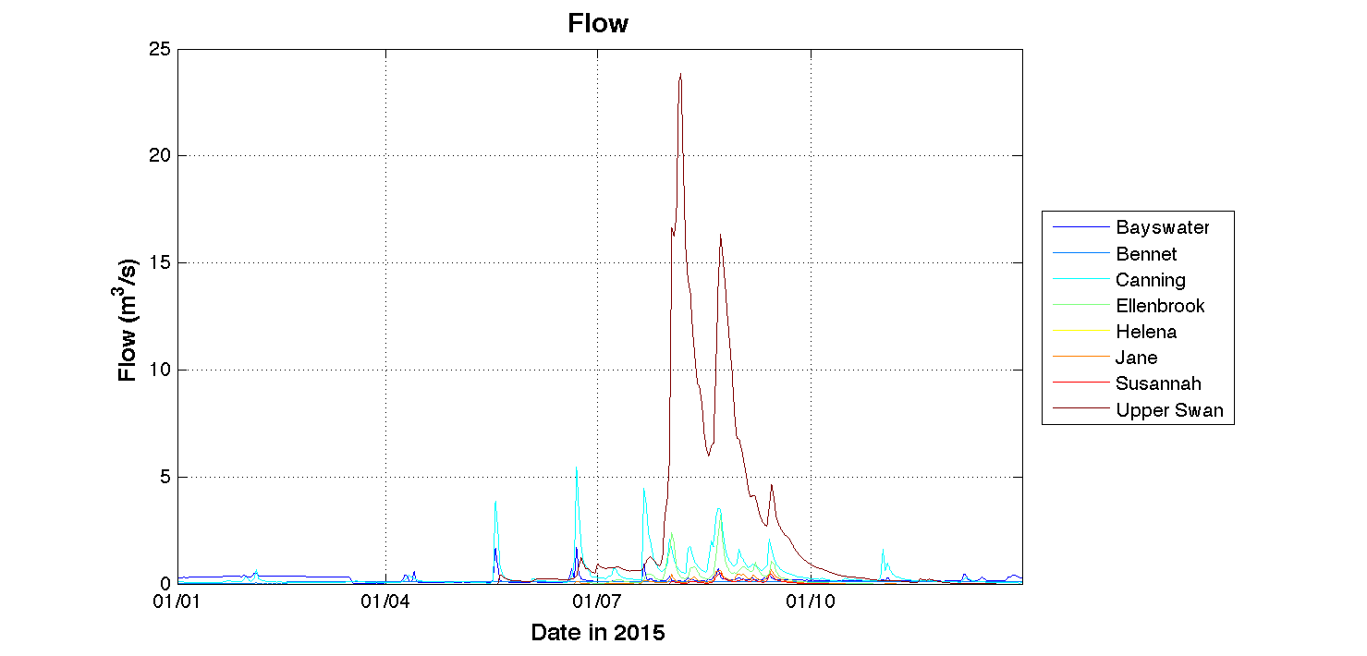

Figure 2. Flow rates at 8 inflow rivers into Swan-Canning Estuary.

# 3. Model Performance Assessment

## 3.1 Time series of model output against measurements at representative stations

The model is assessed against the monitoring data at multiple sites within the estuary, of which 6 (ARM, RIV, NAR, RON, STJ, SUC, see figure 1) are used to summarise model performance here. These sites were carefully selected as they are evenly distributed along the estuary (except RIV which represents Canning River) and rich data were available at these sites for model validations. Data from the model and monitoring is summarised over the surface and bottom due to the high degree of stratification that commonly occurs.

The following sub-sections describe the model performance on each variable and comment on the model performance and reasons for discrepancies.

## Salinity

* The model confidently captures the vertical and horizontal variation in salinity over the simulation period.
  + Correlation R: 0.75 - 0.90
  + RMSE: 1.54 – 6.15 psu
  + MAE: 1.22 – 5.18 psu
  + MEF: 0.12 – 0.73

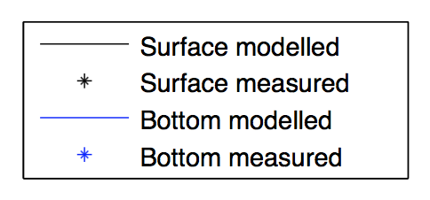

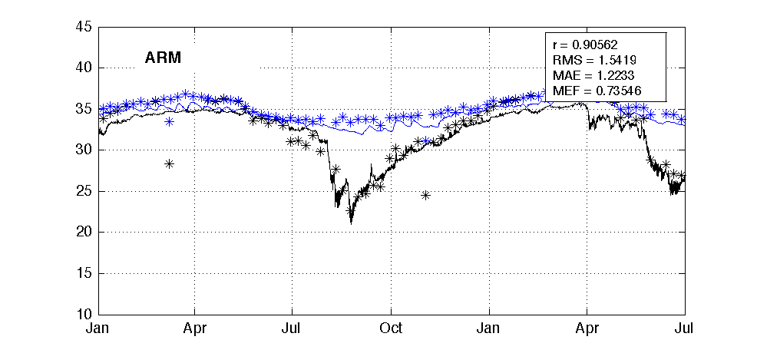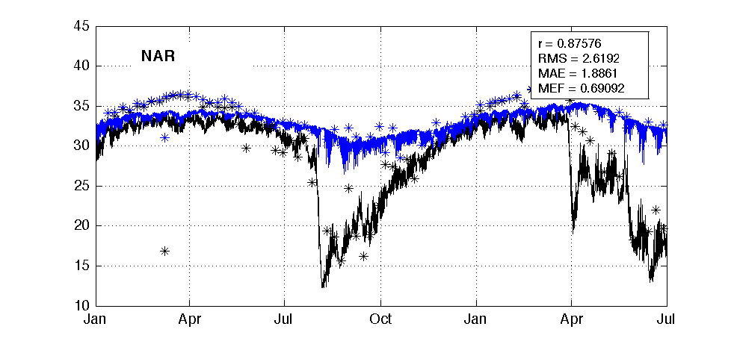

psu

psu

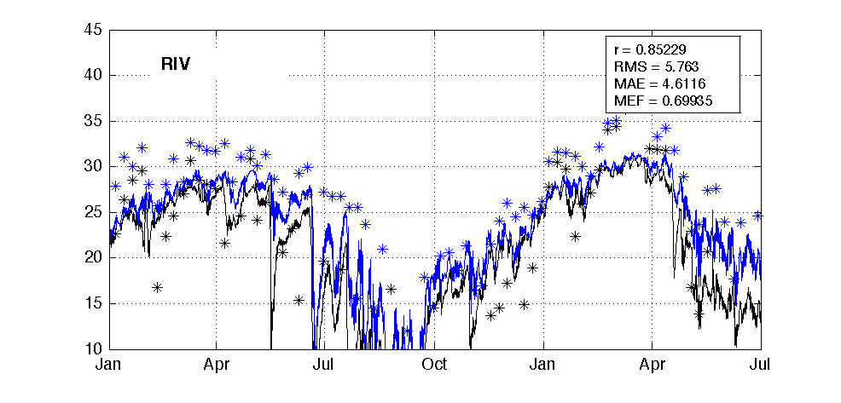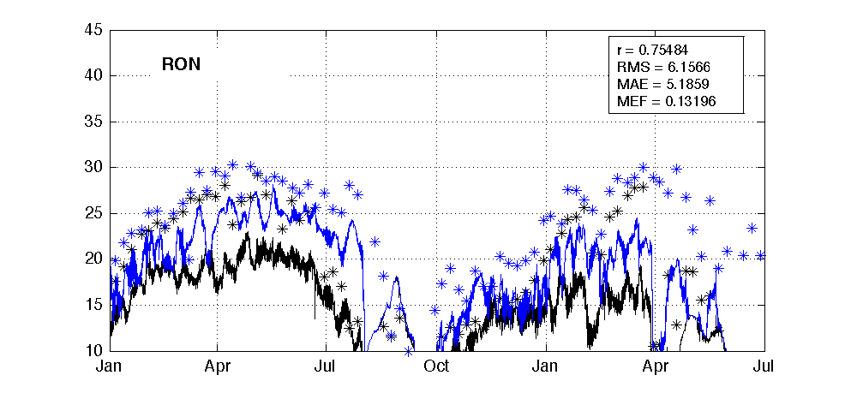

psu

psu

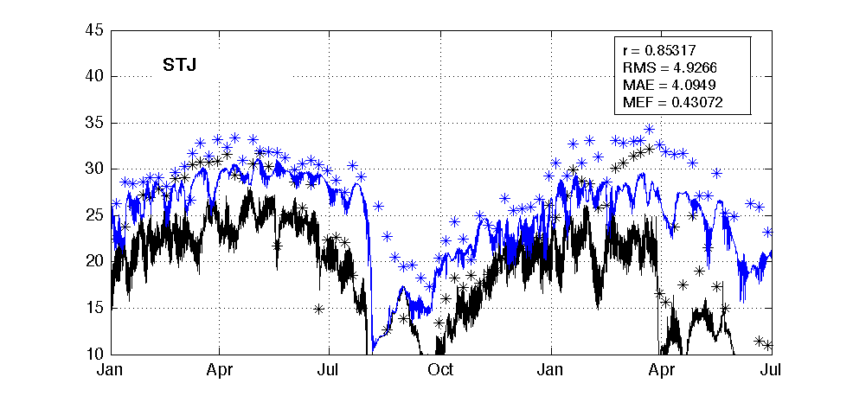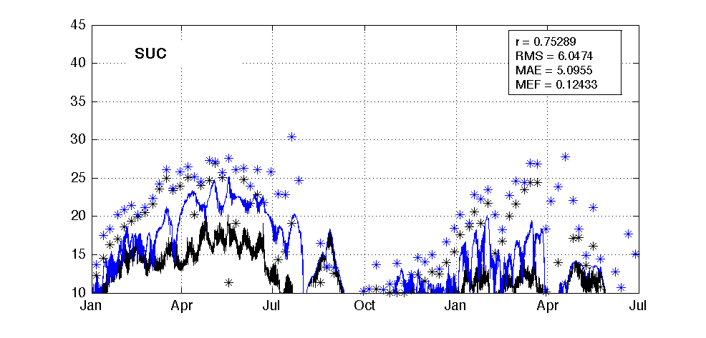

2015 - 2016

2015 - 2016

psu

psu

Figure 3. Salinity at six representative sites.

## Temperature

* The model confidently captures the diurnal and seasonal variation in temperature over the simulation period.
  + Correlation R: 0.90 - 0.95
  + RMSE: 2.00 – 2.95 degrees
  + MAE: 1.45 – 2.36 degrees
  + MEF: 0.51 – 0.80



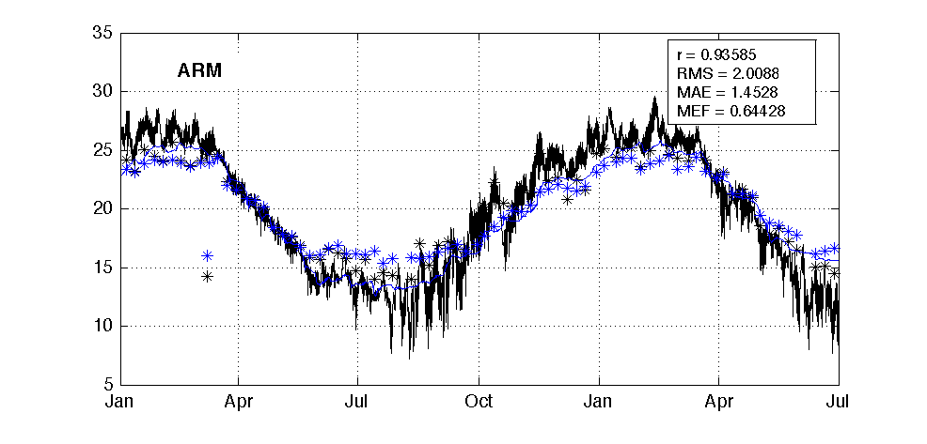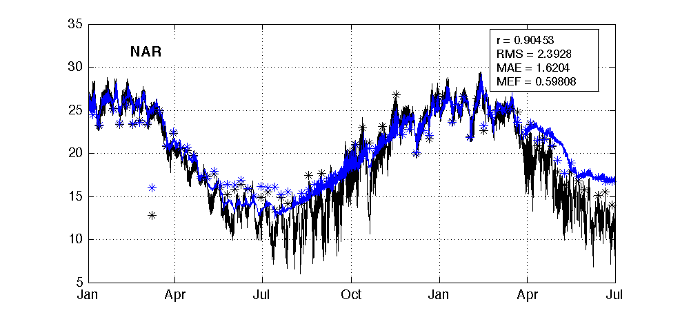

degrees

degrees

degrees

degrees

degrees

degrees

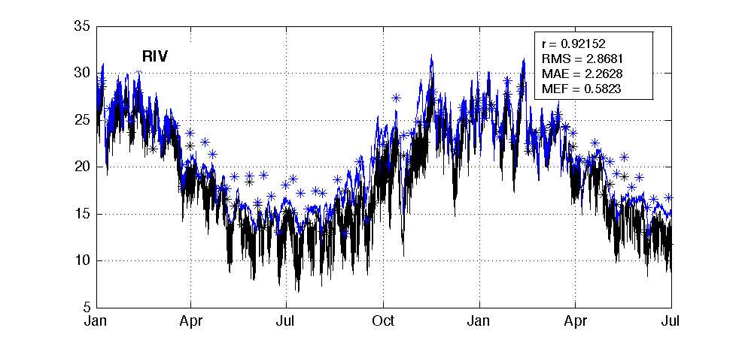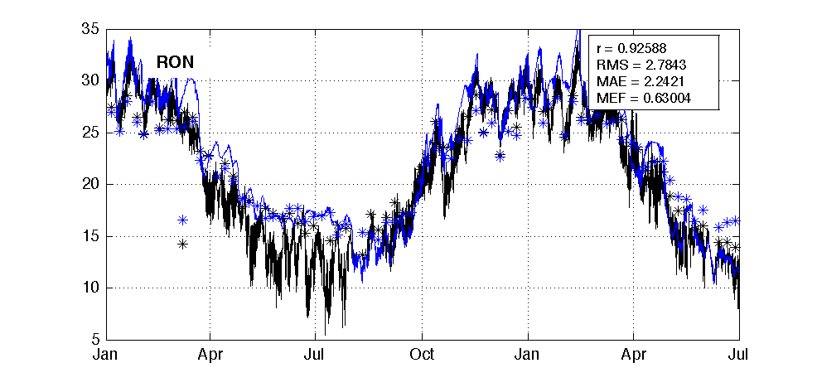

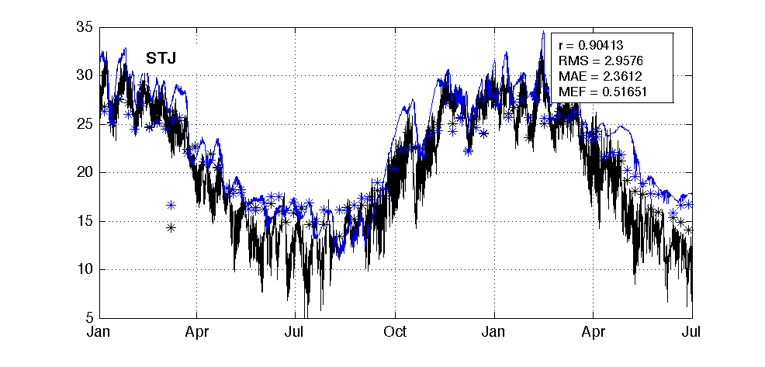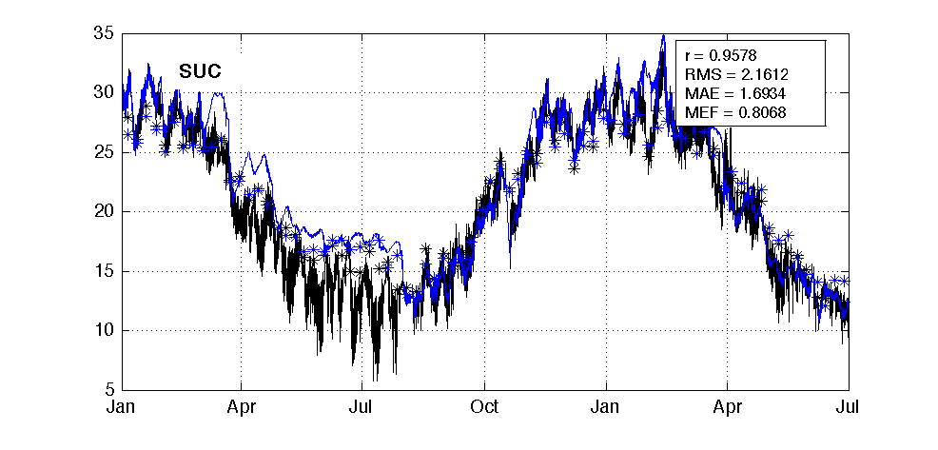

2015 - 2016

2015 - 2016

Figure 4. Temperature at six representative sites.

## Dissolved Oxygen (DO)

* The model captures the seasonal variability of DO and the degree of vertical stratification over the simulation period;
* There are trends of underestimation of DO in surface and bottom water of ARM, NAR and RON. This is likely due to inadequate oxygen production from phytoplankton photosynthesis. Improvements in capturing the mechanisms of phytoplankton biology such as vertical migration will help to improve the DO prediction.
  + Correlation R: 0.51 - 0.68
  + RMSE: 1.64 – 2.57 mg/L
  + MAE: 1.28 – 2.08 mg/L
  + MEF: -1.70 – 0.16



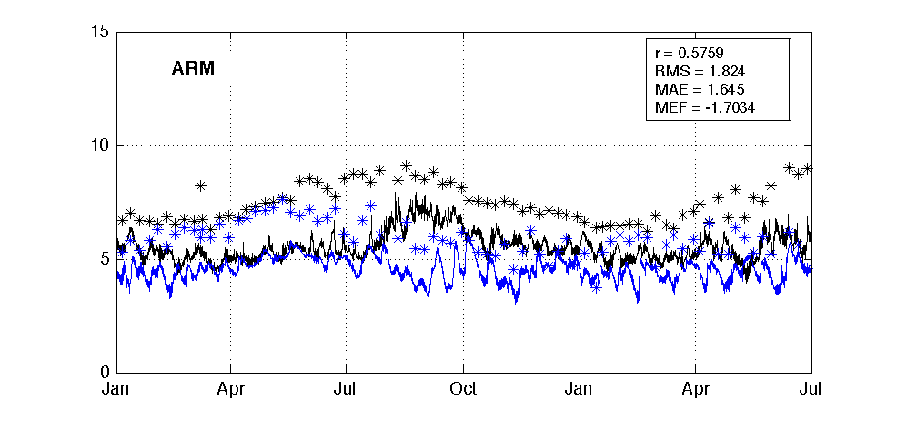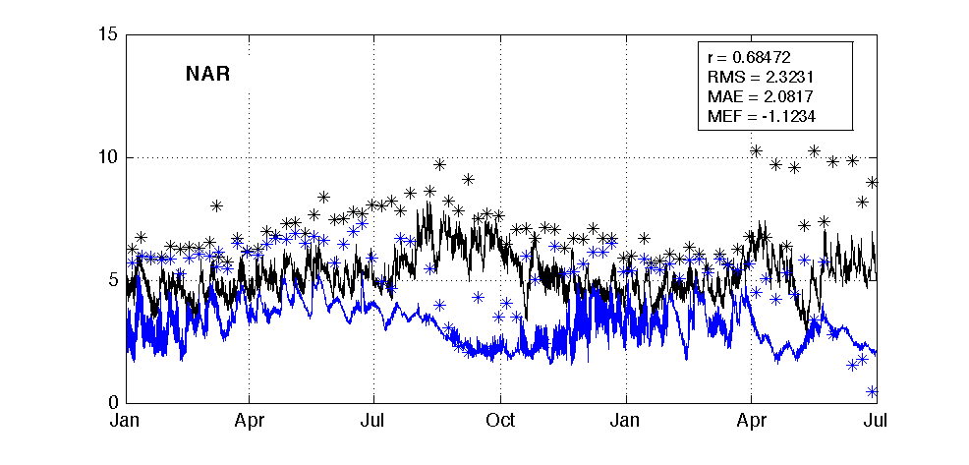

mg/L

mg/L

mg/L

mg/L

mg/L

mg/L

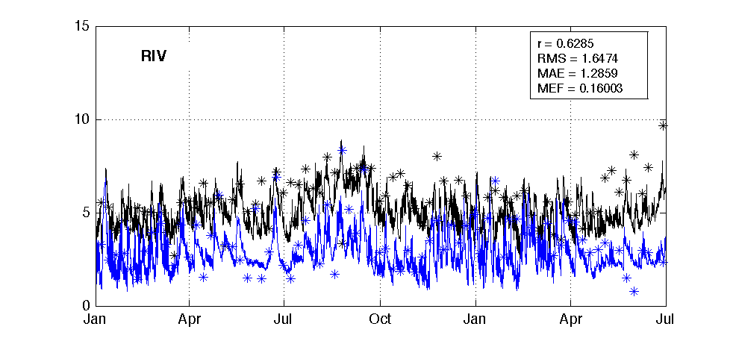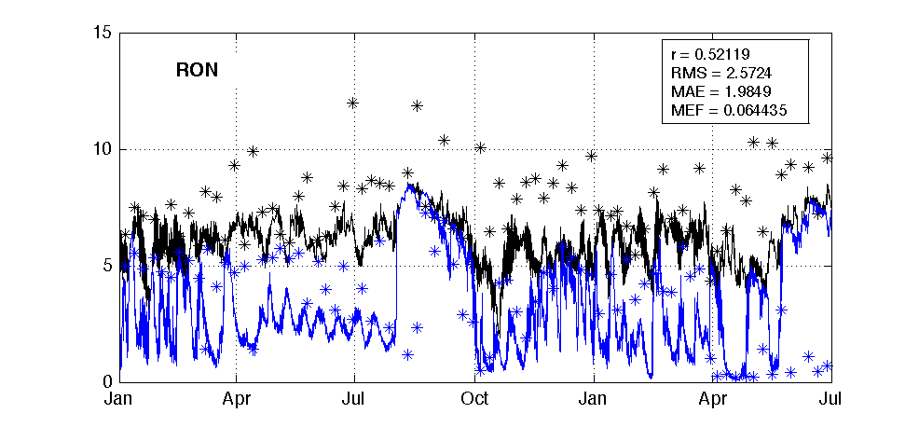

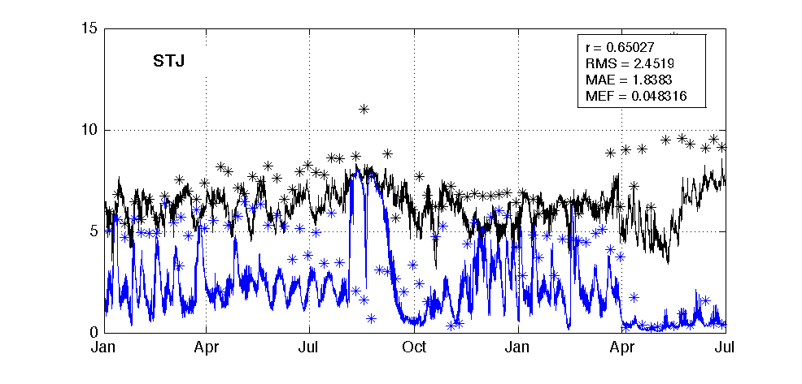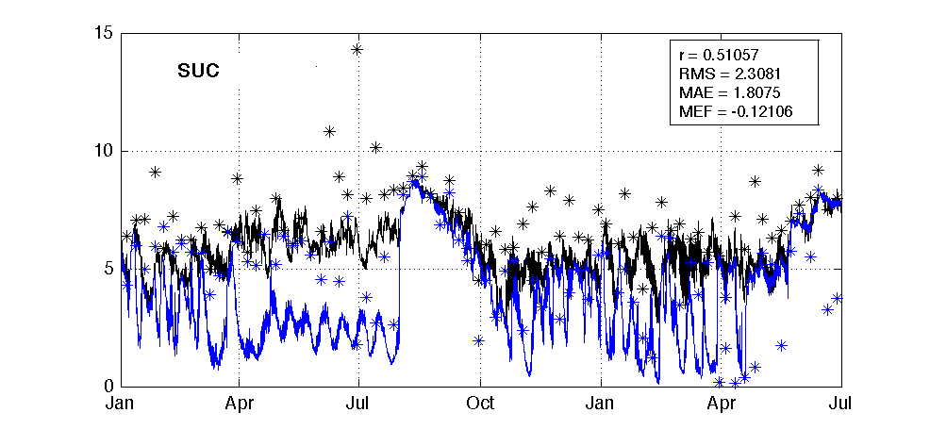

2015 - 2016

2015 - 2016

Figure 5. DO concentration at six representative sites.

## Phosphorus: Total Phosphorus (TP)

* The model reasonably reproduces the seasonal TP variation over the simulation period, although there are overestimation of TP from Jan 2015 to Aug 2015 at all sites, maybe due to insufficient boundary inputs during that period.
  + Correlation R: 0.29 - 0.53
  + RMSE: 0.86 – 3.12 mmol/m3
  + MAE: 0.72 – 2.08 mmol/m3
  + MEF: -6.49 – 0.02



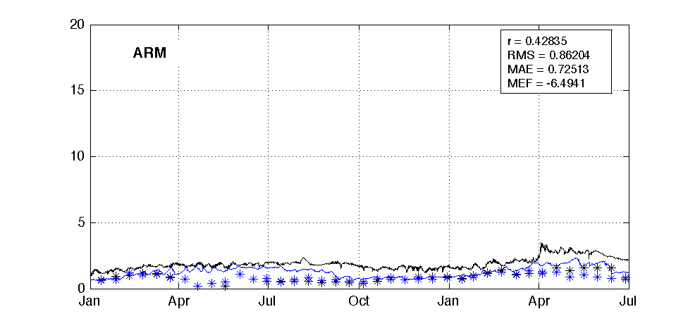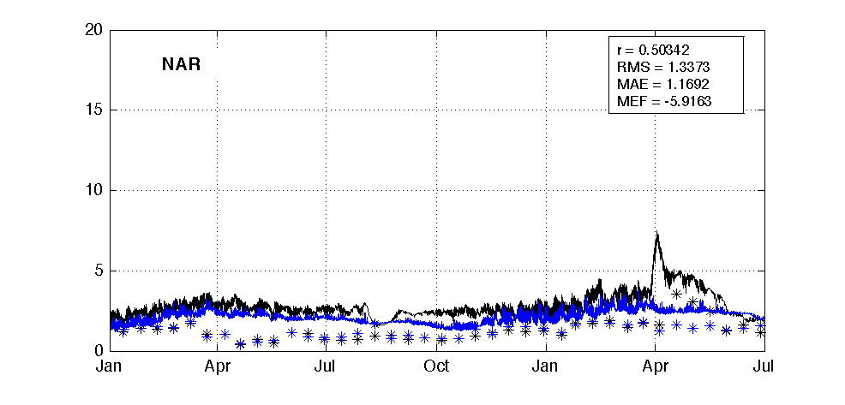

mmol/m3

mmol/m3

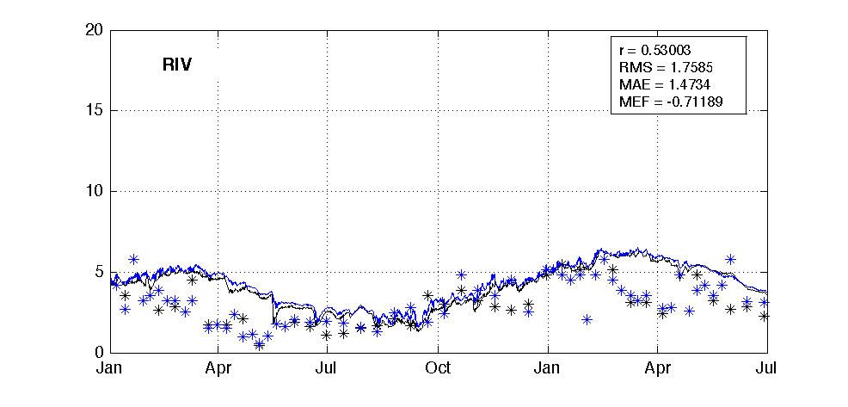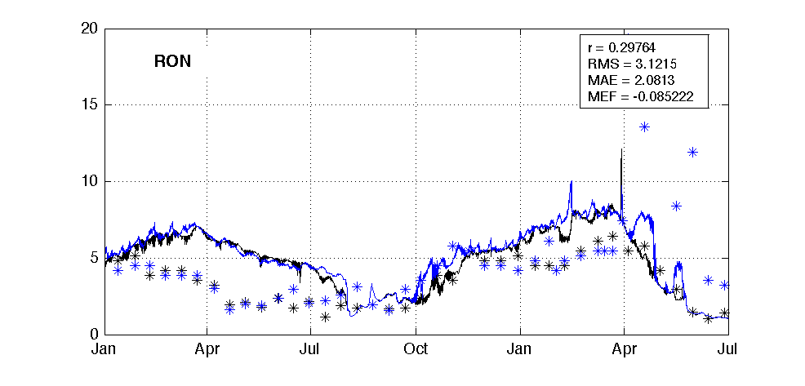

mmol/m3

mmol/m3

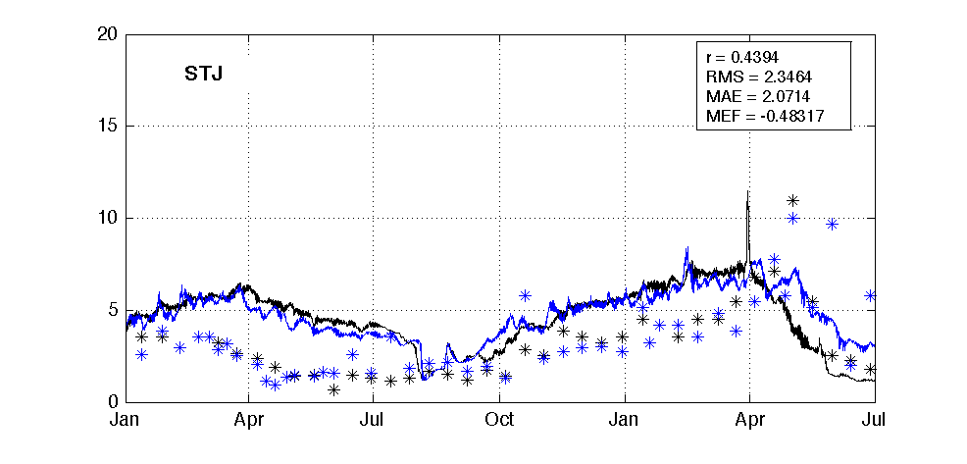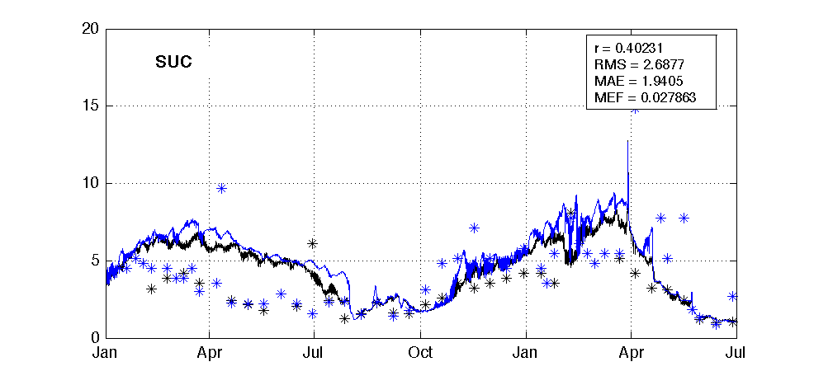

2015 - 2016

2015 - 2016

mmol/m3

mmol/m3

Figure 6. Total Phosphorus concentration at six representative sites.

## Phosphorus: Phosphate (PO4)

* Similar to the performance of TP, the model captures the seasonal variation of PO4 over the simulation period, while overestimations are found during Jan – Aug 2015.
  + Correlation R: 0.05 - 0.57
  + RMSE: 0.45 – 2.87 mmol/m3
  + MAE: 0.37 – 1.28 mmol/m3
  + MEF: -9.77 – 0.07



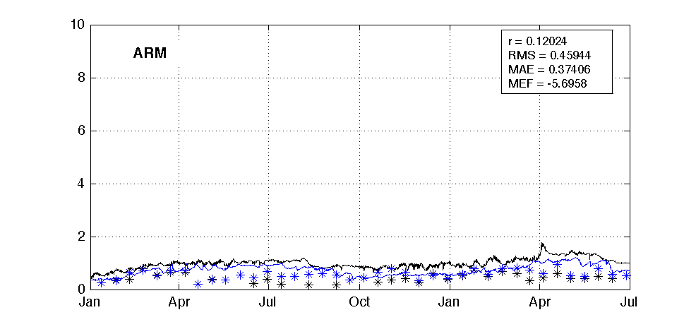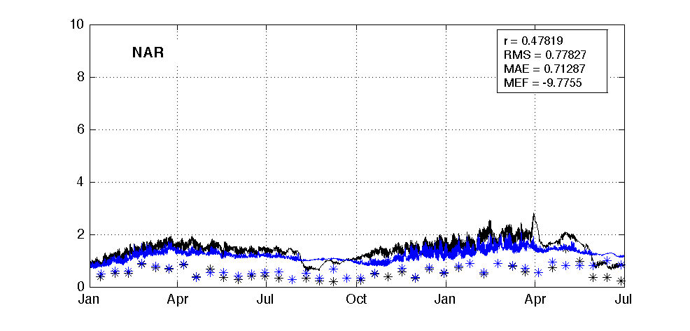

mmol/m3

mmol/m3

mmol/m3

mmol/m3

mmol/m3

2015 - 2016

2015 - 2016

mmol/m3

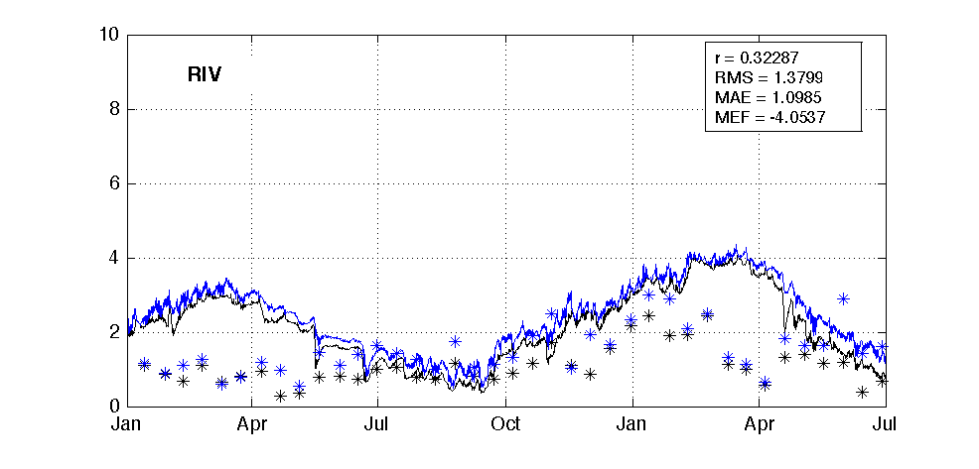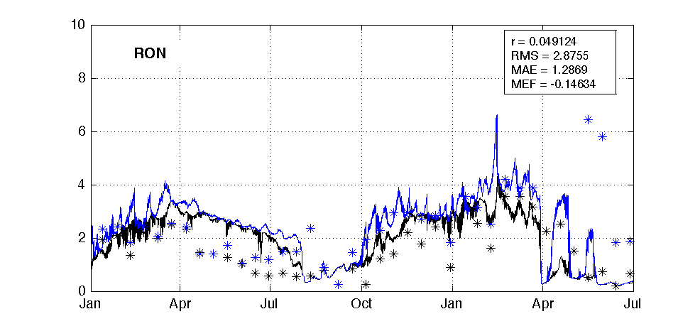

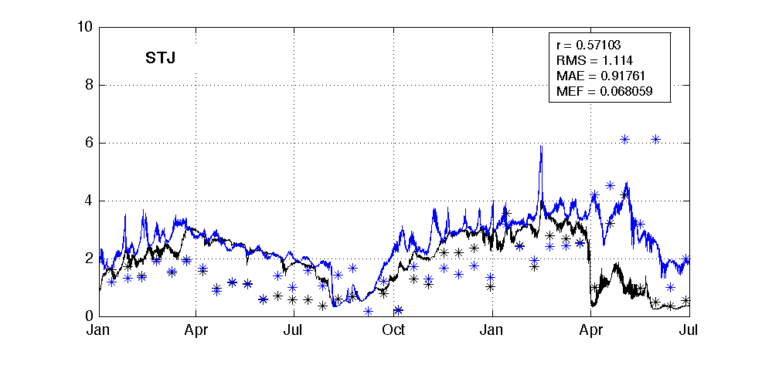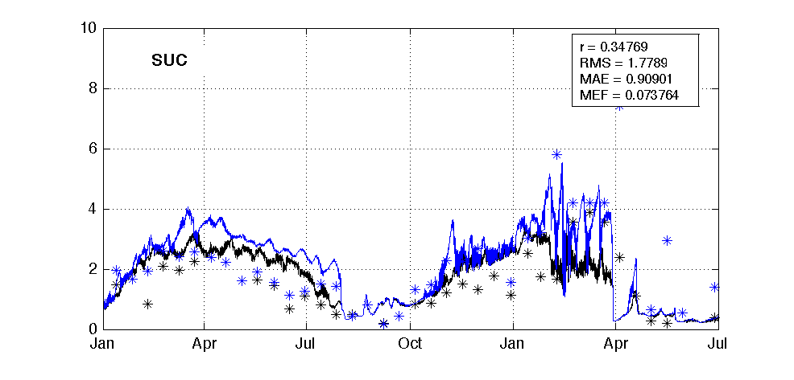

Figure 7. Phosphate concentration at six representative sites.

## Nitrogen: Total Nitrogen (TN)

* The model captures the seasonal variation of TN over the simulation period. However the TN concentration in Upper Swan (RON, STJ, SUC) are consistent over-predicted. This is reflected in the statistics that the ‘R’ values are good in all sites while the deviations (RMSE and MAE) are high in Middle and Upper Swan sites. Given the TN prediction is good in previous runs (Hipsey et al., 2016b), this is likely due to insufficient boundary monitoring data of nitrogen to force the water quality model. Further discussions are given in Chapter 4 and Chapter 5.
  + Correlation R: 0.33 - 0.93
  + RMSE: 15.88 – 77.67 mmol/m3
  + MAE: 11.95 – 64.50 mmol/m3
  + MEF: -7.29 – -0.69



2015 - 2016

2015 - 2016

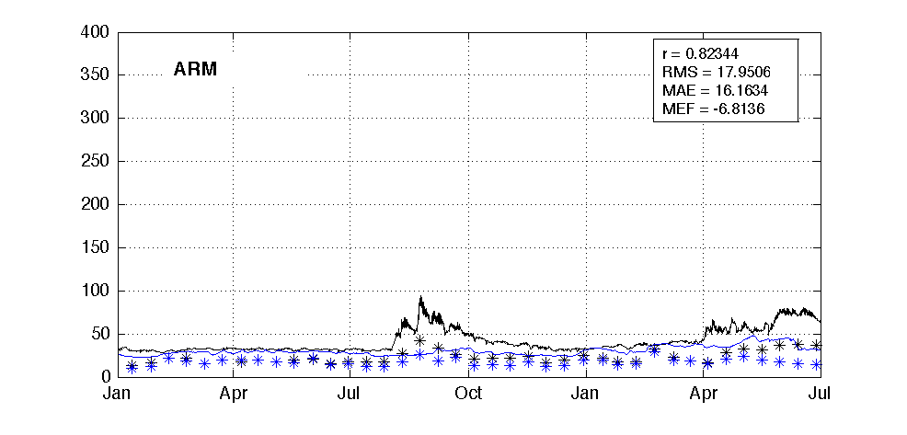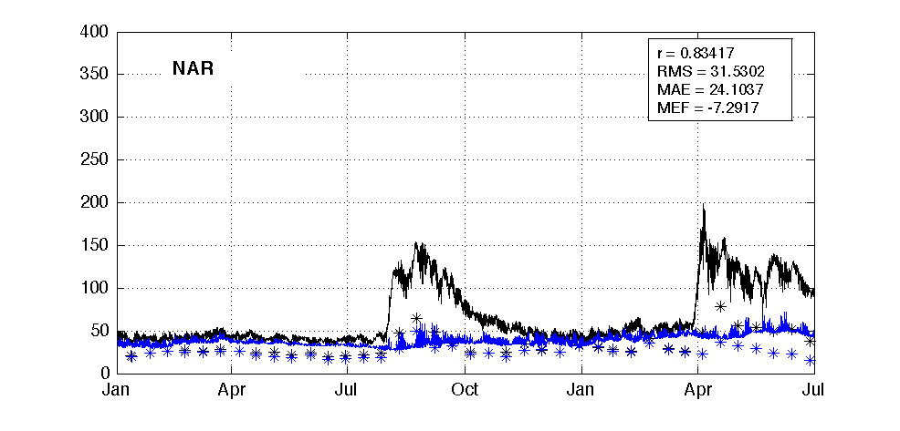

mmol/m3

mmol/m3

mmol/m3

mmol/m3

mmol/m3

mmol/m3

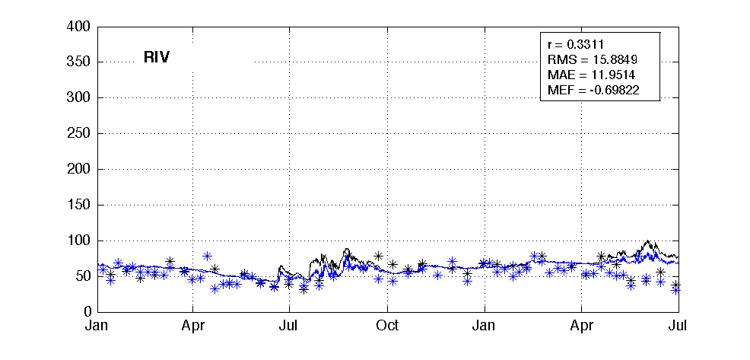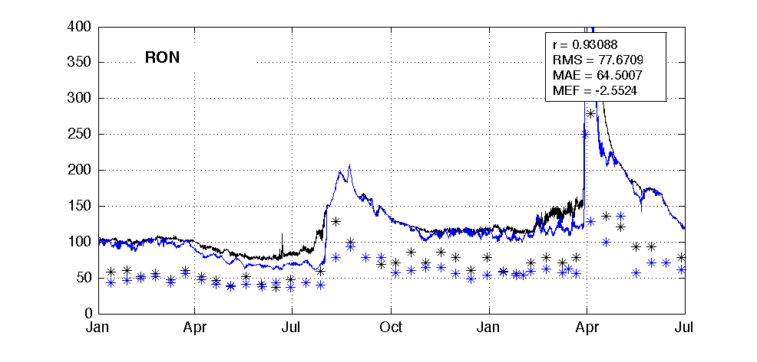

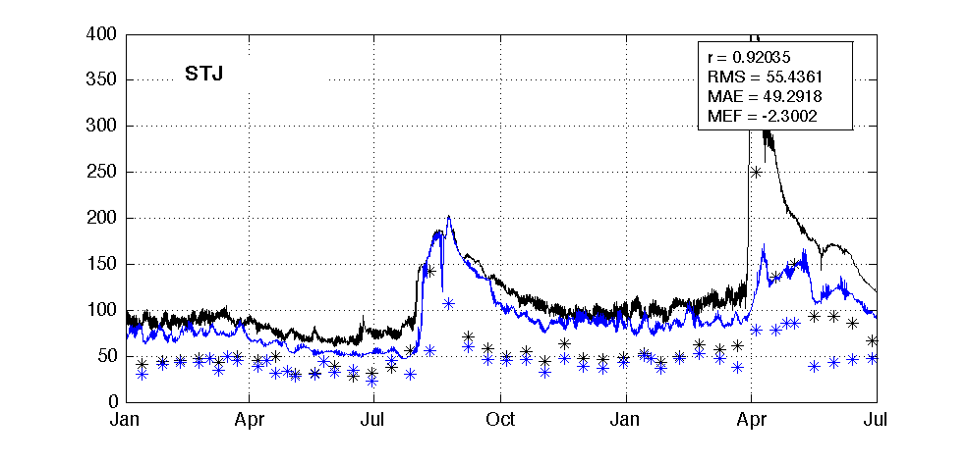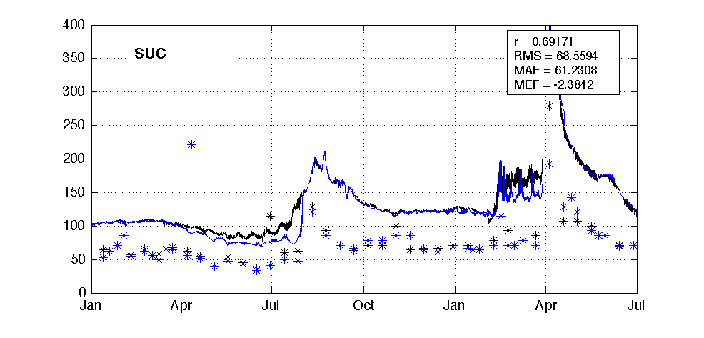

Figure 8. Total Nitrogen concentration at six representative sites.

## Nitrogen: Ammonium (NH4)

* The model captures the spatial variation of NH4 across the estuary and the vertical stratification over the simulation period; however, the NH4 behaviours at RIV and Upper Swan are intensive. Both the model and measurements show strong variations that make it difficult to get good statistics values. Again, higher frequency of monitoring at boundaries and within Upper Swan is recommended to improve the model performance.
  + Correlation R: 0.04 - 0.61
  + RMSE: 1.44 – 11.63 mmol/m3
  + MAE: 1.05 – 6.67 mmol/m3
  + MEF: -1.88 – 0.16



mmol/m3

mmol/m3

mmol/m3

mmol/m3

mmol/m3

2015 - 2016

2015 - 2016

mmol/m3

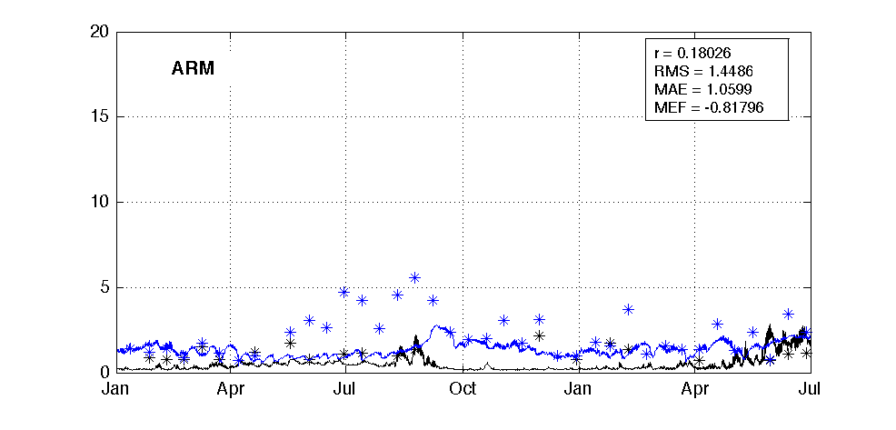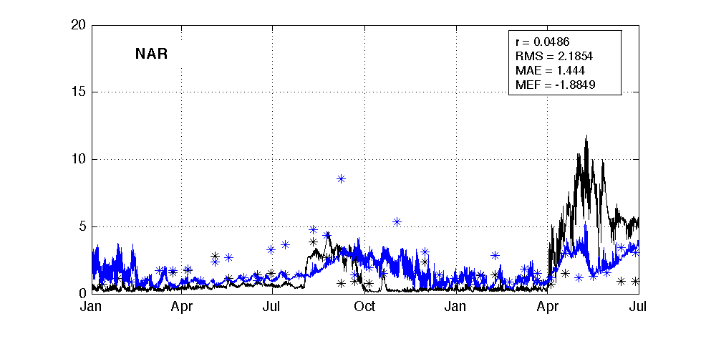

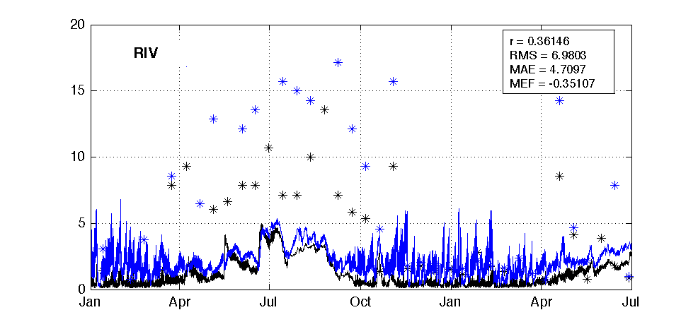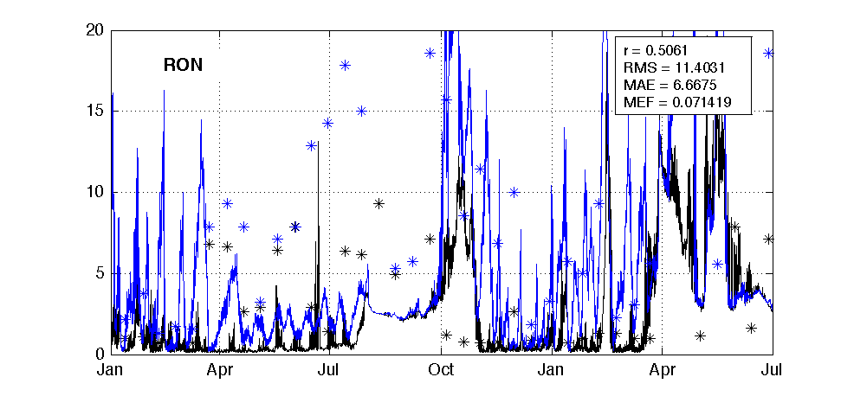

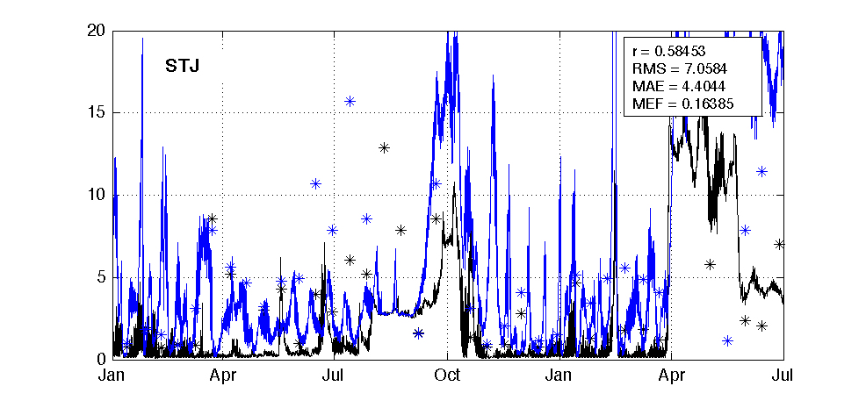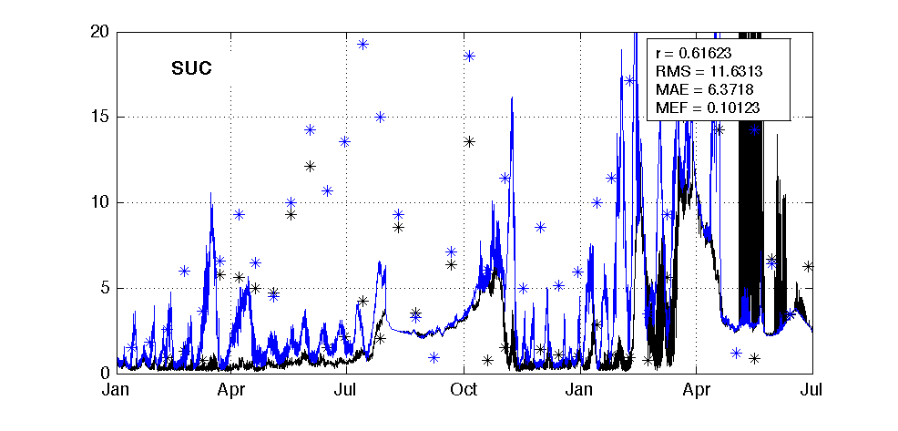

Figure 9. Ammonium concentration at six representative sites.

## Nitrogen: Nitrate (NOx)

* The model captures the spikes of nitrate over the simulation period, and the spatial variation along the estuary; however, the model generally underestimates the nitrate.
  + Correlation R: 0.23 - 0.88
  + RMSE: 1.54 – 16.03 mmol/m3
  + MAE: 1.37 – 5.96 mmol/m3
  + MEF: -3.86 – 0.52



mmol/m3

mmol/m3

mmol/m3

mmol/m3

mmol/m3

2015 - 2016

2015 - 2016

mmol/m3

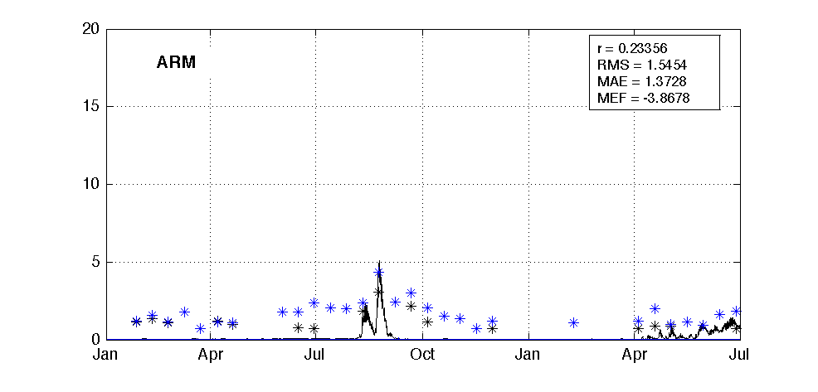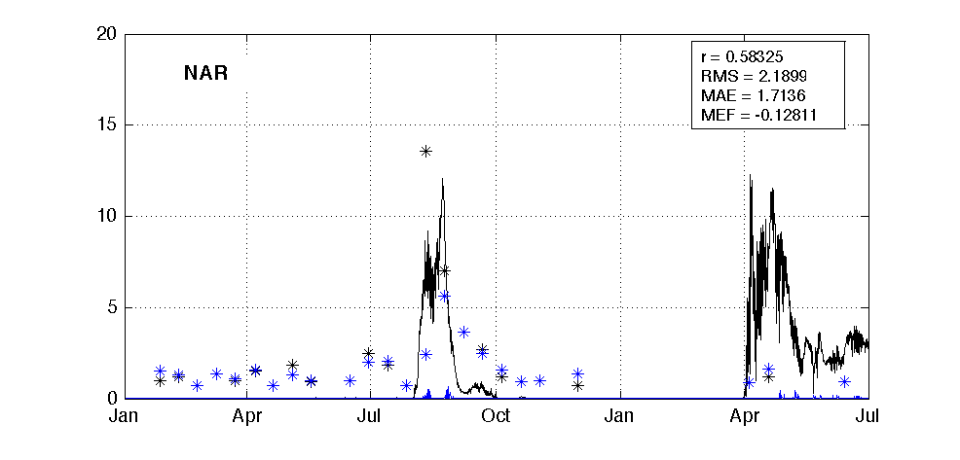

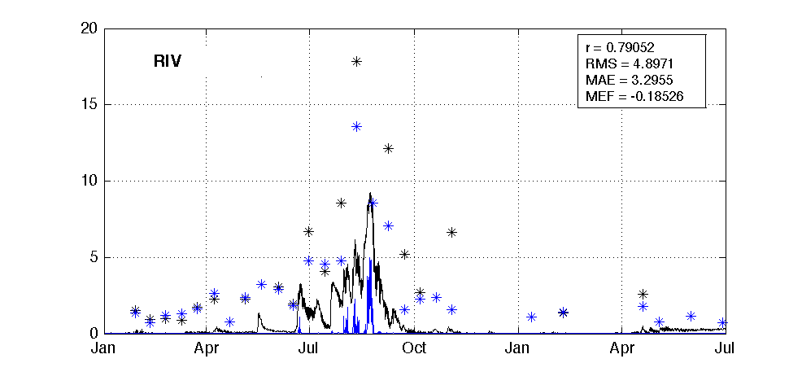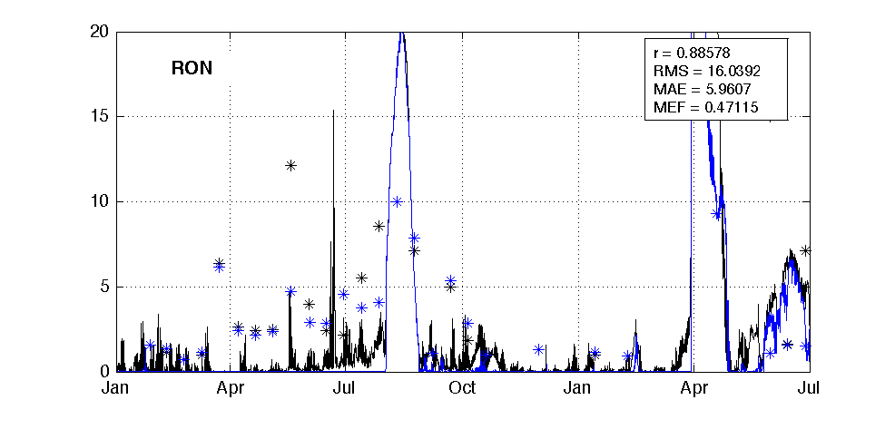

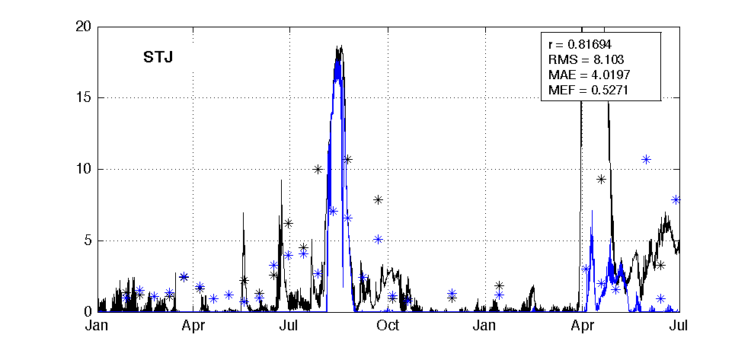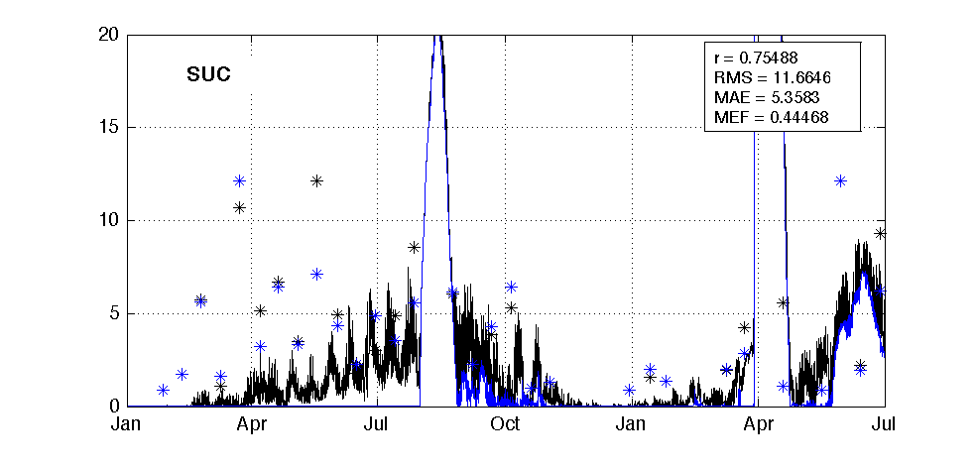

Figure 10. Nitrate concentration at six representative sites.

## Nitrogen: Dissolved Organic Nitrogen (DON)

* The model captures the seasonal variation of DON over the simulation period, and the spatial variation along the estuary; however, the model tends to overestimate the DON at Upper Swan stations from Jan – Jul 2015, suggesting an over-supply of DON from boundaries or sediment during this time period or inadequate rates of mineralisation of phytoplankton exudate.
  + Correlation R: -0.08 - 0.61
  + RMSE: 5.34 – 27.24 mmol/m3
  + MAE: 4.03 – 24.04 mmol/m3
  + MEF: -1.71 – -0.03



2015 - 2016

2015 - 2016

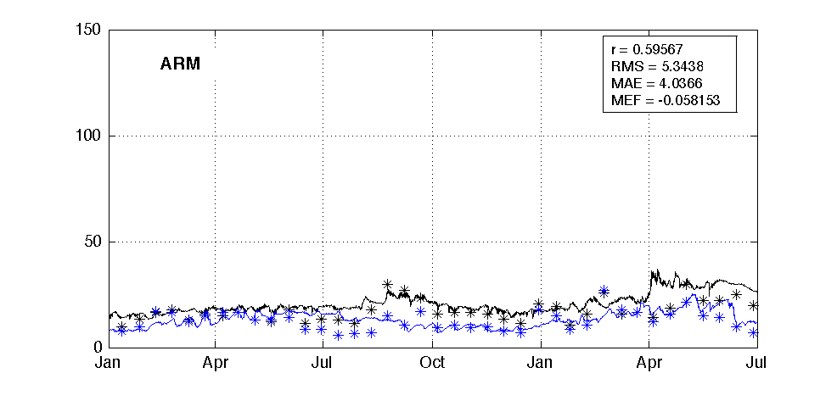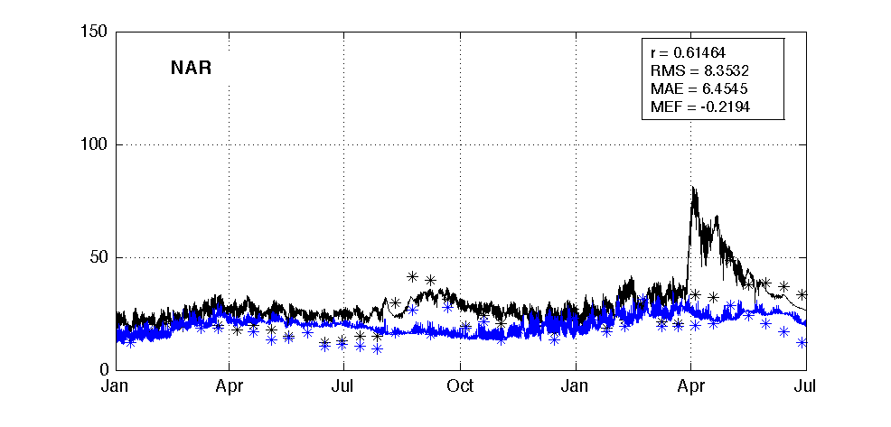

mmol/m3

mmol/m3

mmol/m3

mmol/m3

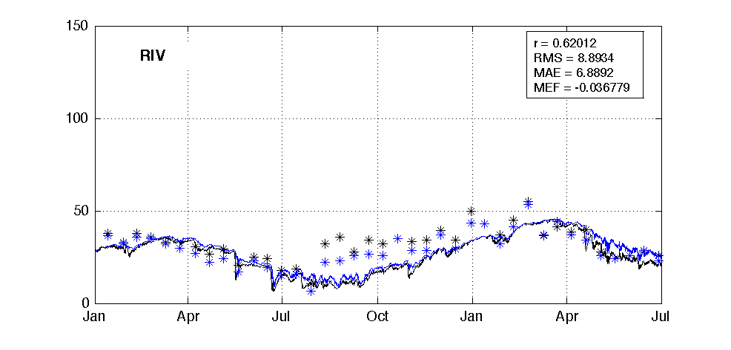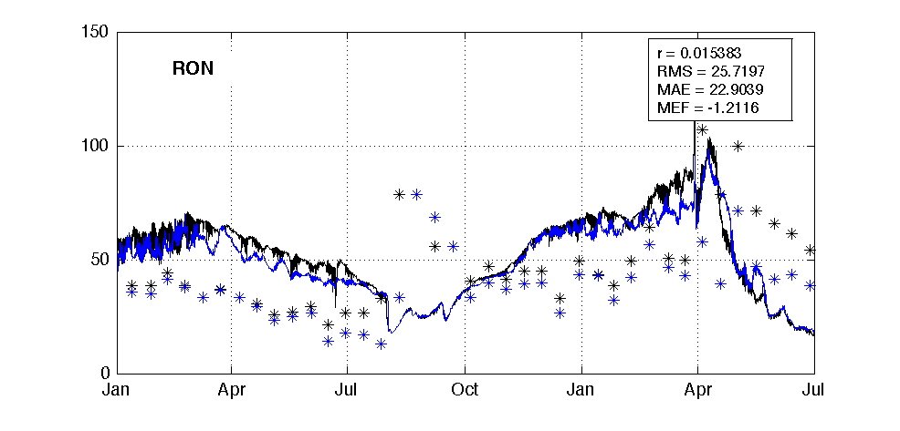

mmol/m3

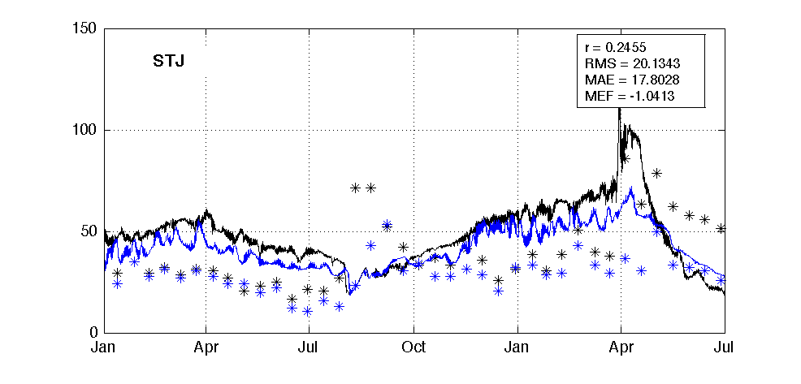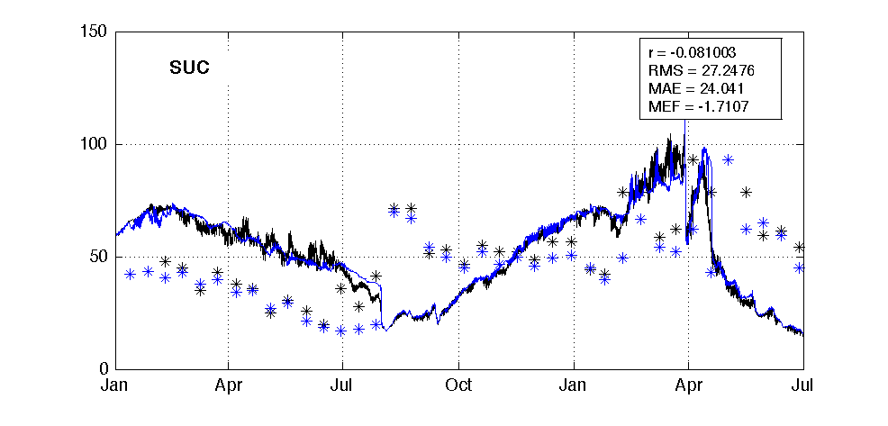

mmol/m3

Figure 11. DON concentration at six representative sites.

## Silica: Reactive Silica (RSi)

* The model captures the spikes of reactive silica over the simulation period, and the spatial variation along the estuary. The model generally underestimates the reactive silica in RIV, indicating under-supply from boundary input or over-consumption by diatom at RIV.
  + Correlation R: 0.15 - 0.66
  + RMSE: 24.55 – 41.15 mmol/m3
  + MAE: 18.33 – 37.56 mmol/m3
  + MEF: -4.11 – 0.08



2015 - 2016

2015 - 2016

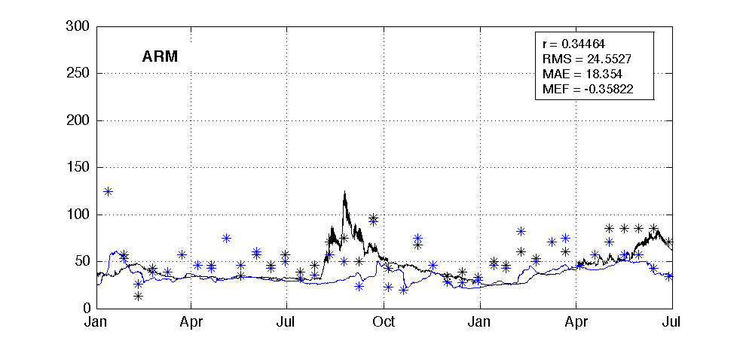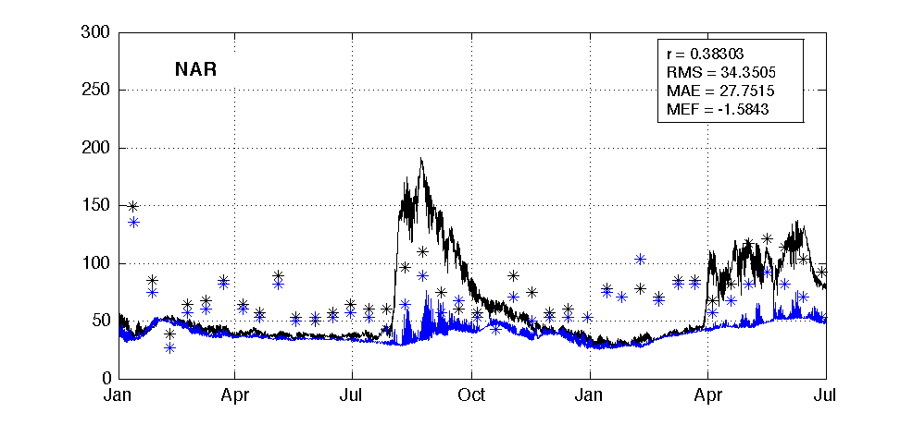

mmol/m3

mmol/m3

mmol/m3

mmol/m3

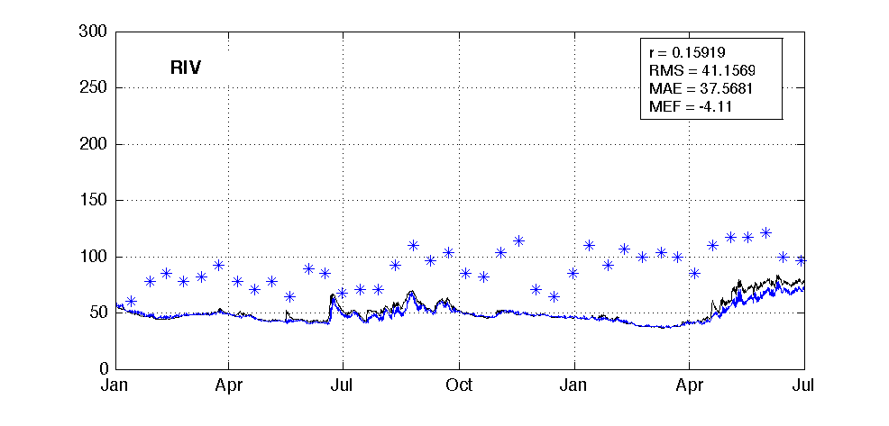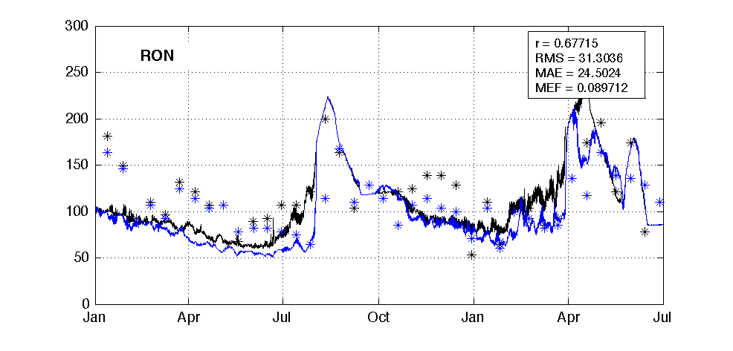

mmol/m3

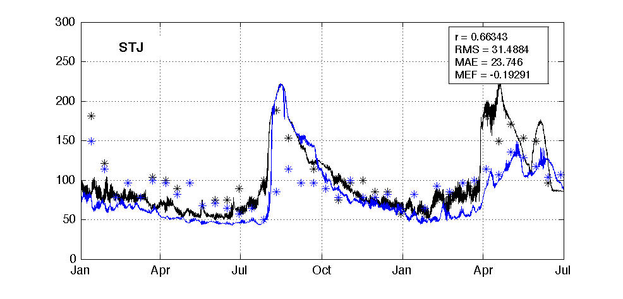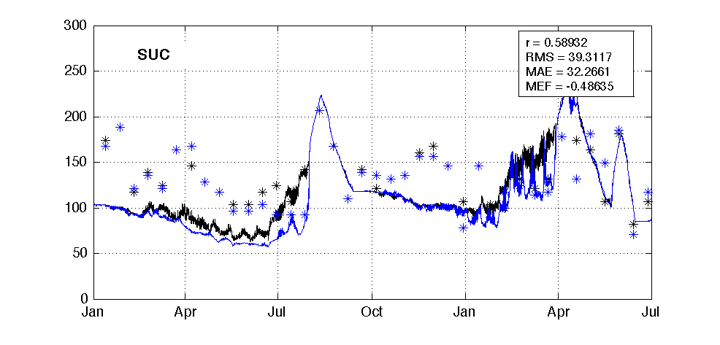

mmol/m3

Figure 12. RSi concentration at six representative sites.

## Phytoplankton: Chlorophyll-a (TCHLA)

* The model is able to capture the spatial difference between the Lower Swan, Middle Swan and Upper Swan; however, the model has a tendency to over-predict the bottom TCHLA. This is likely due to the lack of vertical migration configured in the dinoflagellate group, which allow dinoflagellate to accumulate when the river is not under turbulence. The measured TCHLA is also highly scattered, indicates the high variability of phytoplankton biology that need to improve in the water quality model.
  + Correlation R: -0.31 - 0.36
  + RMSE: 2.47 – 15.67 μg/L
  + MAE: 1. 70 – 8.55 μg/L
  + MEF: -0.60 – 0.11



**μg/L**

**μg/L**

**μg/L**

2015 - 2016

2015 - 2016

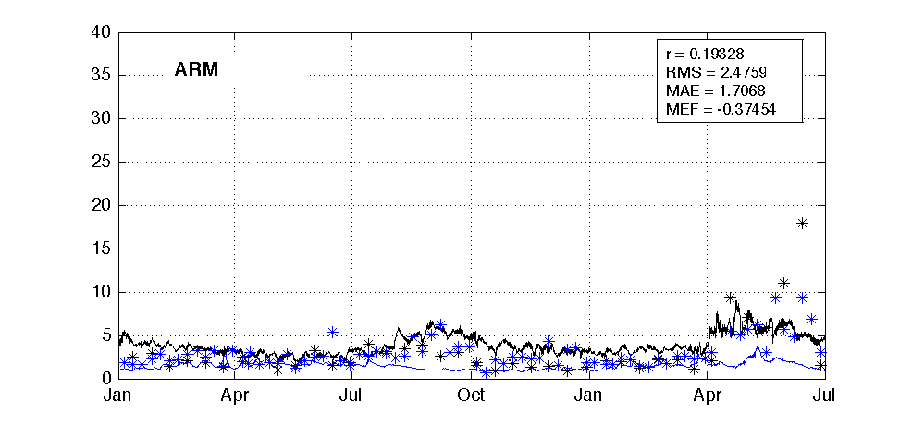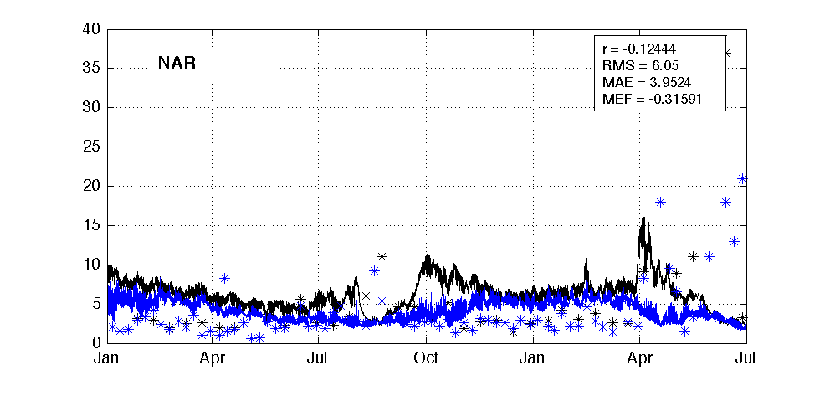

**μg/L**

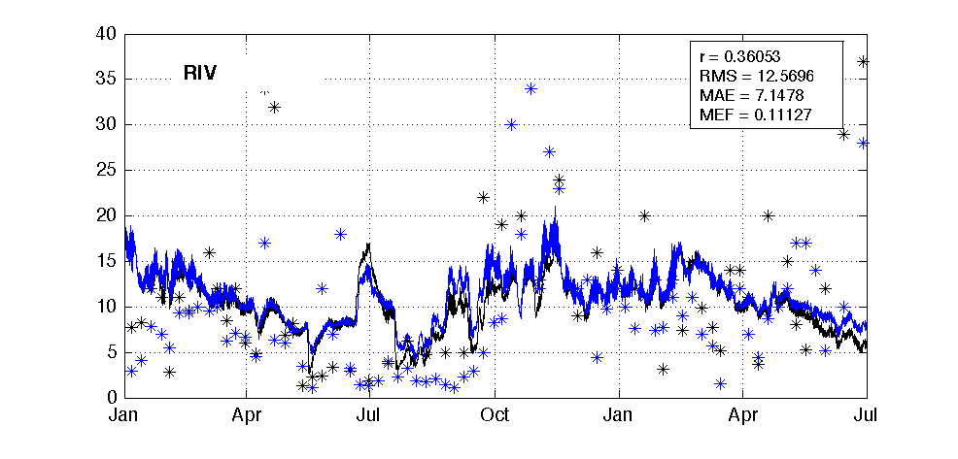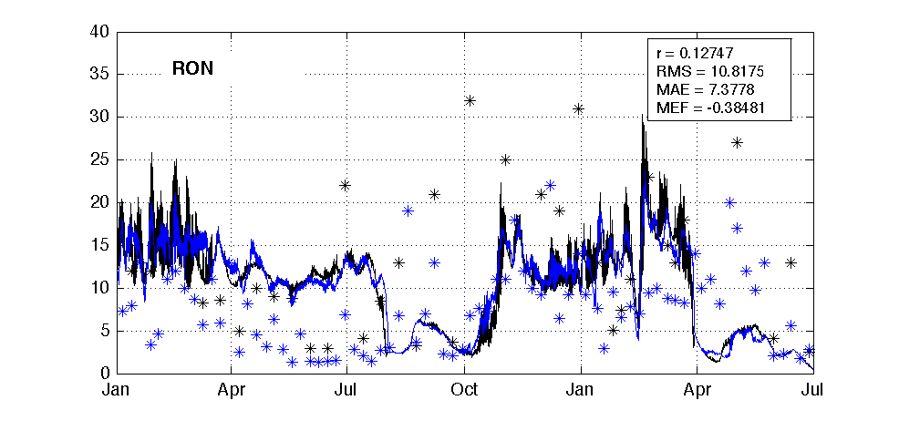

**μg/L**

**μg/L**

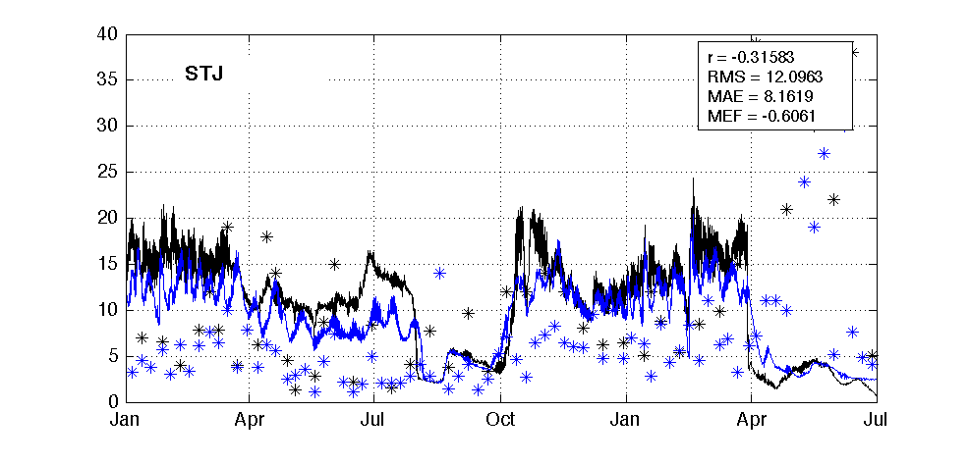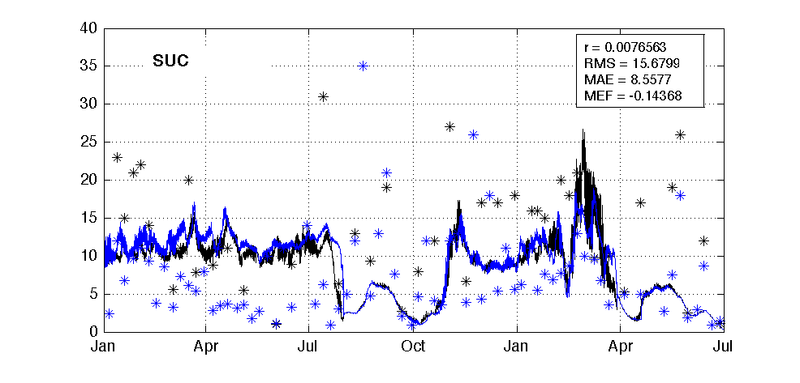

Figure 13. Total Chlorophyll-a concentration at six representative sites.

## 3.2 Transect thalweg (whole river view) of selected variables

## Transect thalweg plots of surface waters

* The modelled surface salinity shows a gradual decrease from Lower Swan to Upper Swan, well matched the field measurements; while the surface temperature doesn’t show much variety across the estuary;
* The model captured the spatial variety of TN, Nitrate, and DON, although the TN tends to be overestimated and Nitrate tends to be underestimated. This matches the statistics results in Chapter 3.1 that the modelled TN and Nitrate have a good regression coefficients against the measured TN and Nitrate, but big deviations are found.
* The spatial variation of TP and Phosphate are well captured, although the TP is tended to be overestimated;
* The surface dissolved oxygen doesn’t show much variety across the estuary;
* The surface TCHLA is underestimated in the Upper Swan;

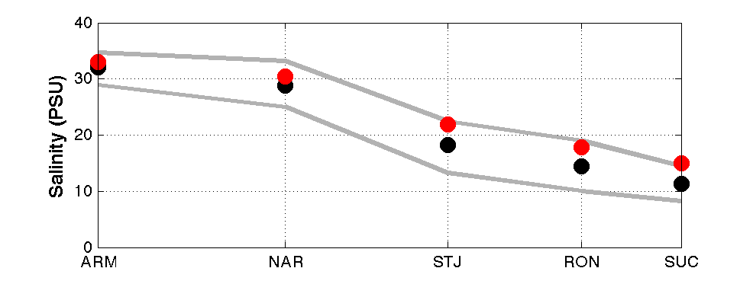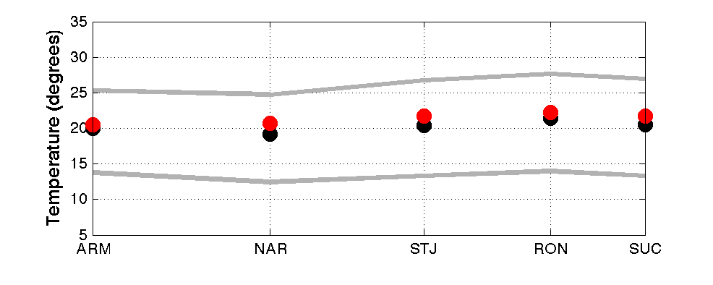

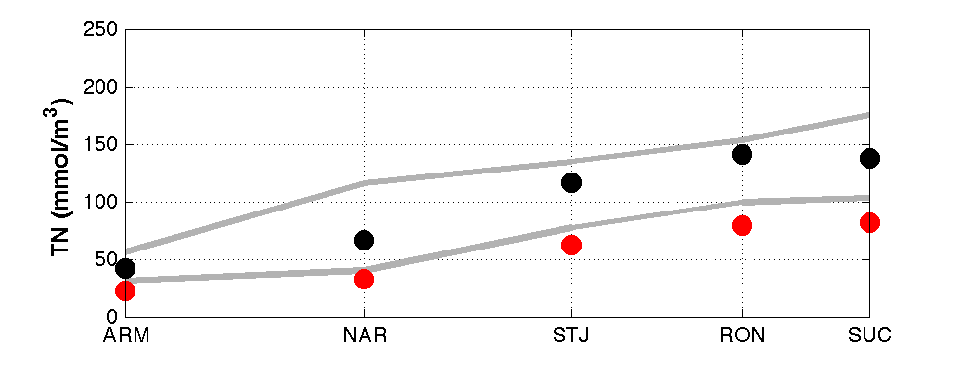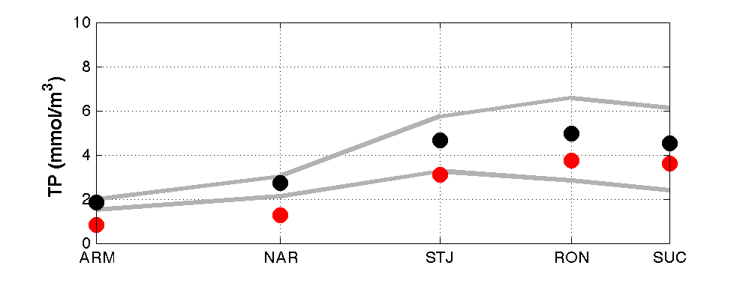

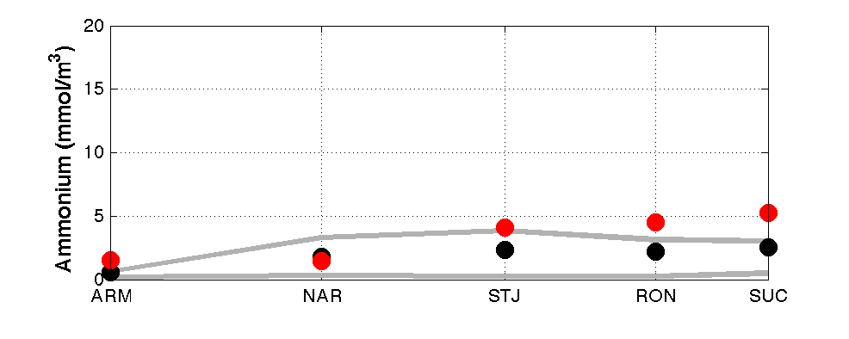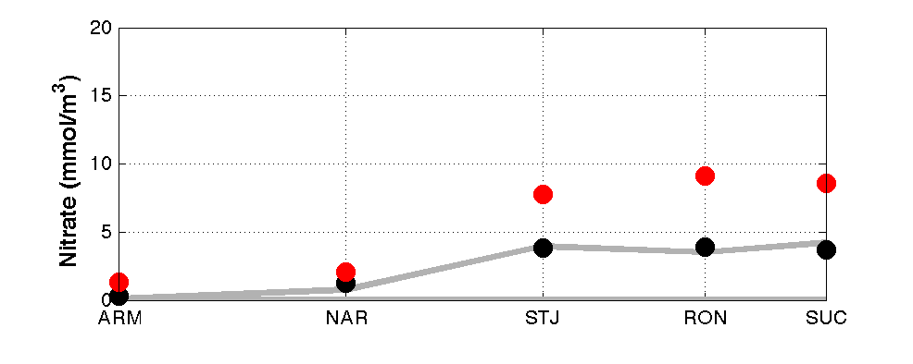

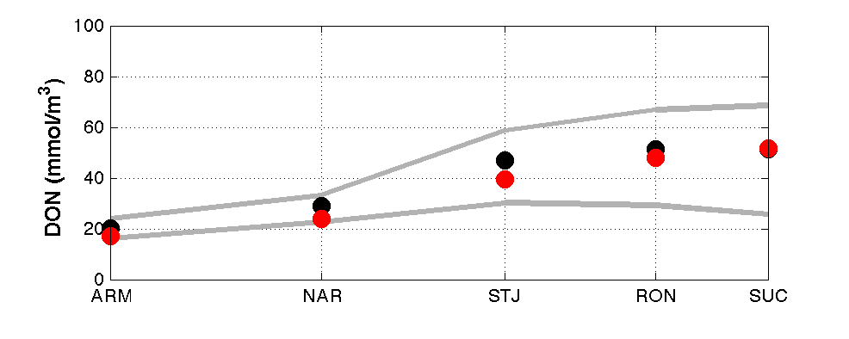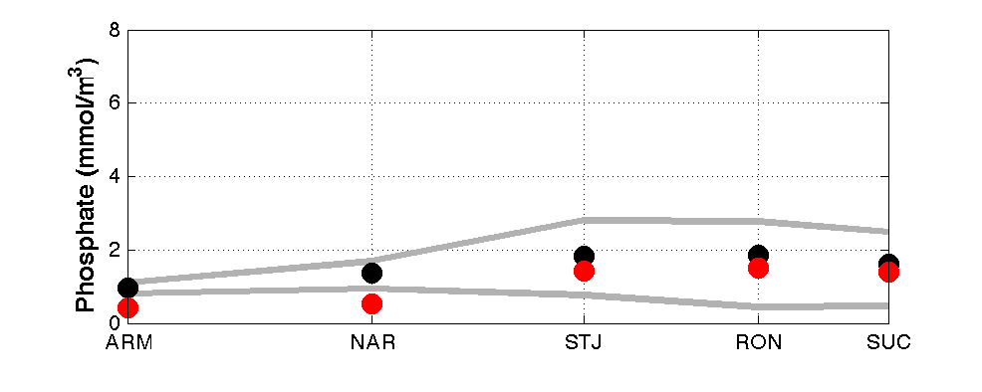

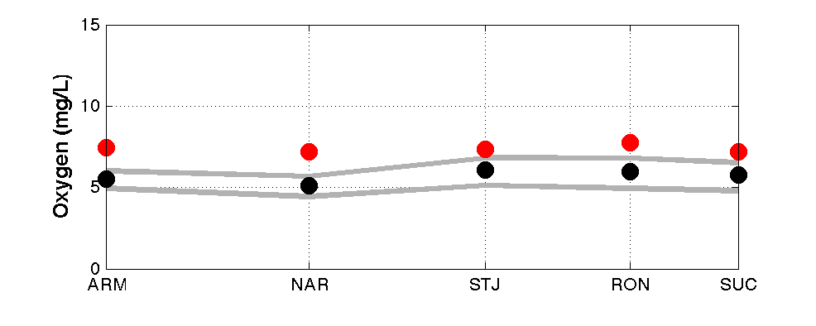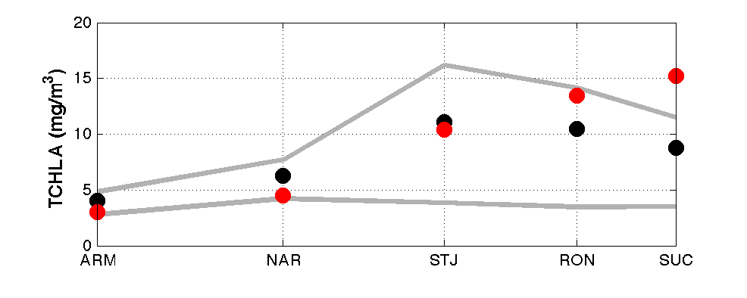

Figure 14. Thalweg plots of the spatial distribution of surface water properties and model performance along the Swan River from Lower Swan to Upper Swan (except RIV which is at Canning River). Grey lines indicate the 20 – 80% modelled envelope; black dots represent the mean modelled value, while red dots represent the mean measured value.

## Transect thalweg plots of bottom waters

* Similar to the plots of surface water, the modelled bottom salinity shows a gradual decrease from Lower Swan to Upper Swan, while the bottom temperature at ARM and NAR is a bit lower than other sites doesn’t due to deeper water depths;
* The model captured the spatial variety of bottom TN, Nitrate, and DON, but again the TN tends to be overestimated and Nitrate tends to be underestimated. The Ammonium performance is good in lower and middle Swan while under-predicted in upper Swan;
* The spatial variation of bottom TP and Phosphate are well captured;
* The spatial variation of the bottom DO is well captured; the lowest bottom DO is found in the middle Swan;
* The bottom TCHLA increase from lower Swan to Upper Swan;

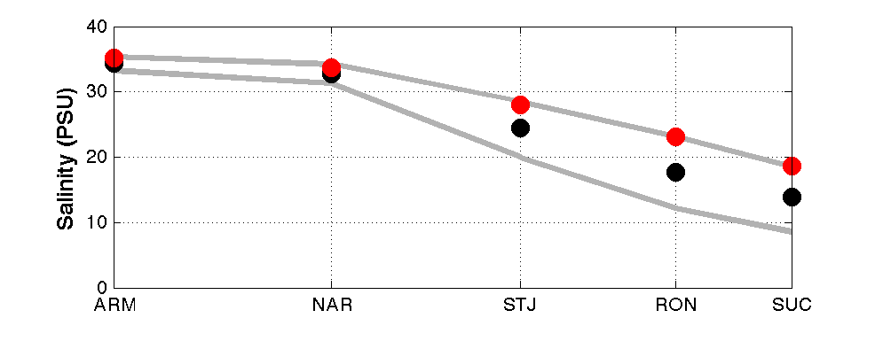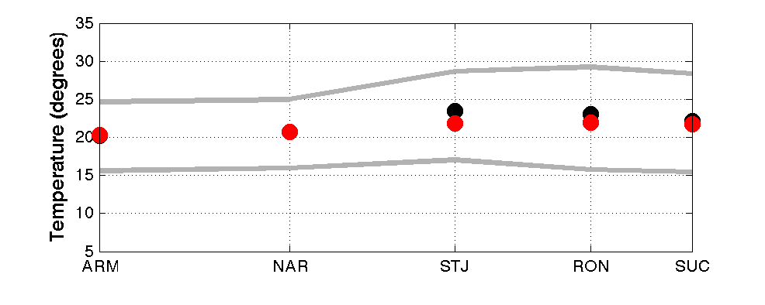

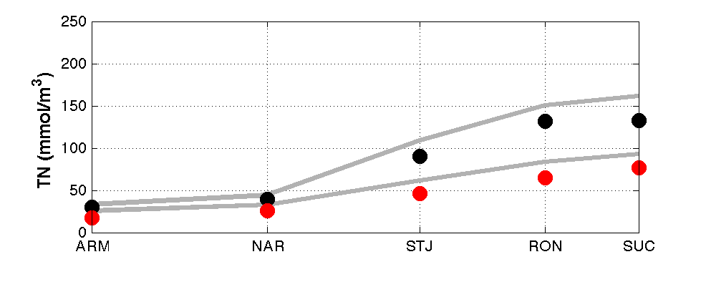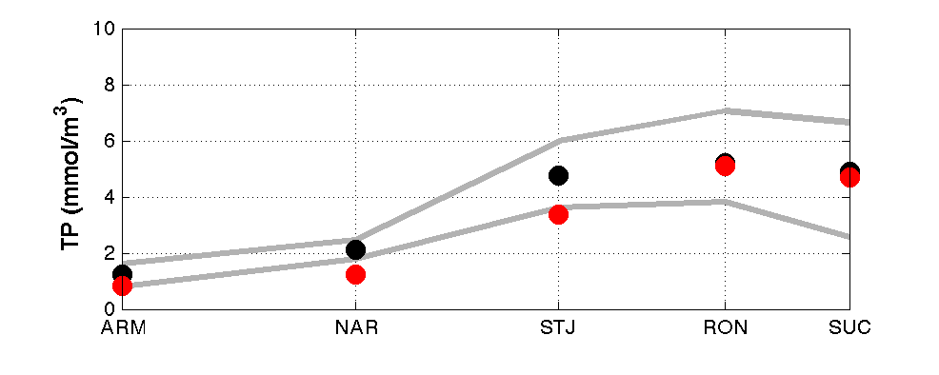

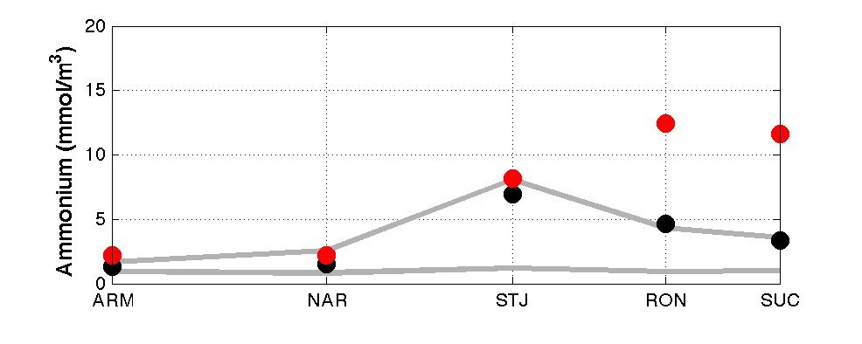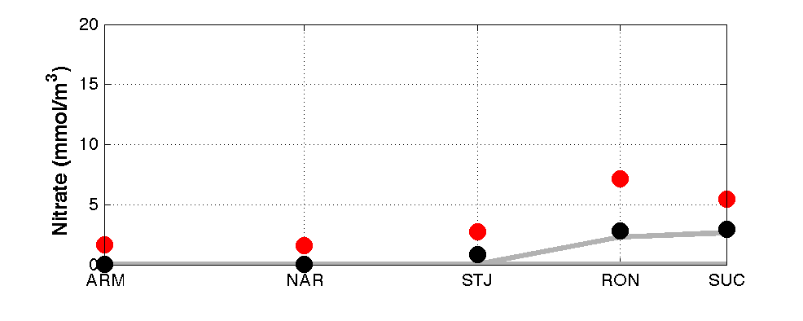

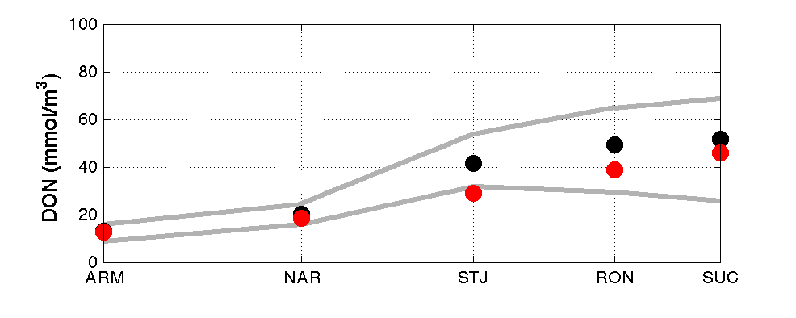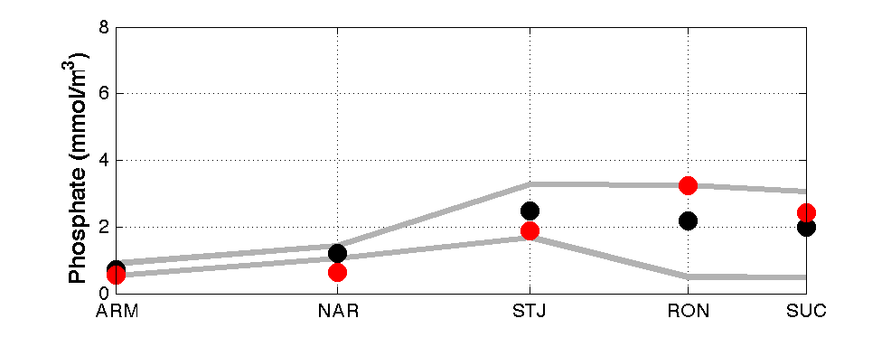

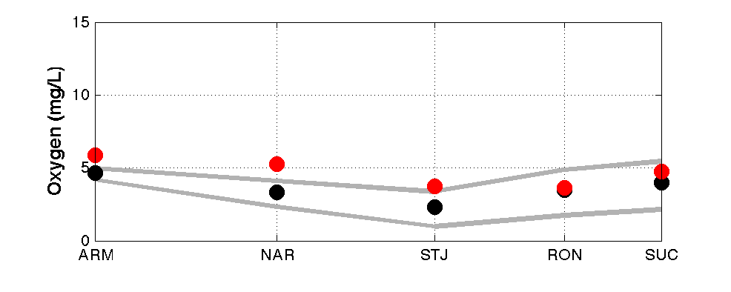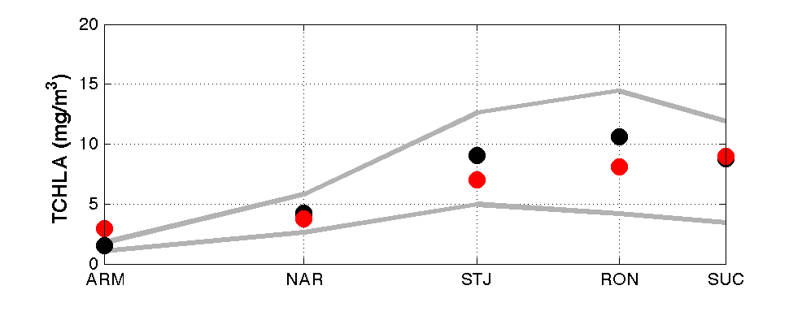

Figure 15. Similar to figure 14 except for properties in bottom water.

## 3.3 Error assessment by region

## Lower Swan + Canning River – include sites of ARM, HEA, BLA, RIV

* The physical properties (salinity and temperature) are well captured;
* The modelled nitrogens (TN and nitrogen components) have good regression coefficients against the measurements, except ammonium that has medium performance values;
* The distributions of TP, Phosphate, and DO are well captured;
* 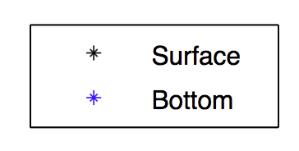The model reasonably captures TCHLA variations in the Lower Swan

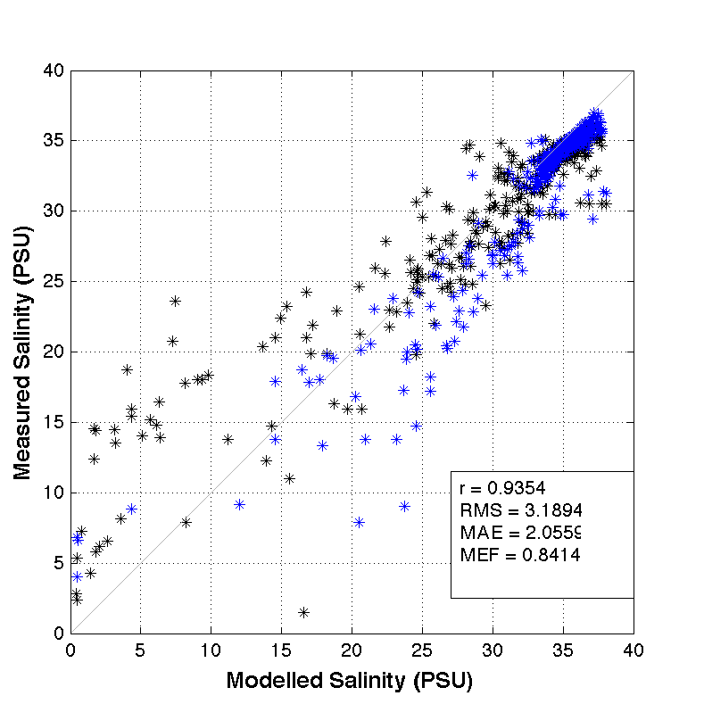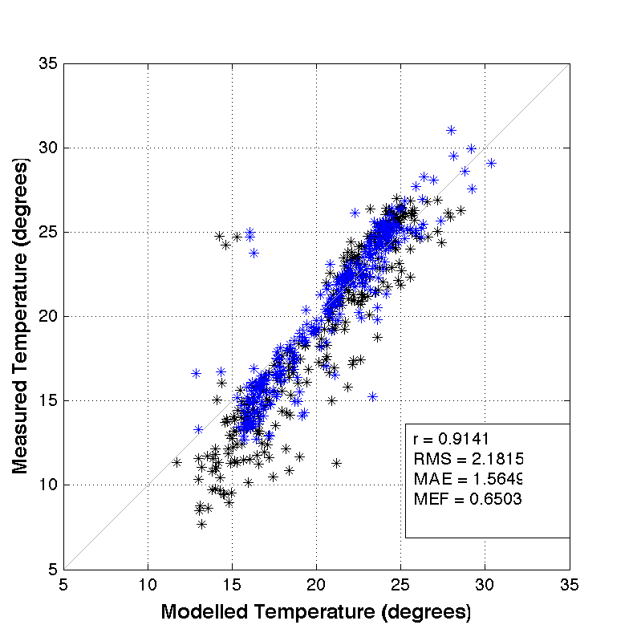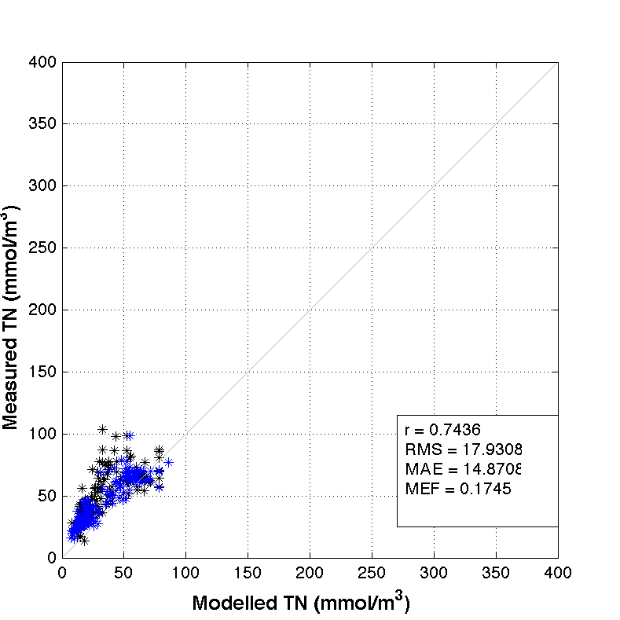

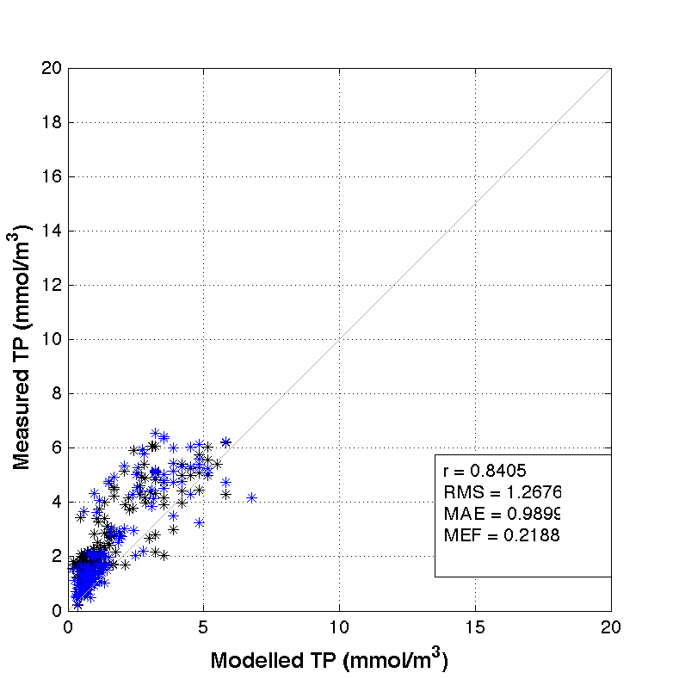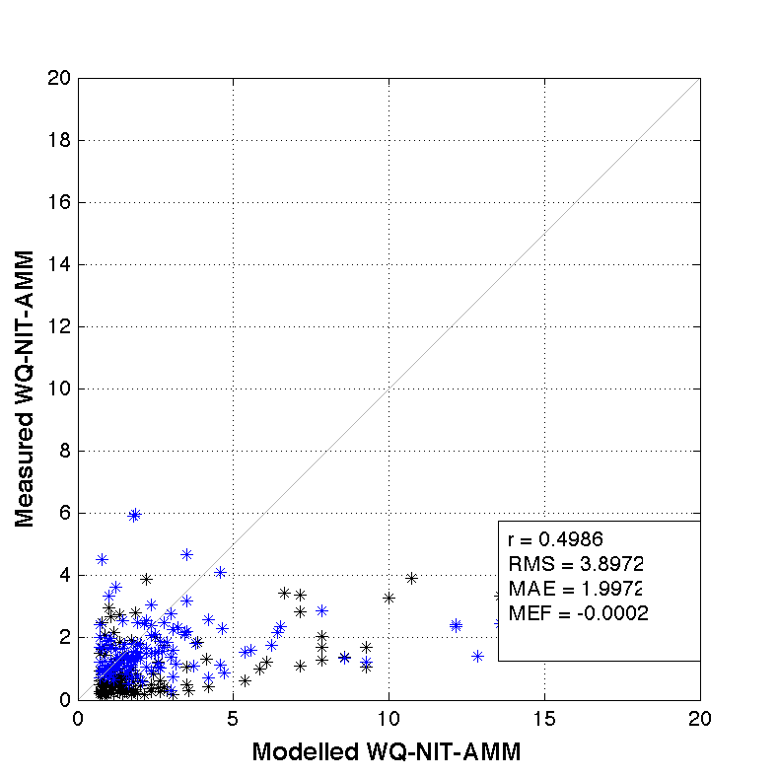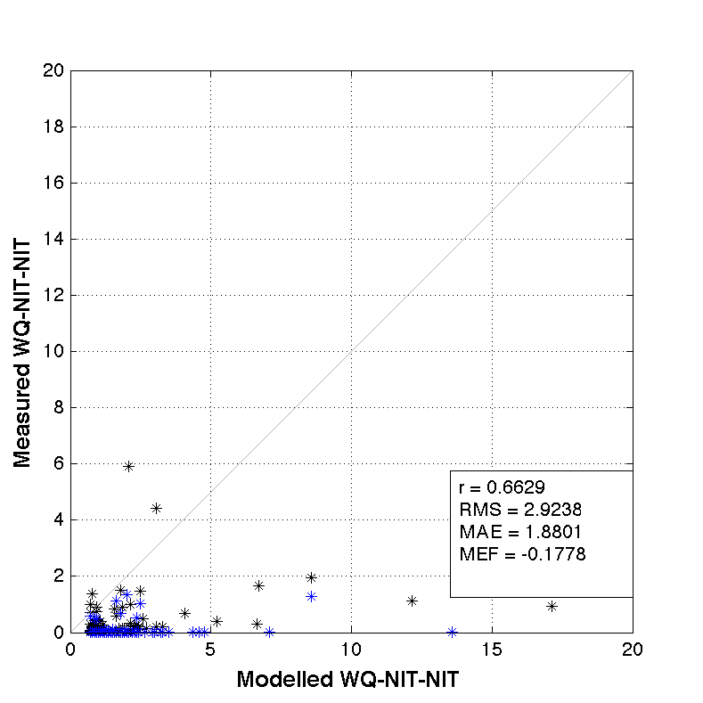

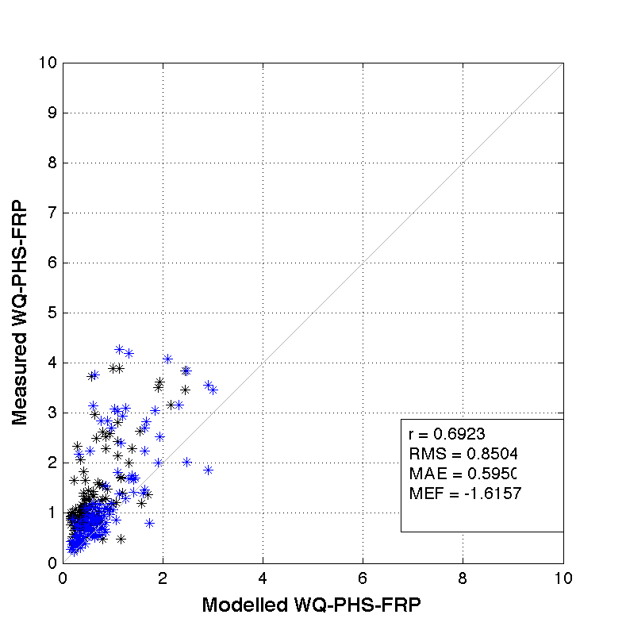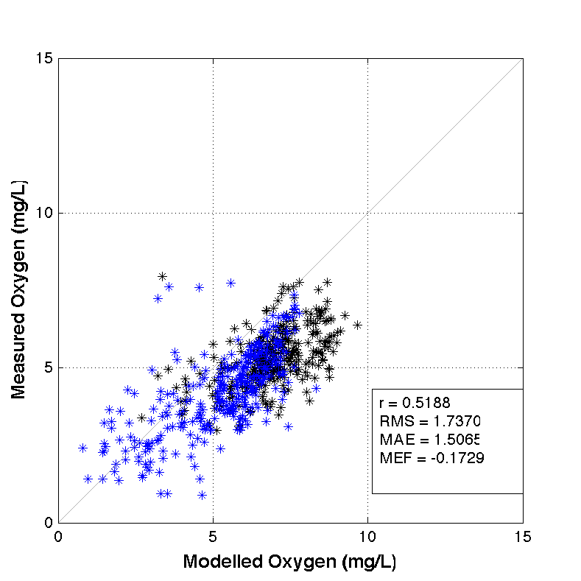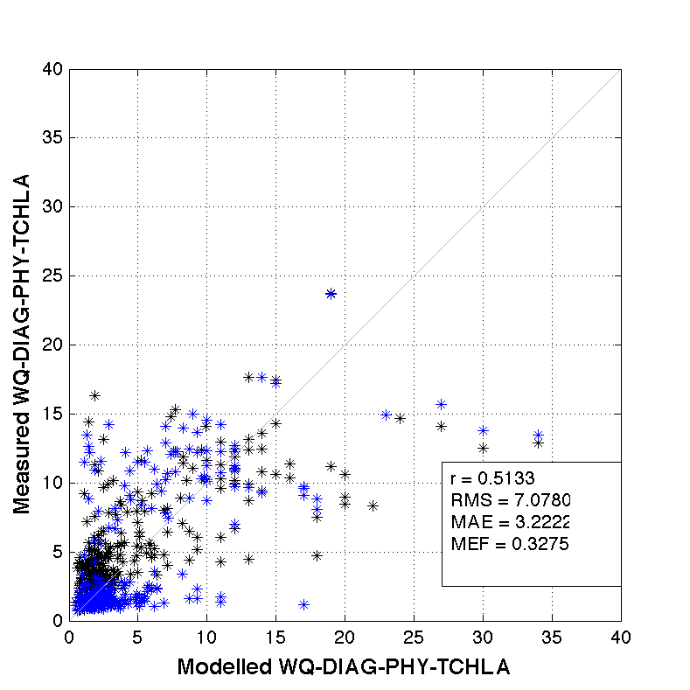

Figure 16. Scatter plots with model performance metrics in Lower Swan.

## Middle Swan – include sites of MAY, NAR, NIL, STJ

* The physical properties (salinity and temperature) are well captured;
* The modelled nitrogens (TN and nitrate) have good regression coefficients against the measurements, but large deviations were found, indicating the nitrogen variations are captured but there is a systematic error that might come from the boundary inputs;
* The distributions of TP, Phosphate, and DO are reasonably captured;
* The low regression and MEF values for TCHLA indicate the complexity of phytoplankton activities as well as the necessary to increase the phytoplankton monitoring frequency in Middle Swan (further discussion is provided in Chapter 5).

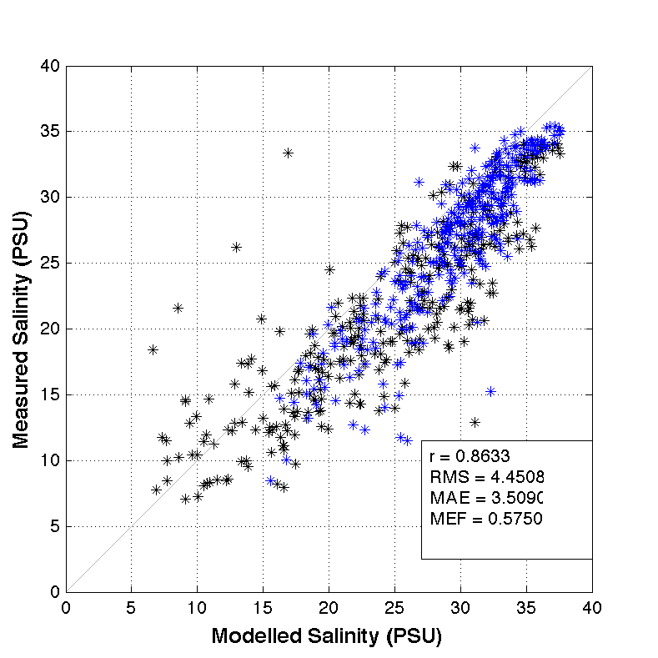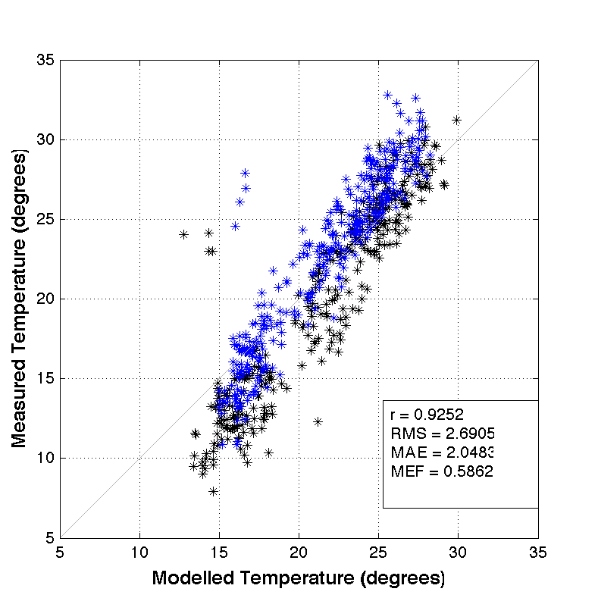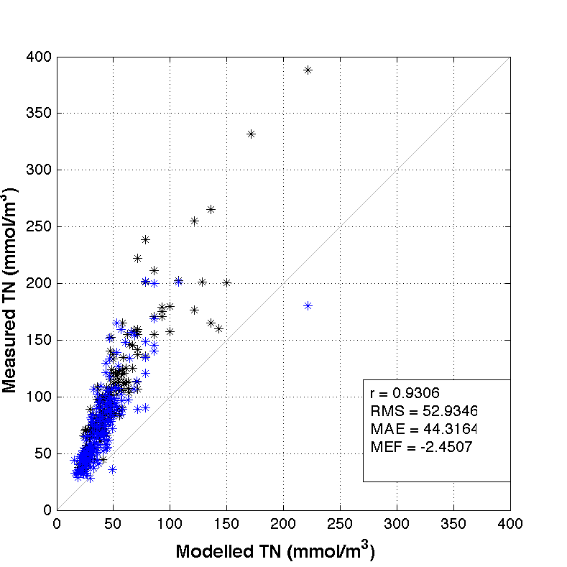

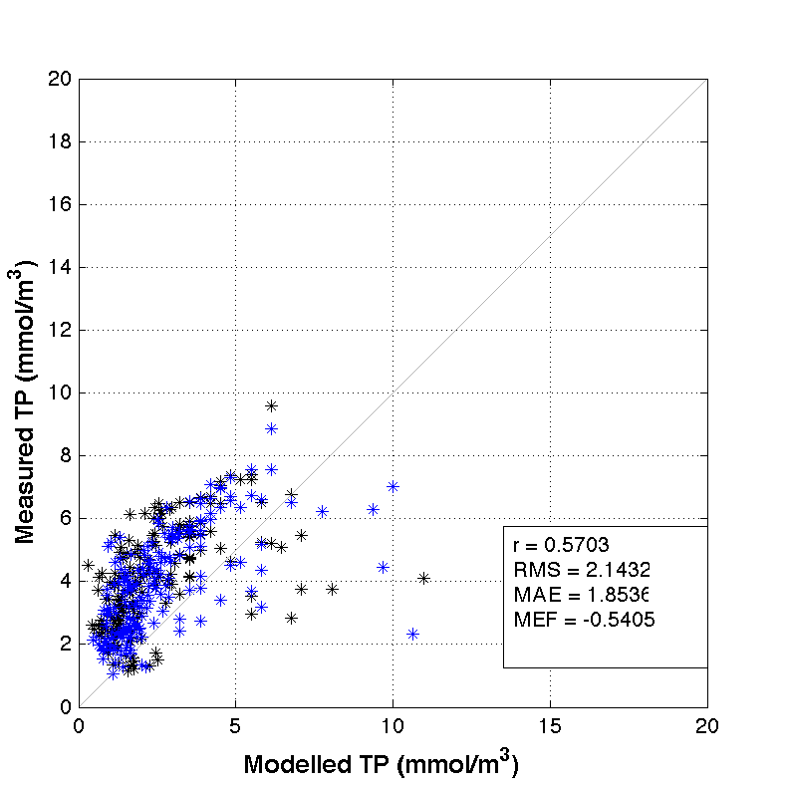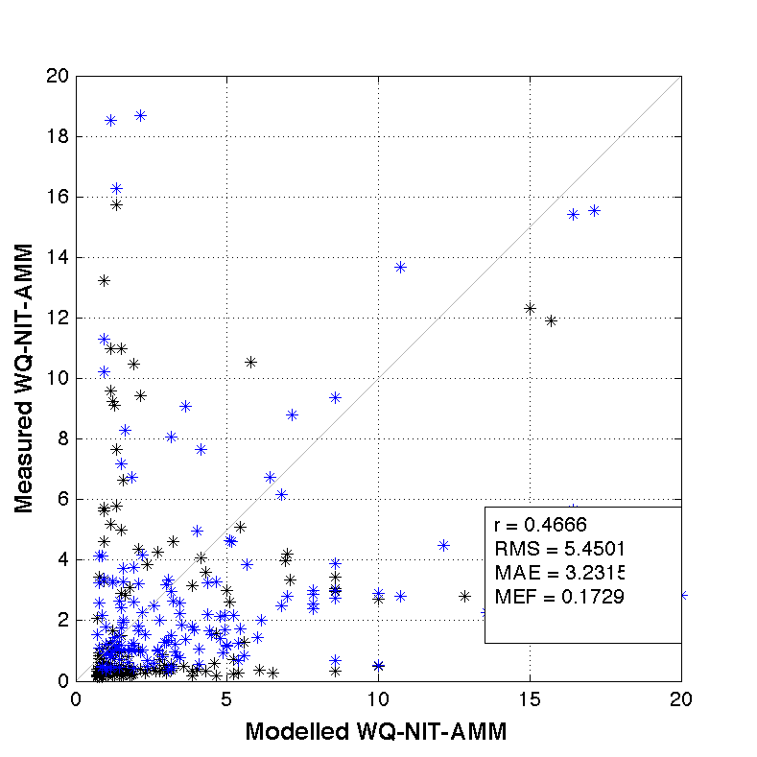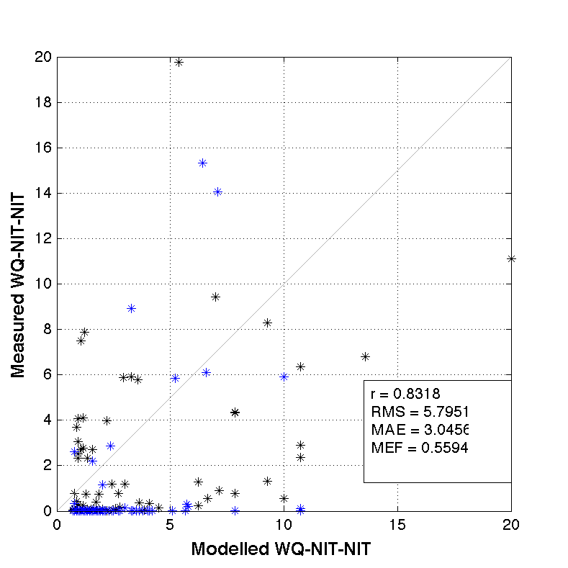

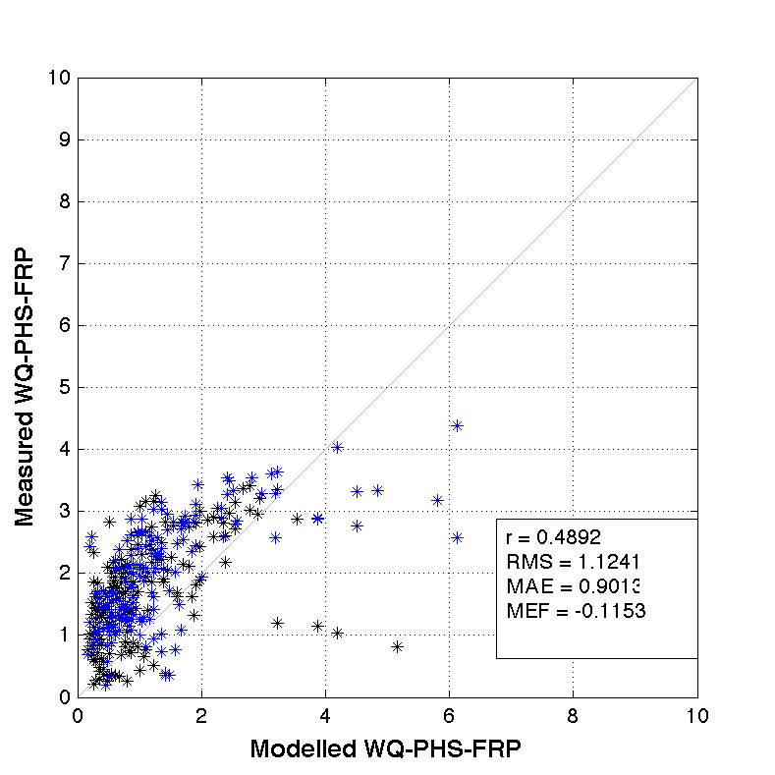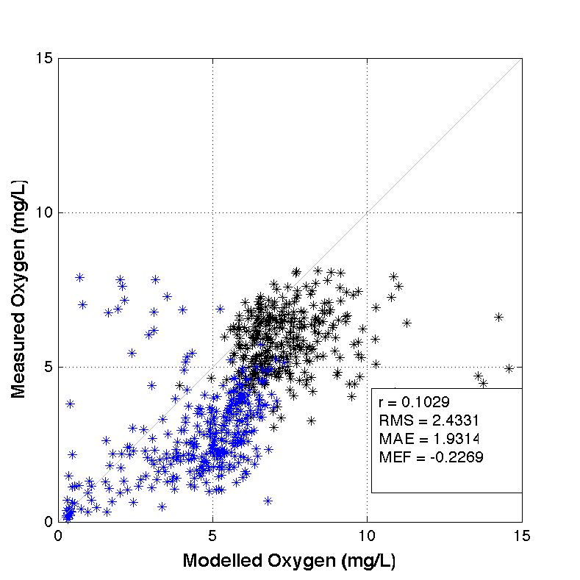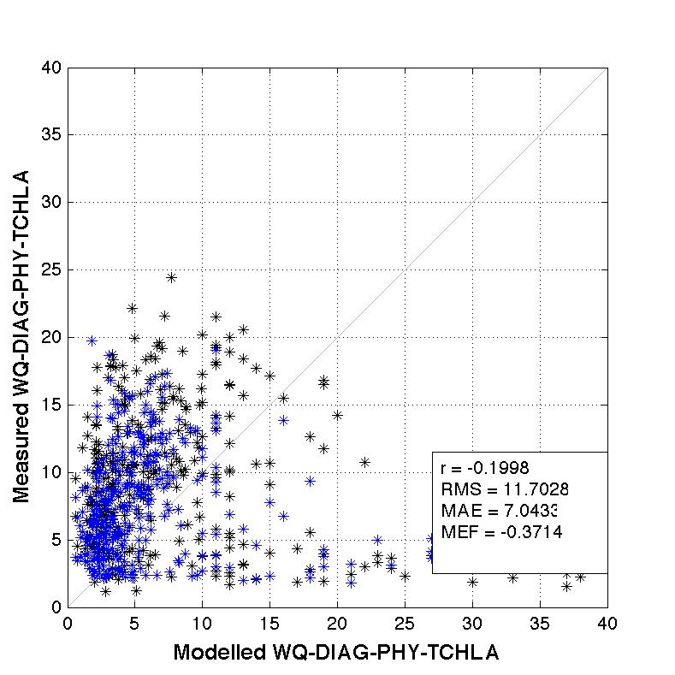

Figure 17. Scatter plots with model performance metrics in Middle Swan.

## Upper Swan – include sites of KIN, MSB, RON, SUC

* The physical properties (salinity and temperature) are well captured, although both the surface and bottom salinity tends to be slightly overestimated;
* Similar to Middle Swan, the modelled nitrogens (TN and nitrogen components) have good regression coefficients against the measurements, but large deviations were found;
* The distributions of TP, Phosphate, and DO are well captured;
* The performance of TCHLA in Upper Swan is better than Middle Swan, but low regression and MEF values are still found.



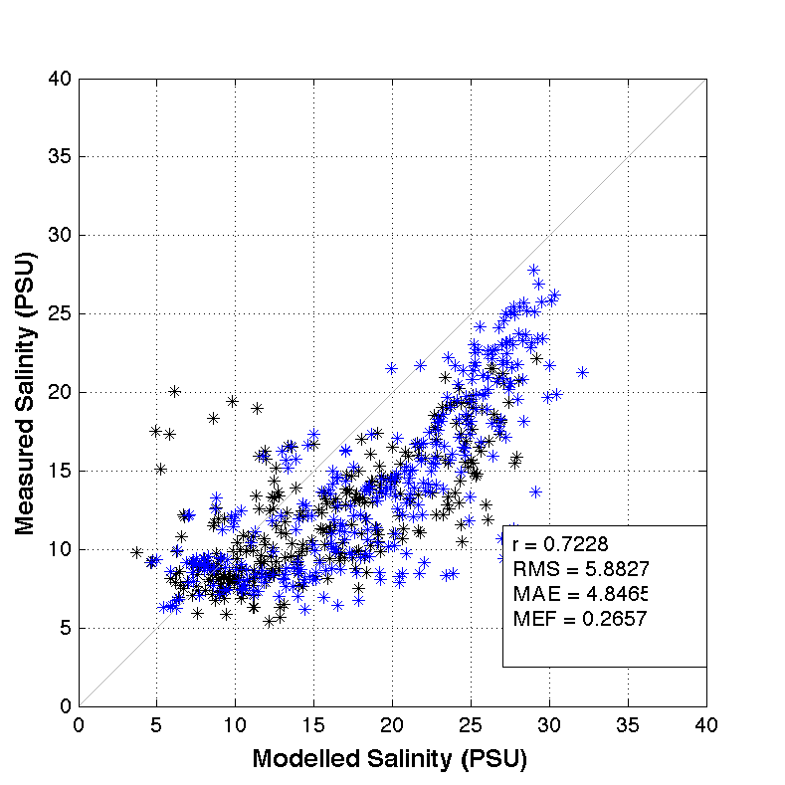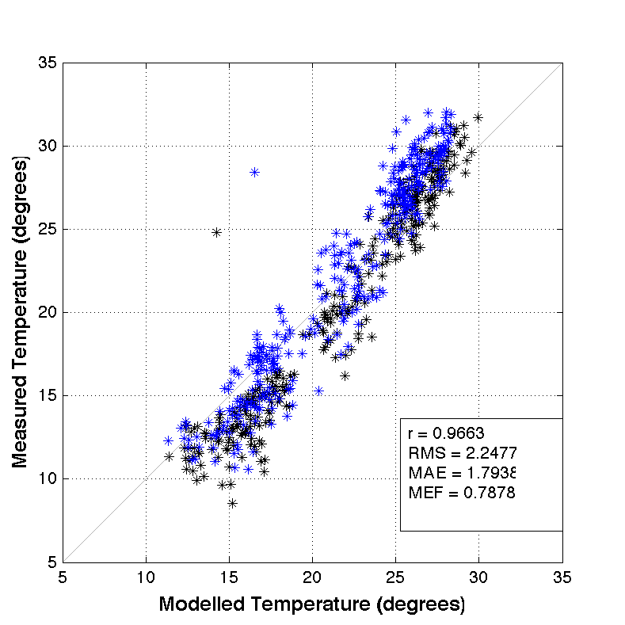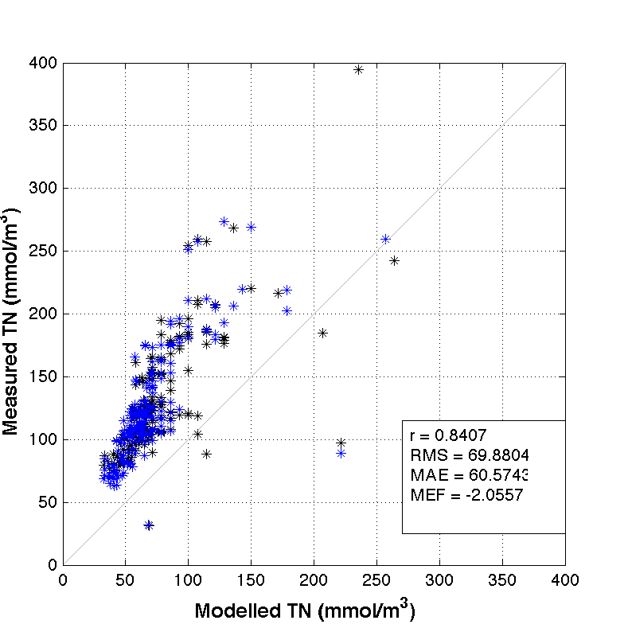

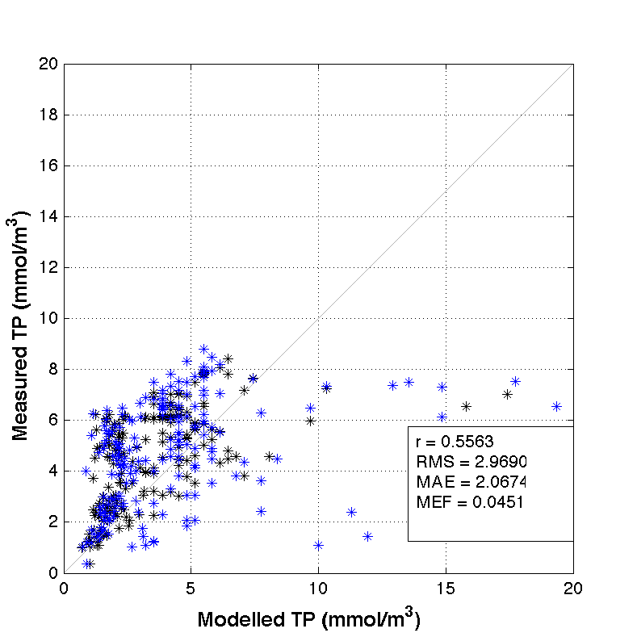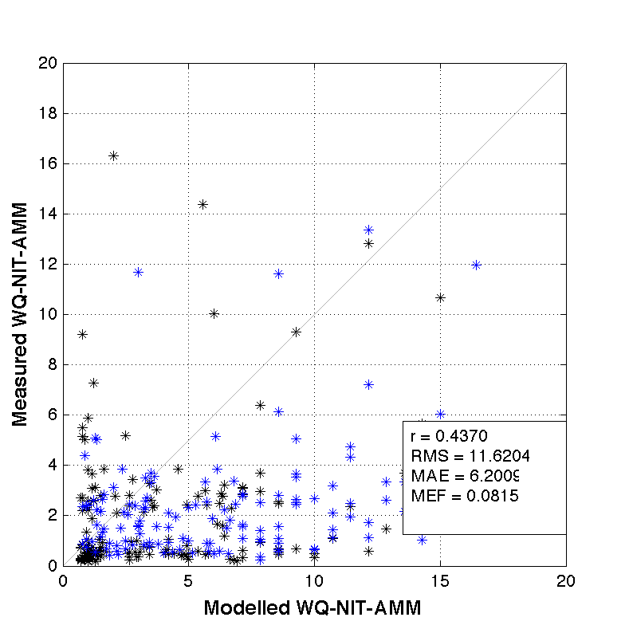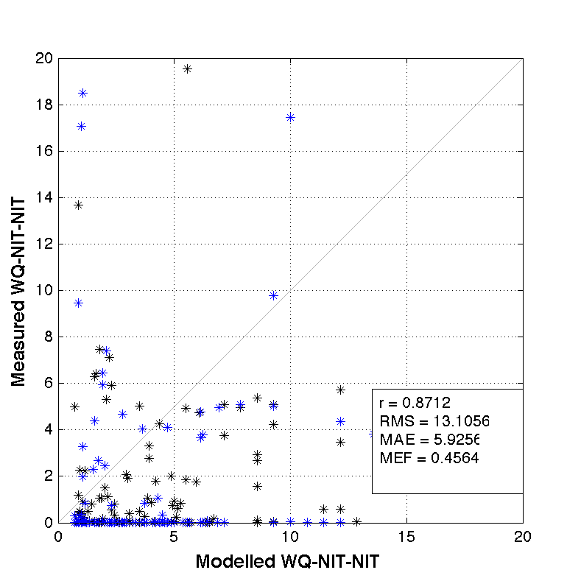

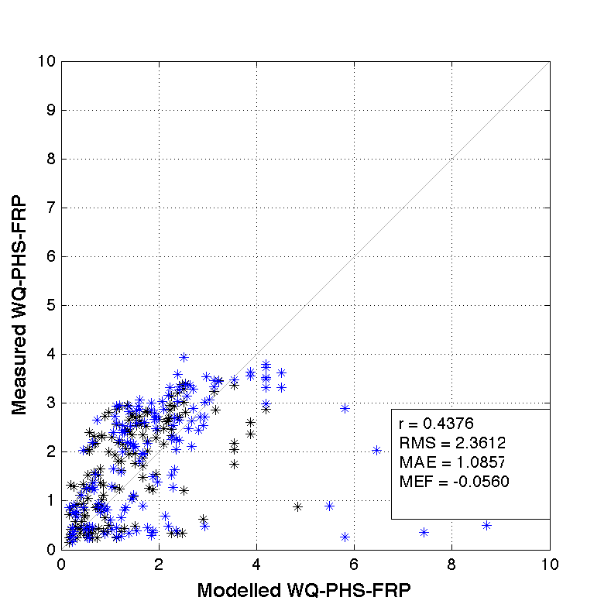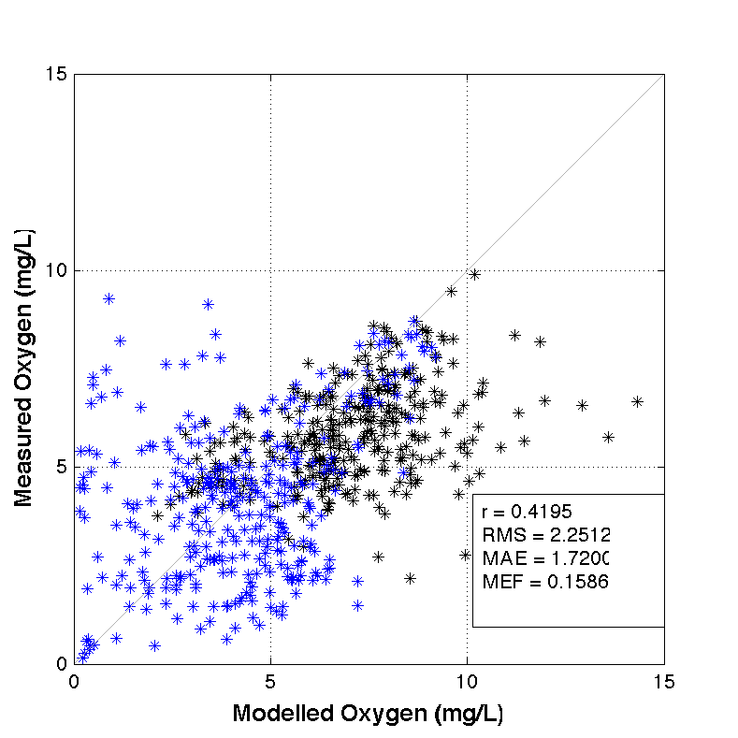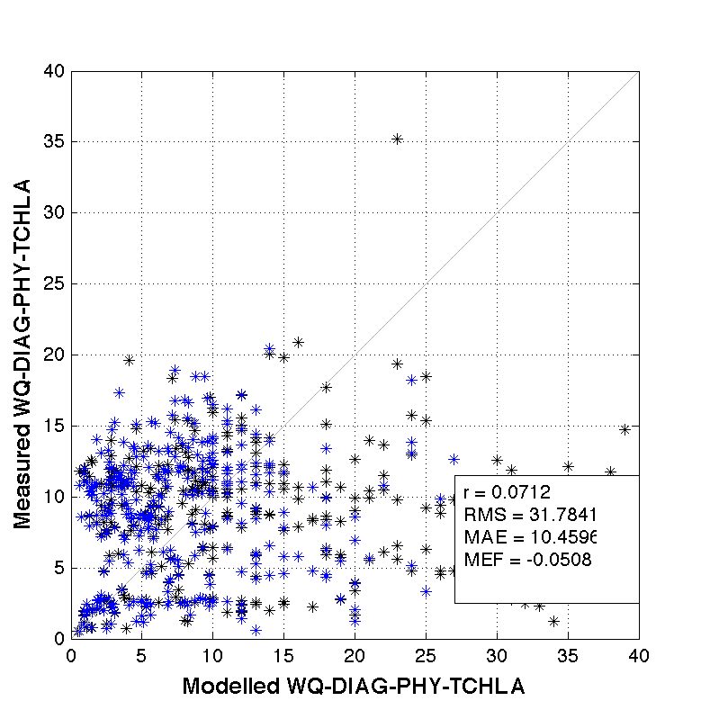

Figure 18. Scatter plots with model performance metrics in Middle Swan.

## Summary

The model performance in three regions as well as for each variable is summarised in Table 3, which suggest:

* Lower Swan has the best performance in three regions, maybe due to the fact that other two regions (Middle Swan and Upper Swan) were more affected by boundary inflows that had not been well set up in the model due to insufficient monitoring data;
* Salinity and Temperature have the best performance in all the variables, indicate the physics of the estuary are well captured;
* The good regression but poor deviation values of TN and Nitrate suggest the model captures the nitrogen variations but there are systematic errors that might come from boundary inputs or parameter settings in the water quality model. Poor performance of TCHLA suggests more attention to phytoplankton biology and monitoring is required in future work by enhancing boundary monitoring, improving water quality model algorithms, and increasing monitoring frequency inside the estuary.

**Table 3: Summary of model performance at three regions and for each variable. The RMSE and MAE have been normalized with background values of each variable when average variable and region performance are considered.**

|  |  |  |  |  |  |  |  |  |  |  |  |  |  |  |  |  |  |  |  |  |  |  |  |  |  |  |  |  |  |
| --- | --- | --- | --- | --- | --- | --- | --- | --- | --- | --- | --- | --- | --- | --- | --- | --- | --- | --- | --- | --- | --- | --- | --- | --- | --- | --- | --- | --- | --- |
|  | **Upper Swan** | |  | |  | |  | | **Mid.**  **Swan** |  | |  | |  | | **Lower Swan** | |  | |  |  | | **Var.**  **Ave.** | |  | |  | |  |
|  | r | | RMS | | MAE | | MEF | | r | RMS | | MAE | | MEF | | r | | RMS | | MAE | MEF | | r | | RMS | | MAE | | MEF |
| SAL | 0.72 | | 5.88 | | 4.85 | | 0.27 | | 0.86 | 4.45 | | 3.51 | | 0.58 | | 0.94 | | 3.19 | | 2.06 | 0.84 | | 0.84 | | 0.23 | | 0.17 | | 0.56 |
| TEMP | 0.97 | | 2.25 | | 1.79 | | 0.79 | | 0.93 | 2.69 | | 2.05 | | 0.59 | | 0.91 | | 2.18 | | 1.56 | 0.65 | | 0.94 | | 0.13 | | 0.10 | | 0.67 |
| TN | 0.84 | | 69.88 | | 60.57 | | -2.06 | | 0.93 | 52.93 | | 44.32 | | -2.45 | | 0.74 | | 14.93 | | 14.87 | 0.17 | | 0.84 | | 0.46 | | 0.40 | | -1.44 |
| TP | 0.56 | | 2.97 | | 2.07 | | 0.05 | | 0.57 | 2.14 | | 1.85 | | -0.54 | | 0.84 | | 1.27 | | 0.99 | 0.22 | | 0.66 | | 0.27 | | 0.20 | | -0.09 |
| AMM | 0.44 | | 11.62 | | 6.20 | | 0.08 | | 0.47 | 5.45 | | 3.23 | | 0.17 | | 0.50 | | 3.90 | | 2.00 | 0.00 | | 0.47 | | 0.35 | | 0.19 | | 0.08 |
| NIT | 0.87 | | 13.11 | | 5.93 | | 0.46 | | 0.83 | 5.80 | | 3.05 | | 0.56 | | 0.66 | | 2.92 | | 1.88 | -0.18 | | 0.79 | | 0.91 | | 0.45 | | 0.28 |
| FRP | 0.44 | | 2.36 | | 1.09 | | -0.06 | | 0.49 | 1.12 | | 0.90 | | -0.12 | | 0.69 | | 0.85 | | 0.60 | -1.62 | | 0.54 | | 0.36 | | 0.22 | | -0.60 |
| OXY | 0.42 | | 2.25 | | 1.72 | | 0.16 | | 0.10 | 2.43 | | 1.93 | | -0.23 | | 0.52 | | 1.74 | | 1.51 | -0.17 | | 0.35 | | 0.27 | | 0.21 | | -0.08 |
| TCHLA | 0.07 | | 31.78 | | 10.46 | | -0.05 | | -0.20 | 11.70 | | 7.04 | | -0.37 | | 0.51 | | 7.08 | | 3.22 | 0.33 | | 0.13 | | 0.42 | | 0.17 | | -0.03 |
| Region Ave. | 0.59 | | 0.67 | | 0.38 | | -0.04 | | 0.55 | 0.38 | | 0.27 | | -0.20 | | 0.70 | | 0.22 | | 0.15 | 0.03 | |  | |  | |  | |  |
|  |  | |  | |  | |  | |  |  | |  | |  | |  | |  | |  |  | |  | |  | |  | |  |
|  | |  | | Good | |  | |  | | |  | |  | |  | |  | |  | | |  | |  | |  | |  | |
|  | |  | | Mean | |  | |  | | |  | |  | |  | |  | |  | | |  | |  | |  | |  | |
|  | |  | | Poor | |  | |  | | |  | |  | |  | |  | |  | | |  | |  | |  | |  | |

# 4. Hotspot analysis: tracer model assessment

## 4.1 Hotspot in dry season (February 2015)

* The biogeochemical “hotspots” (where with intensive biogeochemical activities) are found in the north Middle Swan, and upper part of the Canning branch;
* The biogeochemical intensity in the Upper Swan is medium, although the Upper Swan has the highest water retention time during the dry month;
* Water close to Fremantle has both low biogeochemical intensity and low water retention time, due to the high flushing by tidal currents.

(2) Nitrate

(1) Ammonium

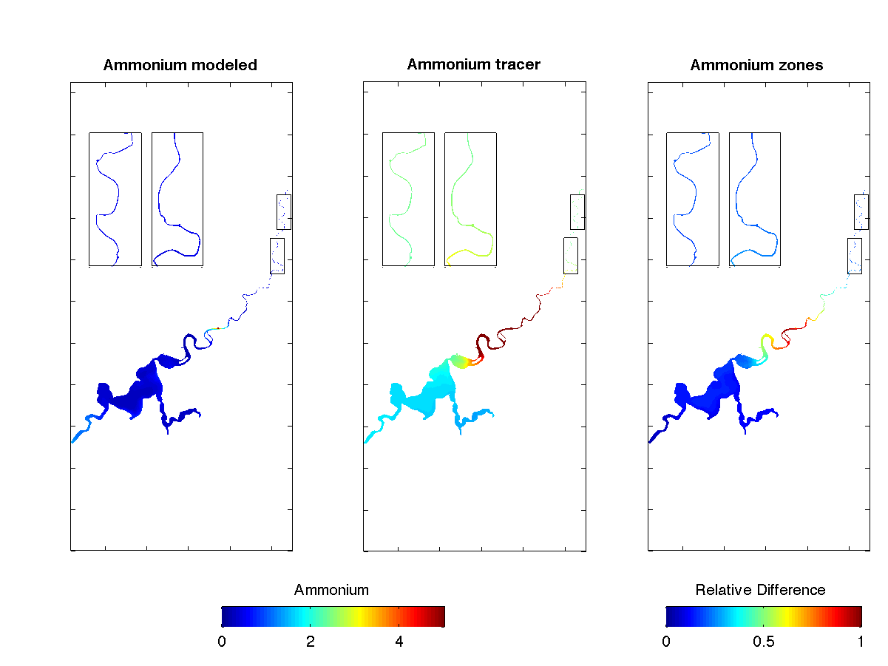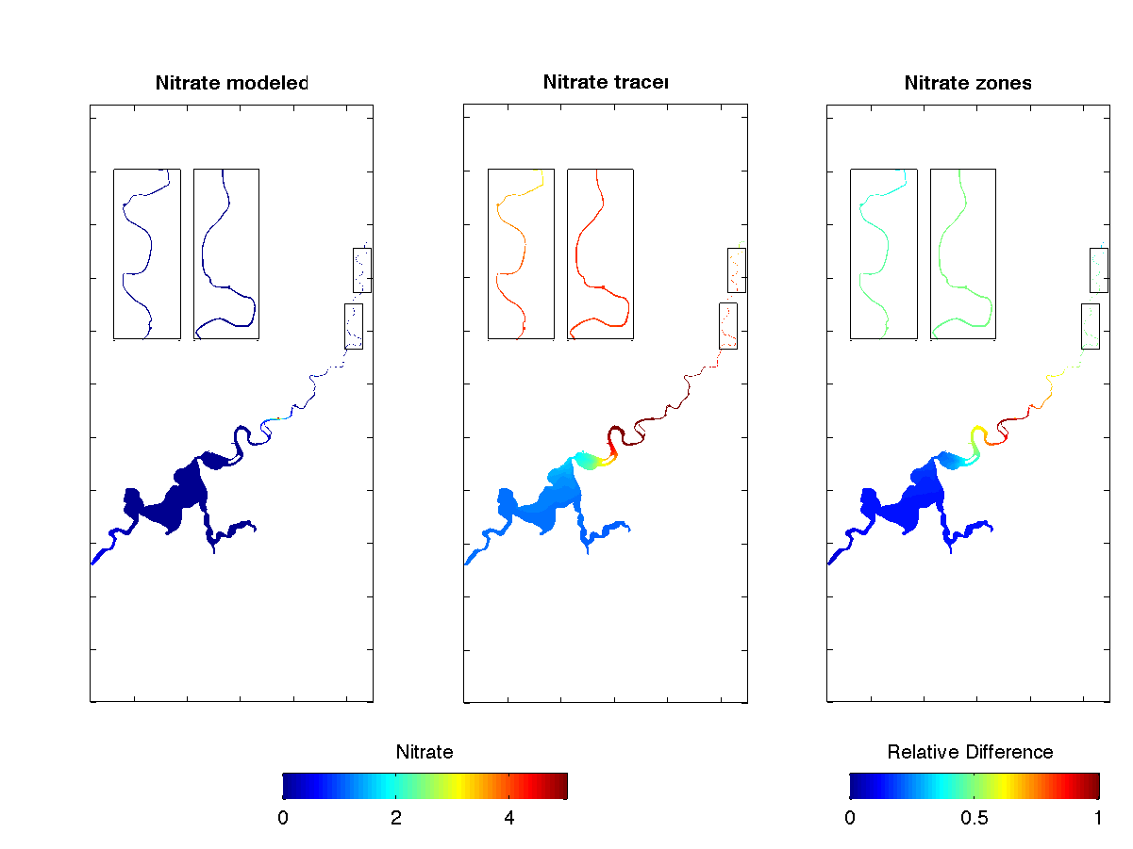

(4) Retention Time

(3) Phosphate

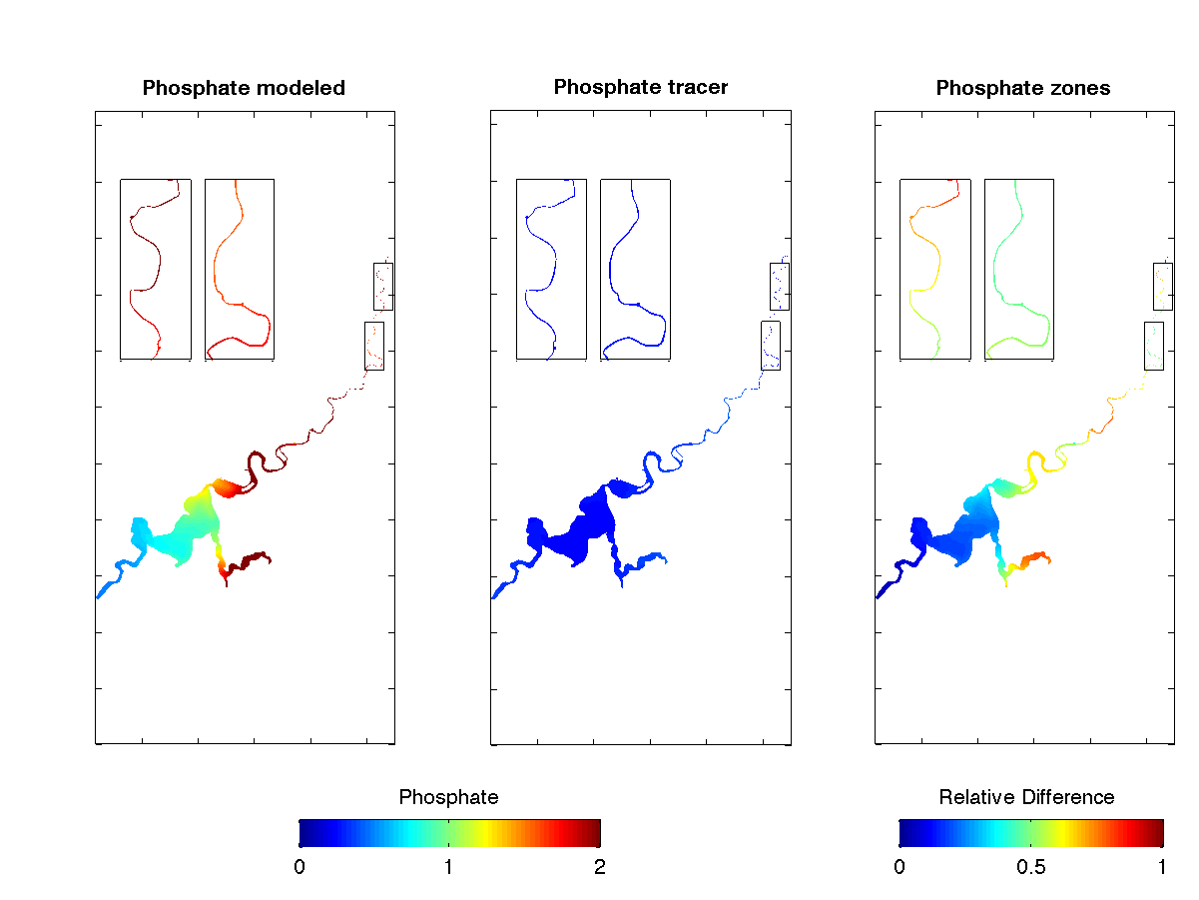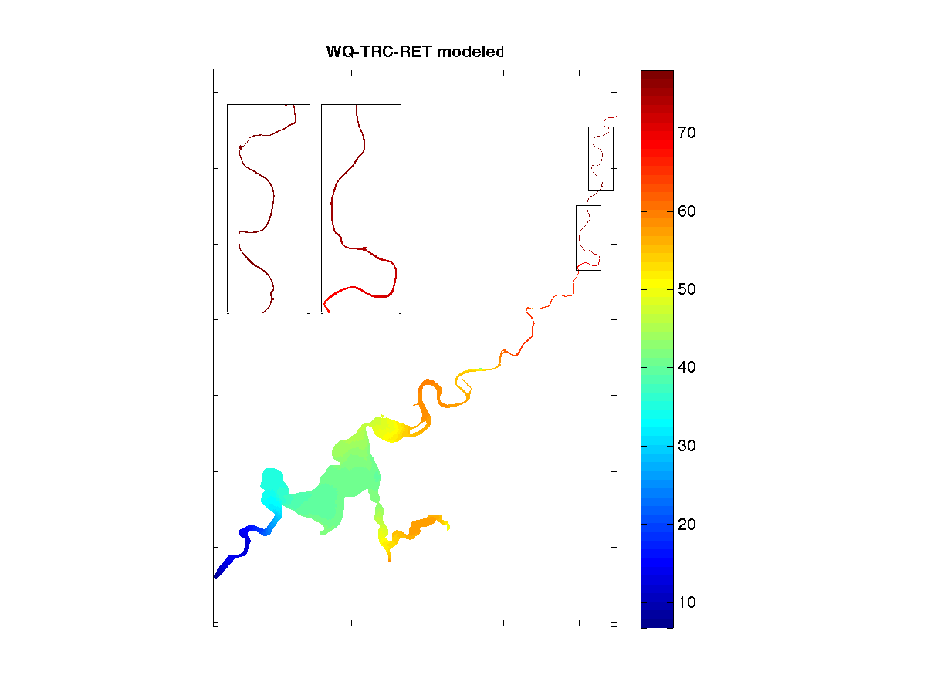

Figure 19. Spatial distributions of “hotspots” (1 - ammonium, 2 - nitrate, 3 - phosphate) and water retention time (4) in dry seasons within estuary domain. For each variable the first panel is the monthly-averaged concentration from the estuarine response model, the second panel is the monthly-averaged concentration from the tracer model, and the third panel is degree of difference between two models.

## 4.2 Hotspot in wet season (August 2015)

* The biogeochemical “hotspots” are found in Lower Swan and south part of Middle Swan, in corresponding to the high water retention time in these areas;
* The biogeochemical intensity and water retention time in the Upper Swan are both low, due to the high flushing effect created by high inflows;
* Water close to Fremantle still has both low biogeochemical intensity and low water retention time due to the high flushing by tidal currents.

(1) Ammonium

(2) Nitrate

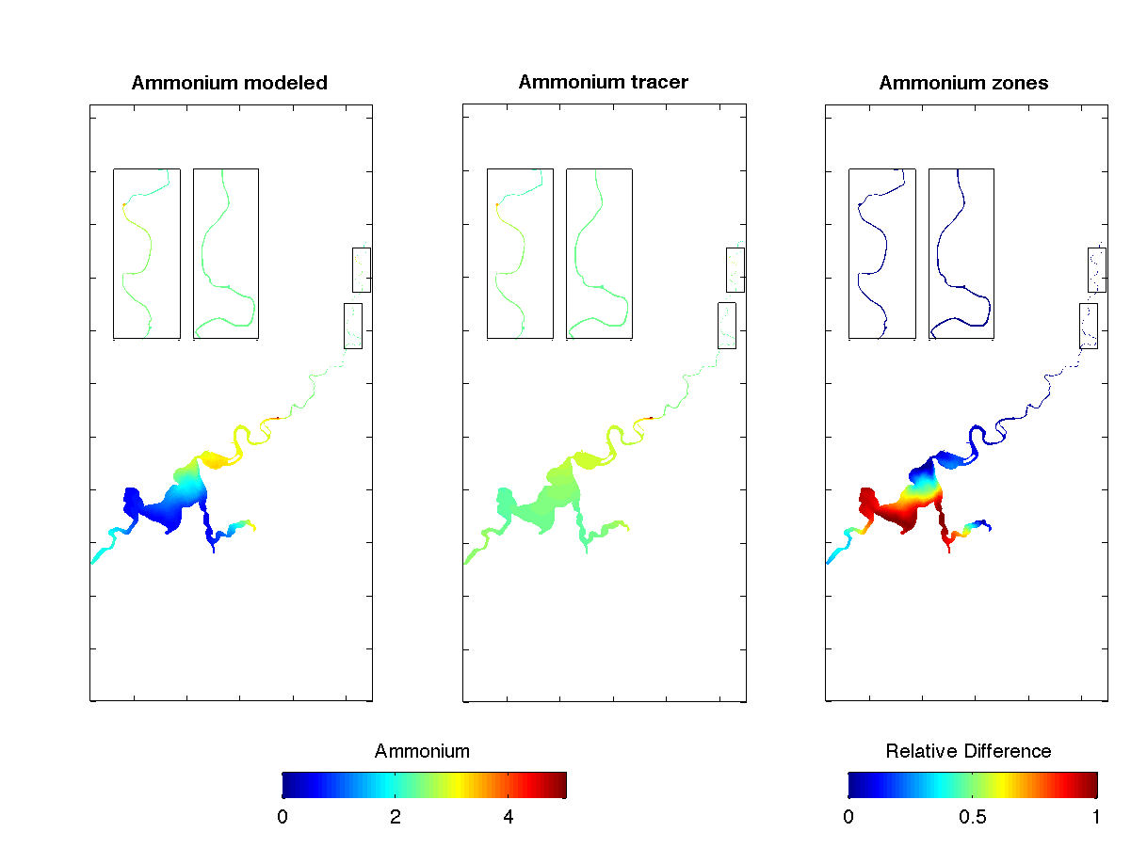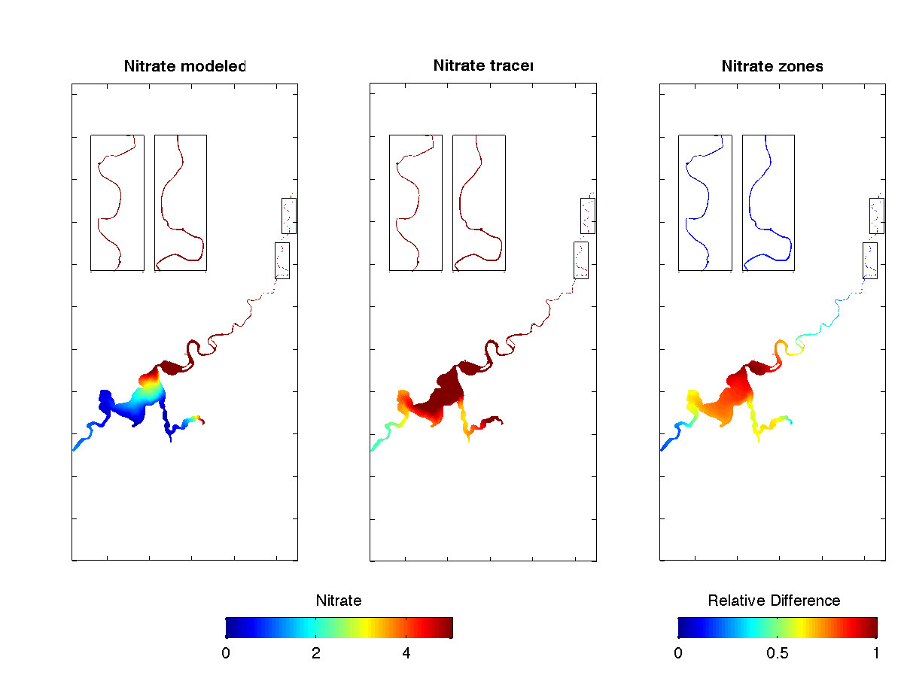

(3) Phosphate

(4) Retention Time

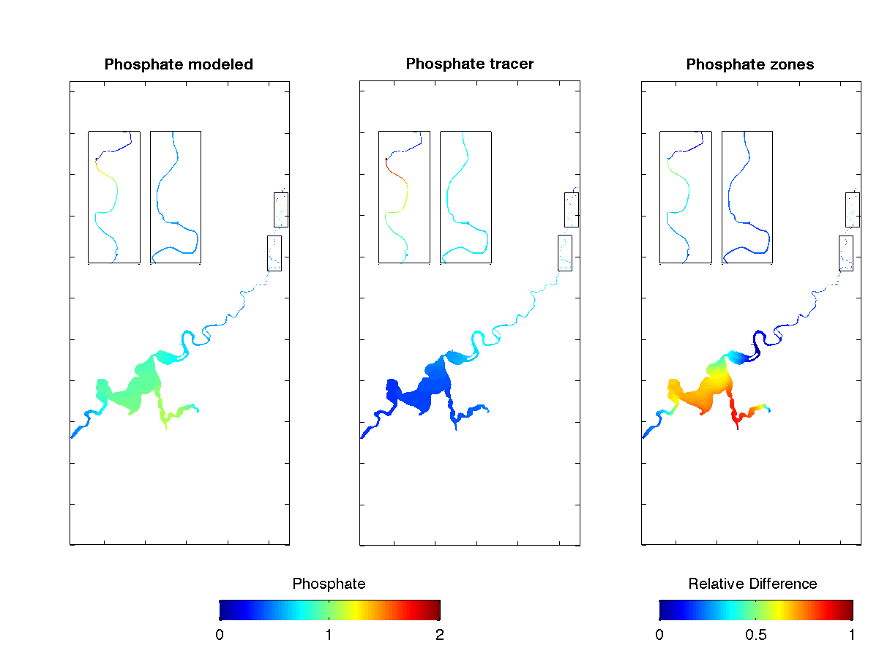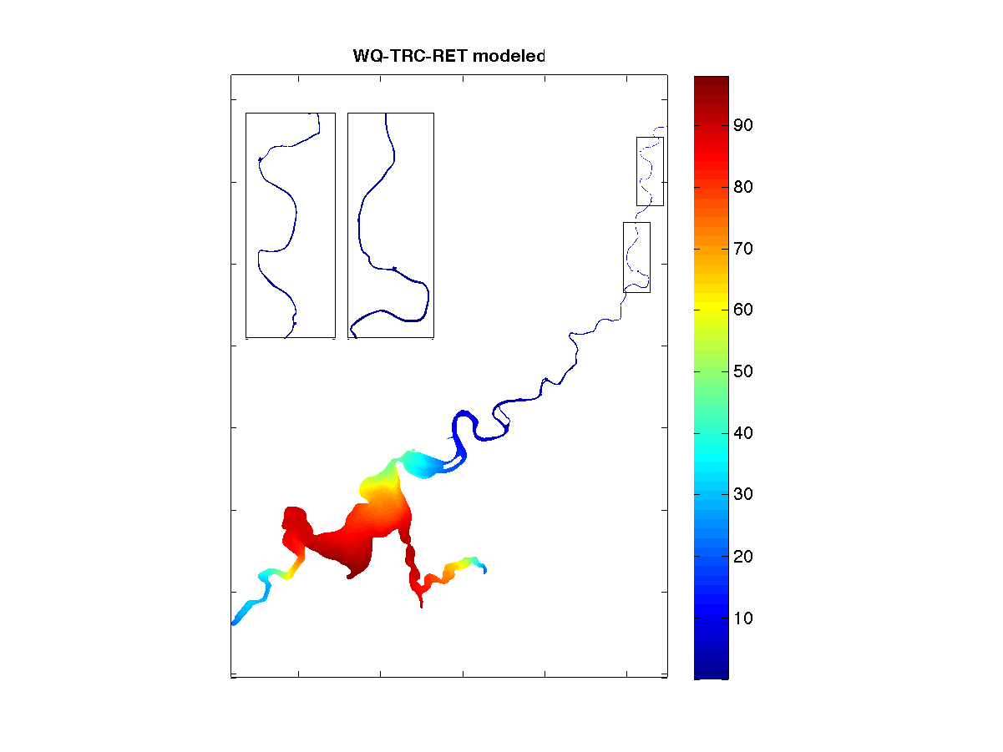

**Figure 20. Similar to figure 19 except for the period of wet season.**

# 5. Assessing Monitoring Data Worth

## 5.1 Is the current monitoring program capturing areas in the domain that are more biogeochemically active?

The analysis of our tracer modelling results in Chapter 4 indicated that the biogeochemical ‘hotspots’ dynamically response to the inflow rates. In the dry seasons when inflow rate is low, biogeochemical activities mostly focus in north Middle Swan and upper part of the Canning branch; while in wet seasons when inflow rate is high, biogeochemical activities mostly focus in Lower Swan and south part of Middle Swan. Bear in mind that these hotspots represents where the change rates, not the absolute concentrations, of nutrients are high, so the distribution of these spots might differ to that of the eutrophic states of the waters. From an aquatic system point of view, monitoring data at these hotspots provide more details of how nutrients and energy transfer inside the ecosystem, therefore are more valuable to understand the Swan-Canning ecosystem and improve the model settings and performance. We recommend taking the biogeochemical hotspots into account when design monitoring programs.

## 5.2 Are there strong cross-stream gradients that are not picked up? – Needs for transect monitoring

Current monitoring sites in Lower Swan are set along the central line. In the narrow branch near Fremantle, the water doesn’t show much variation across transect, while in the main body of Lower Swan where the length of transect is up to 2km, some water quality show large variety between shallow and deep waters. Figure 21 shows the range of modelled salinity, DO, and TCHLA across a section of ARM in Lower Swan. The daily-median value of DO across the section is ~6 mg/L with variations of ~2 mg/L, while for TCHLA the median value is 3-6 μg/L but the variations are up to ~3 μg/L. The deviations of modelled data across the section almost account for the deviations between median modelled data and measurements, indicating the need for monitoring across the section at ARM.

**(1) ARM transect map**

**(2) SAL**

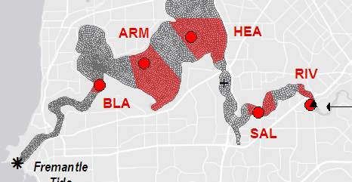 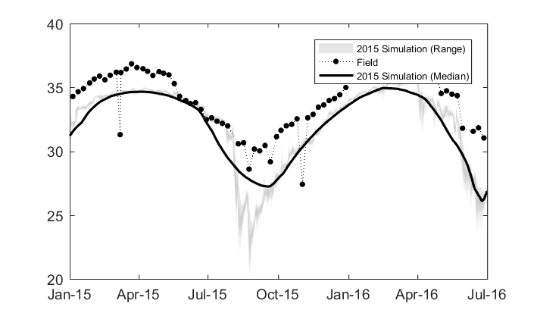

**(4) TCHLA**

**(3) DO**

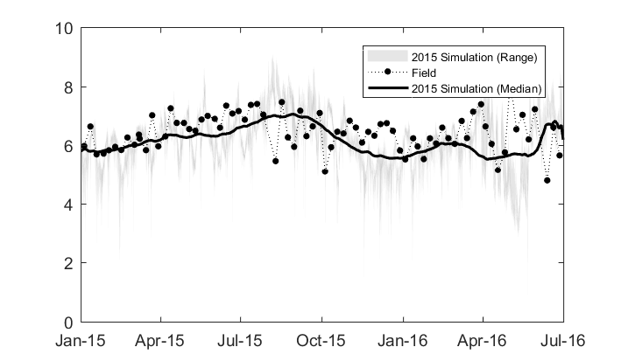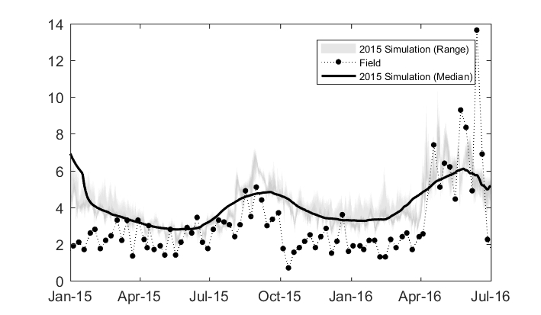

**Figure 21. (1) Transect area around ARM site for comparison; (2) time-series of daily-median and range (99 percentile) of modelled salinity against measurements in the transect area; (3) similar to 2 except for DO; and (4) similar to 2 except for TCHLA.**

Figure 22 also shows that uneven distribution of salinity, DO and TCHLA along transects in Lower Swan and part of the Middle Swan are found in both wet and dry seasons. The reasons for the transect variety could be (1) the water circulation caused by flushing and mixing in shallow near-shore area is different to that in the deep central water and (2) sediment and seagrass could play important roles in modifying water quality in shallow waters.

**(1) Feb 2015**

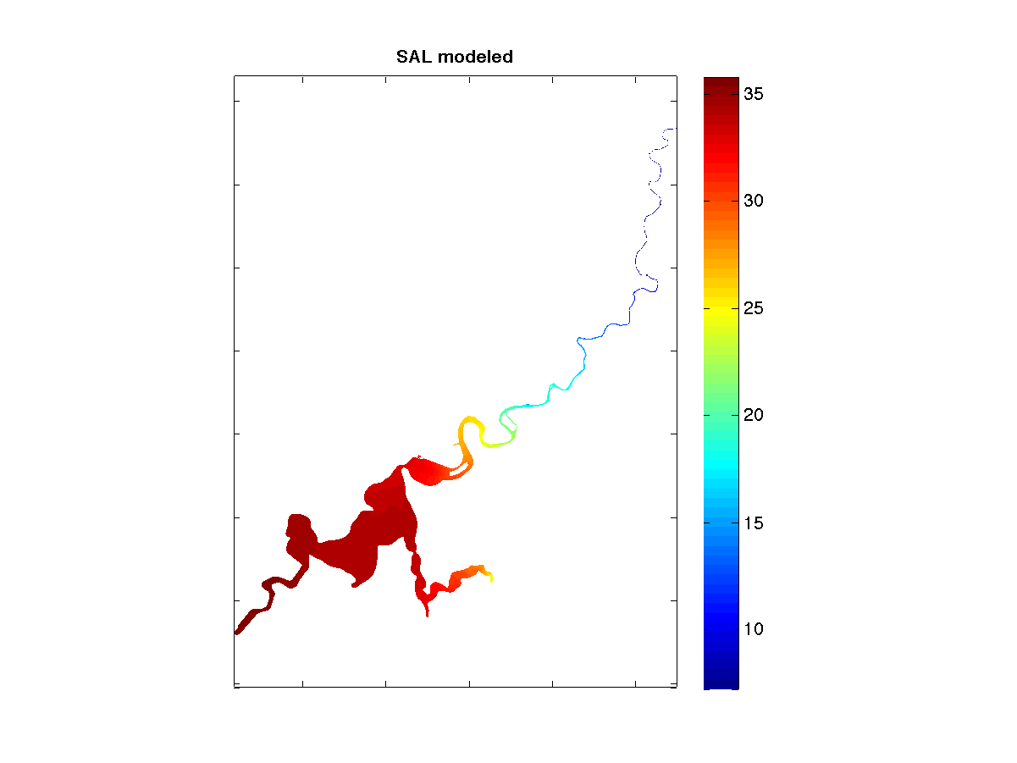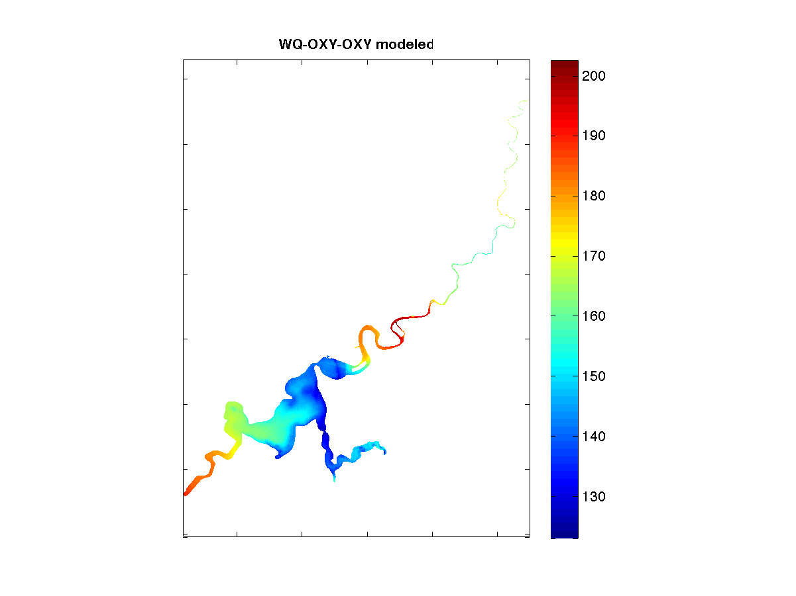 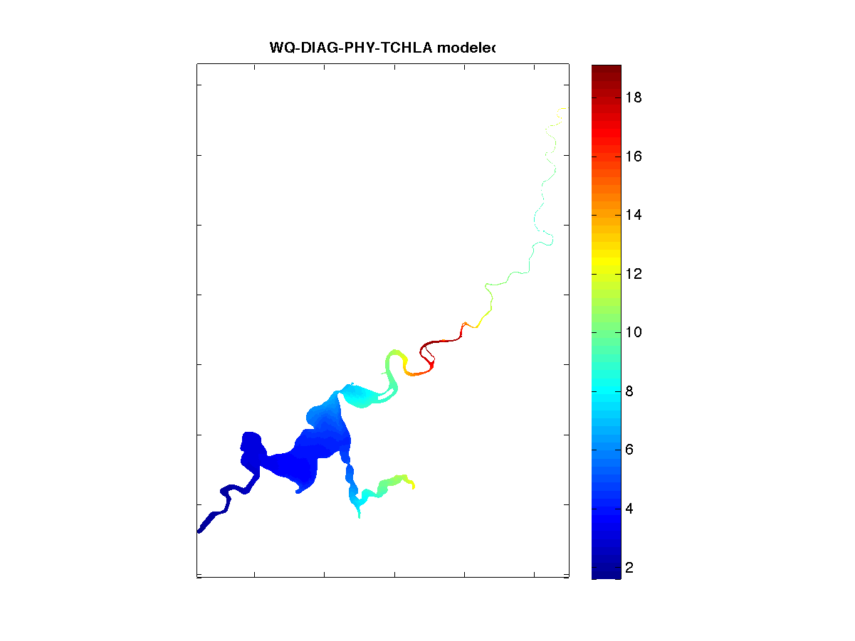

**(2) Aug 2015**

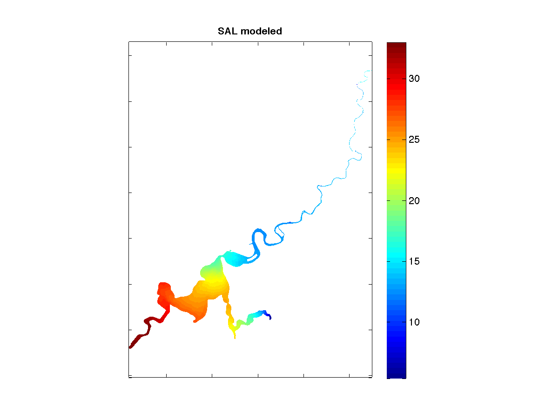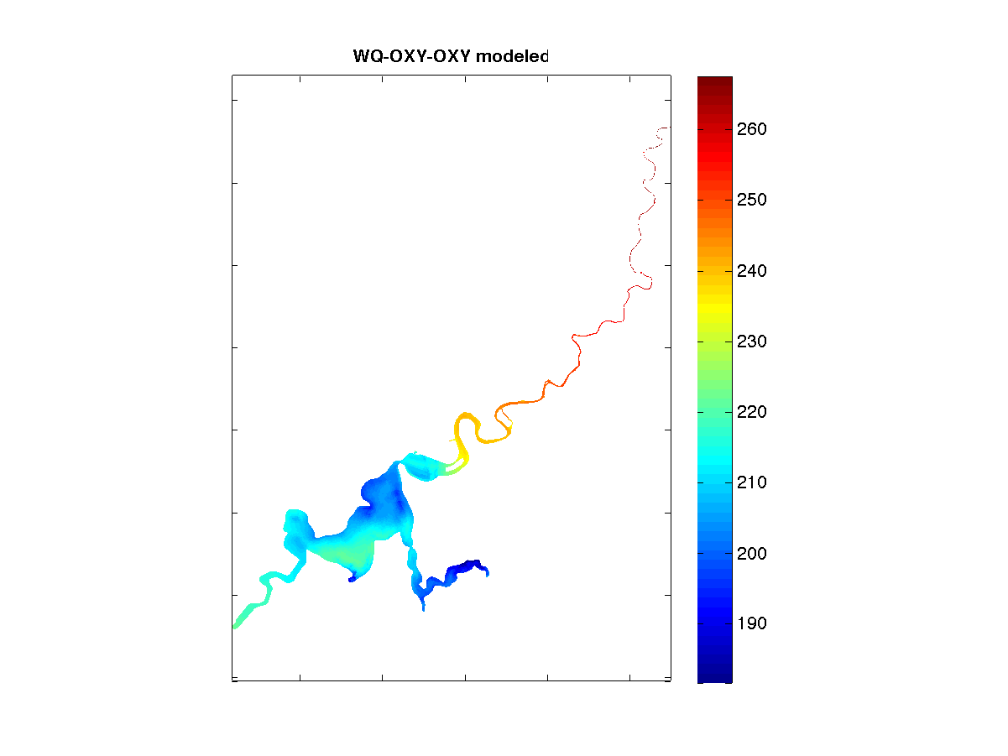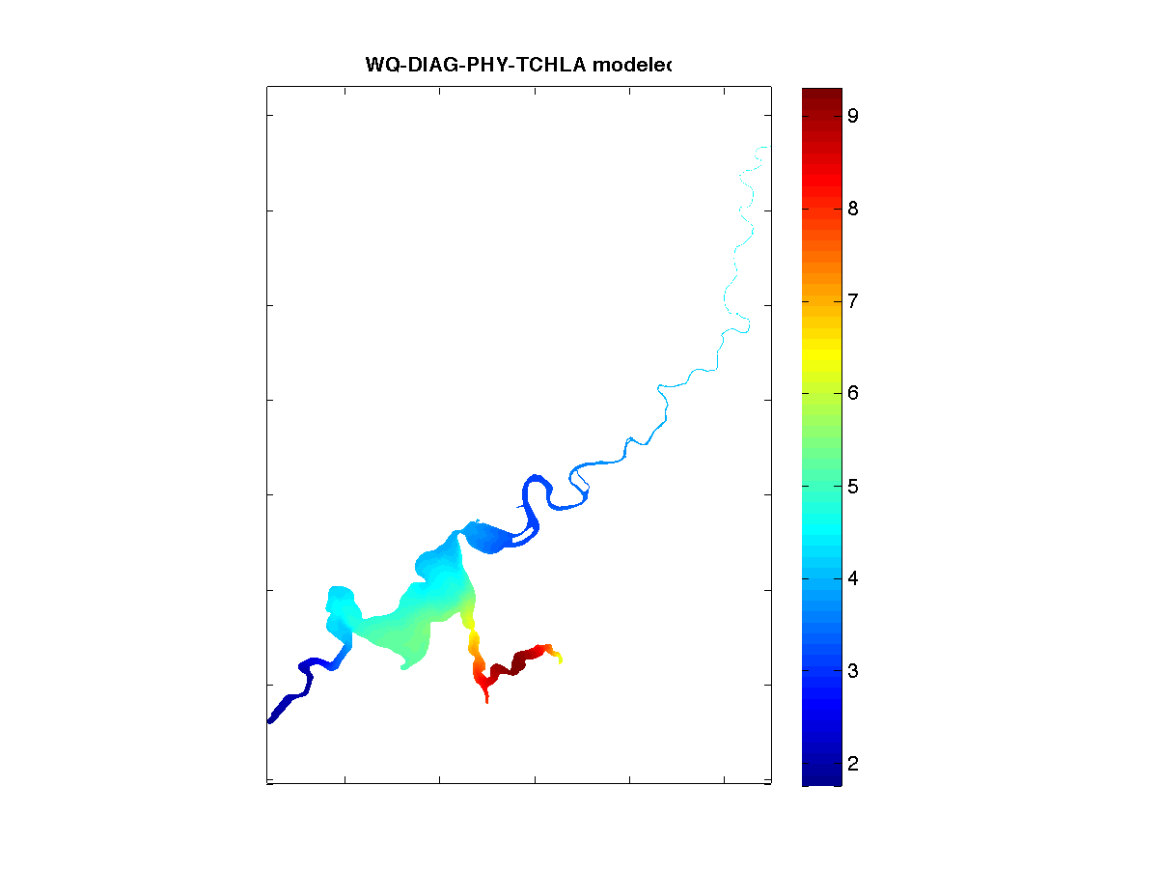

**Figure 22. Spatial distributions of monthly-averaged salinity, DO, and TCHLA in (1) Feb 2015, and (2) Aug 2015.**

## 5.3 Does the regular monitoring adequately capture events and daily variations? - Needs for dynamic monitoring and high-frequency monitoring

The sampling time interval of current water quality data available for model validation is generally weekly. This coarse time interval is fine for monitoring the estuary eutrophic states or the seasonal variation of estuary aquatic ecosystem. However, it might not be enough if a better understanding of some key water quality variables such as DO and TCHLA is needed. As shown in Figure 23, both the DO and TCHLA present a clear daily variation that is impossible to be captured by the weekly sampling campaigns. The reasons for the daily variation could be that light radiations have a direct impact of water temperature and phytoplankton metabolism, which subsequently change the DO concentration. This, from another point of view, indicates the difficulty of validating model performance when sparse weekly field data is used while strong temporal variations is modelled. We therefore recommend that higher-frequency data of DO and TCHLA in consistent days are required in order to capture their variations and provide more information for model settings and validations.

There is also a concern that the low-frequency sampling program would have a bias to non-extreme environmental conditions. That is, the field trips of sampling are done on the ‘calmer weather’ dates to avoid extreme weather conditions, although the extreme weather conditions such as storms could cause significant changes to the estuarine ecosystem in a short time. We therefore recommend setting up a dynamic monitoring program to capture the events with assistance of the estuarine response model to predict the changes in response to different environmental condition scenarios.



(2) TCHLA at RON

(1) DO at RON

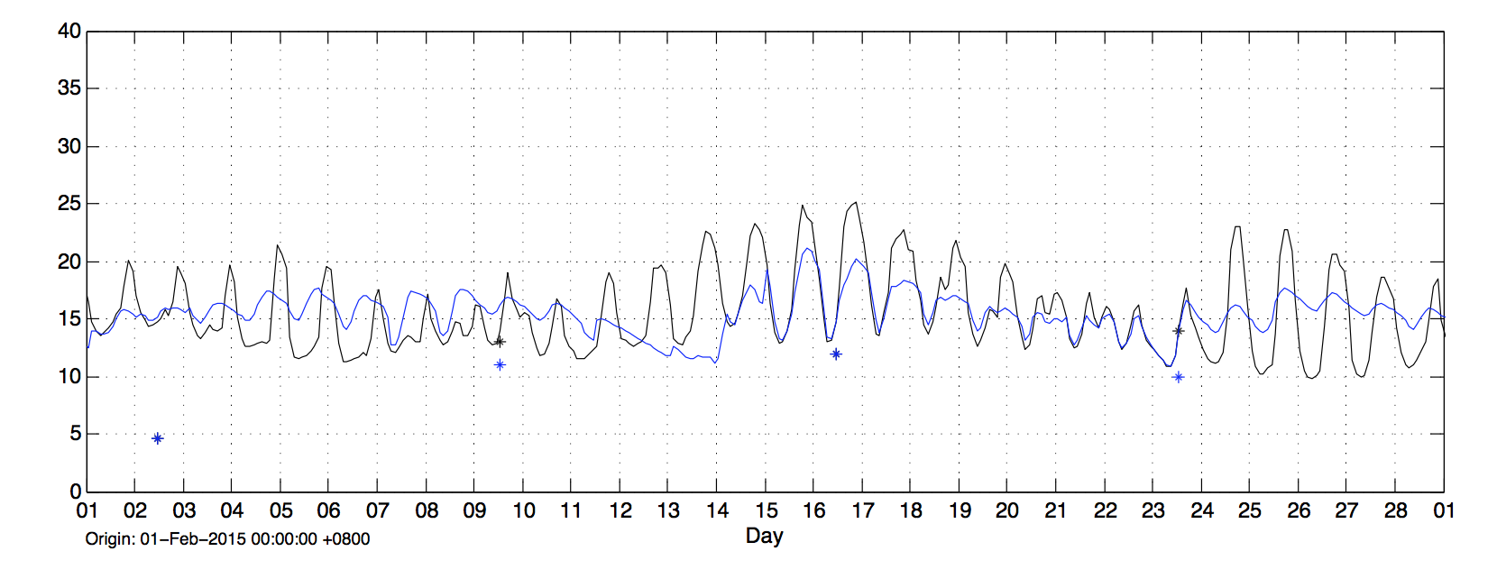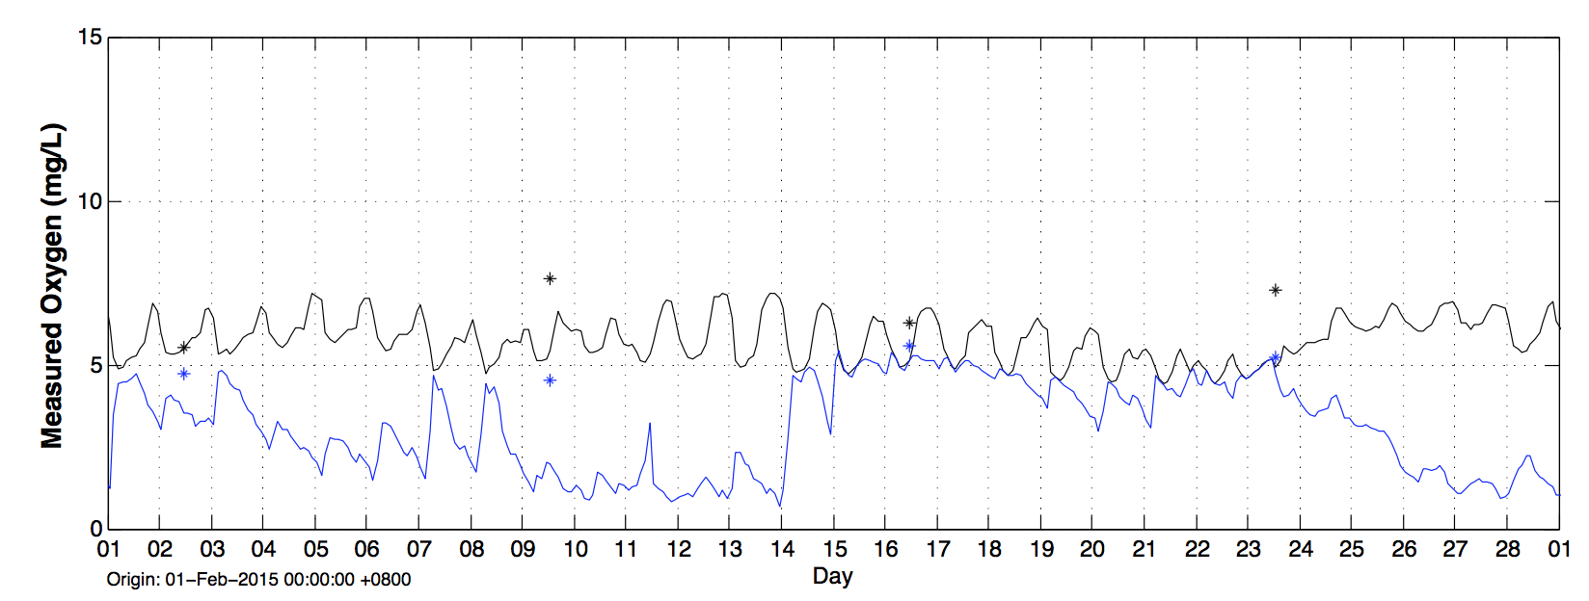  

TCHLA (ug/L)

DO (mg/L)

**Figure 23. Example daily variations of (1) DO, and (2) TCHLA at RON.**

## 5.4 Do we adequately monitor what is coming into the estuary? - Need to improve boundary monitoring

Figure 24 shows the inflow rates and some of the water quality variables recorded in boundary rivers that were used to force the estuary model. The time interval of inflow rate is daily, but of water quality varies from fortnightly to monthly. This coarse sampling frequency results in poor boundary inputs to the estuary model, especially when the river flow rate changes quickly over a short time period while the water quality information is lost. In that case the water quality is interpolated between data measured at close events, but systematic errors are unavoidable. For example, there are strong inflows coming from river at north Upper Swan in August and September 2015 (figure 24, panel 1) when nitrate concentration varied quickly in same period (figure 24, panel 3) maybe due to being brought from soil to the river by flushing. The large amount of water coming into the estuary with coarse nitrate data likely cause a systematic error in the performance of nitrate and TN (as shown in Chapter 3.1 and Chapter 3.3). Therefore we recommend to enhance the boundary monitoring of water quality by increasing sampling frequency to weekly, or set up a dynamic monitoring program in response to high flow events to catch the high variety of nutrient concentrations at that short-term periods.

# Macintosh HD:Users:peisheng:Desktop:SwanRiver_SCEVO:tracer_modelling:Flow.pngMacintosh HD:Users:peisheng:Desktop:SwanRiver_SCEVO:tracer_modelling:Amm.png

**(2)**

**(1)**

**(4)**

**(3)**

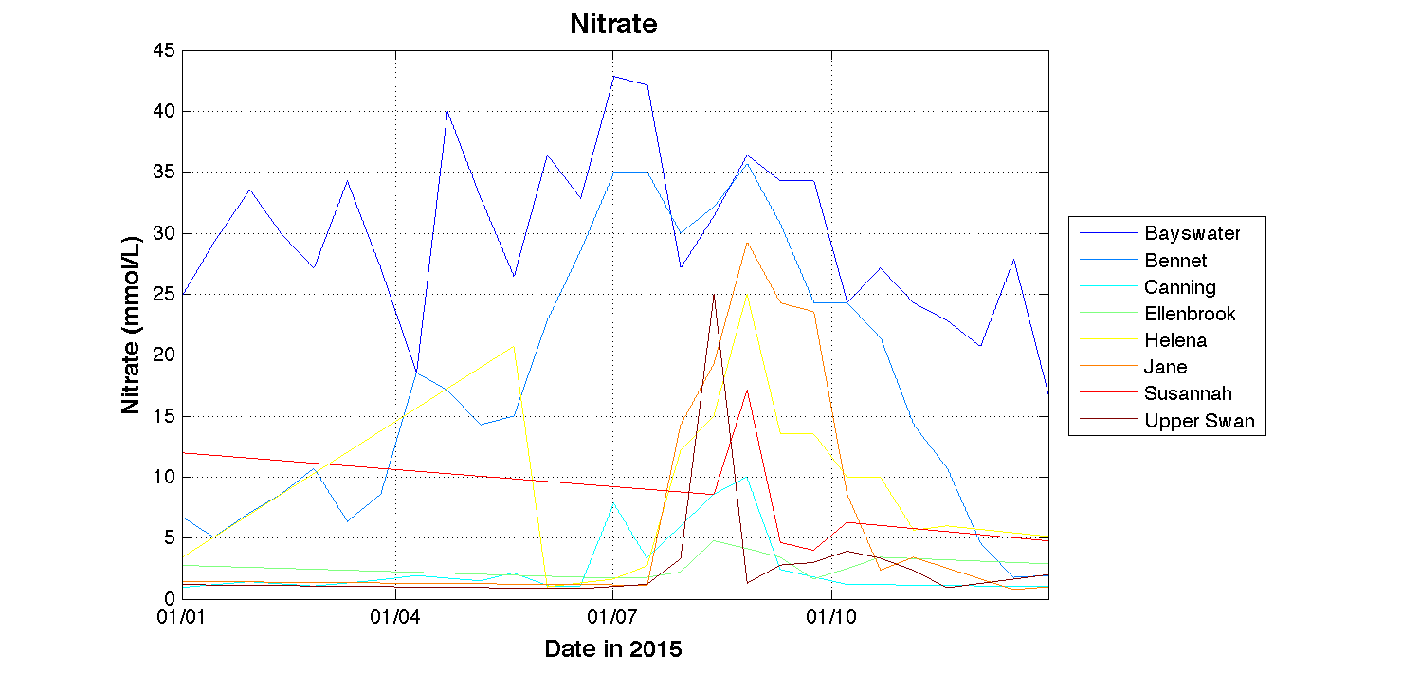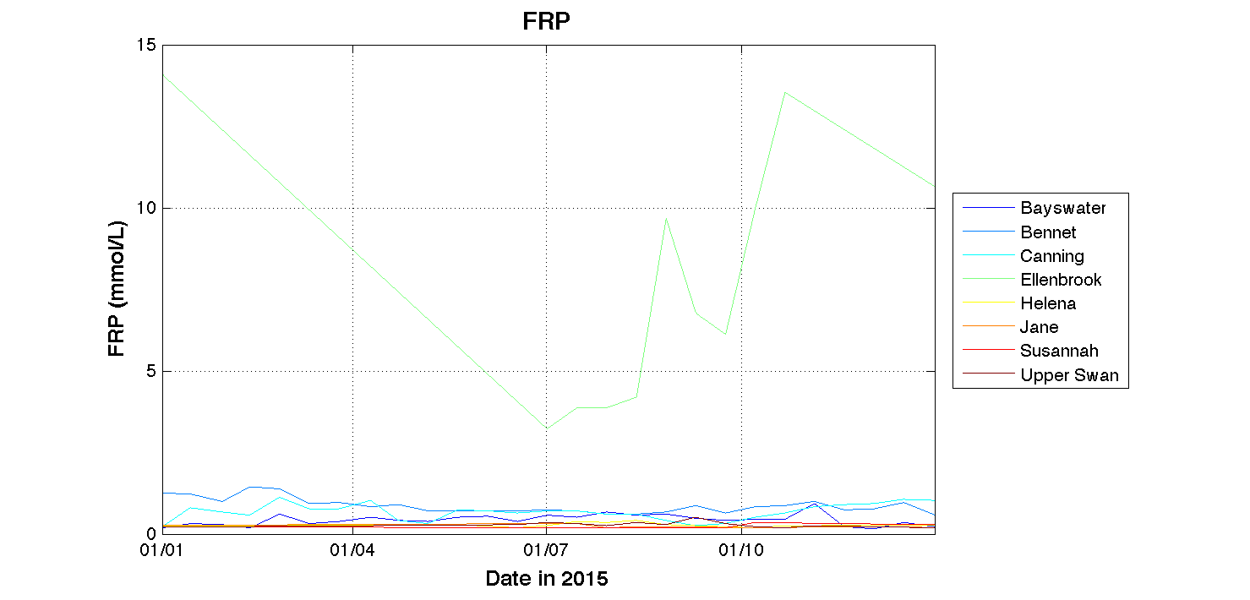

**Figure 24. (1) Daily records of flow rates vs weekly-monthly records of (2) ammonium, (3) nitrate, and (4) filterable reactive phosphorus at 8 inflow rivers.**

## 5.5 Would reducing sampling frequency affect the model validation?

Given the field water quality data is expensive to obtain, one last question we want to know is that if we change the field sampling frequency to reduce the number of field data, how would that affect the model validation? To answer this question and illustrate the impacts of sampling frequency on model validations, we reduced the field measurement data numbers to 1/2, 1/4, 1/6, and 1/8 of their original numbers (e.g. only used every second, forth, sixth, and eighth data in validation), and then used these “new” datasets to do the same statistics of the model performance and compare their differences.

Figure 25 shows the validation results of two key physical variables (salinity and temperature) and two key biogeochemical variables (TCHLA and DO) with different sampling frequencies. To our surprise, the sampling frequency, even when it is reduced to 1/8, doesn’t significantly affect the model validation. For salinity and temperature that are well captured by the model, the validation is still good even when the sampling frequency reduced to 1/8; while for TCHLA and DO, the validation shows small variations but no significantly worse performance is found with reduced sampling frequencies. So reducing sampling frequency does not seem to affect the model validation. However, we do not recommend reducing the sampling frequency because (1) we need enough number of validation data to make the result statistically significant; (2) the current sampling frequency of weekly is low already. As shown in the discussion of Chapter 5.3, a higher-frequency monitoring program is needed to capture the daily variations of TCHLA and DO.

## 

**(2) MEF**

**(1) Regression - r**

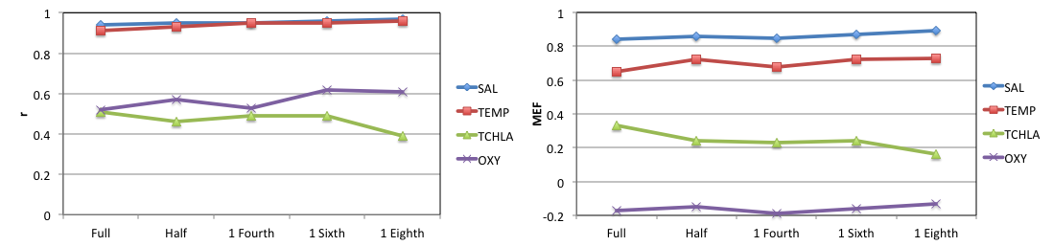

**Figure 25. Variations of (1) regression coefficient and (2) MEF with the reduction of sampling frequency.**

# 6. Real-time Model Operation

## SCEVO model automation framework

SCEVO (Swan-Canning Estuary Visual Observatory) is an online platform providing real-time water quality prediction for Swan-Canning Estuary, based on the water quality model that has been well calibrated with field data since 2008. The model is able to provide water quality hind-cast for the past 5 days and fore-cast for the next 5 days. Key facts of the SCEVO model automation framework (Figure 26) include:

* Tidal forcing is provided by the ROMS coastal model that is set up by UWA Ocean Institute (http:// <http://coastaloceanography.org>) and has been well calibrated with tidal measurement at Fremantle by DoT;
* Meteorological inputs (wind speeds, air temperature, humidity, precipitation, cloud cover) are provided by WRF weather model;
* Due to the time lap (up to ~1 month) of the field measurement at boundary rivers, we are using average water quality data recorded at the same dates (obtained from DoW and DPaW) in the past 8 years to force the model;
* The data pre-processing, mode runs, and post-processing of model outputs are undertaken by ARMS (Aquatic Real-time management System) on a daily basis;
* The model outputs are presented online (<http://swan.science.uwa.edu.au>, this website will be ready for viewing soon) in formats of time series plots and animations.

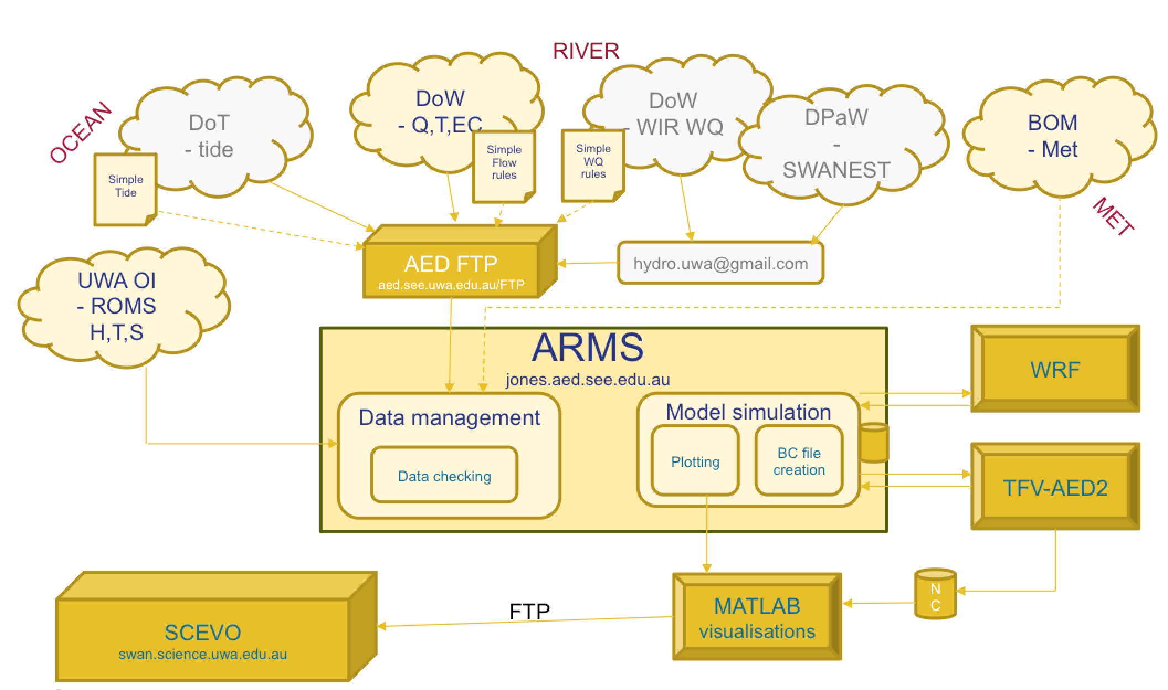

**Figure 26. SCEVO model automation framework.**

## Example outputs, and link to website

Currently the example outputs are available on the AED website (<http://aed.see.uwa.edu.au/research/projects/swan/SCEVO/forecast.html>). Once the SCEVO server computer is fully set up in the AED Research Group of UWA, then the real-time results will be provided for viewing in <http://swan.science.uwa.edu.au>.

# 7. Key Points and Recommendations

## Model Performance

Performance of the Swan-Canning Estuarine Response Model over simulation period from 01/2015 to 07/2016 is evaluated using various statistics methods. The performance analysis results suggest that, the model performed well in capturing salinity, temperature, oxygen, and for some of the nutrient pools such as TP, PO4, and RSi. Reasonable predictions were obtained for other nutrient pools and chlorophyll-a. Among three estuary regions (Lower, Middle, and Upper Swan), the Lower Swan has the best performance, while Middle and upper Swan less performed, maybe because these two regions are more affected by inflows that were not well monitored. Overall, the model performance is consistent to previous simulation in 2008 – 2012 with same model parameters, suggesting in its present form the model is suitable for assessing the management scenarios associated with oxygenation variations, nutrient load management and/or climate change, bearing in mind deficiencies in the predictions outlined in the previous sections. Further work is specifically required on to improve the predictions of TN, Nitrate, TCHLA, sediment resuspension and seagrass in the next round of model calibration. Priority areas for work on model improvement include:

* Sediment resuspension and Suspended solid particle size distribution
* Sediment nutrient flux predictions
* DOM reactivity and photolysis
* Boundary nutrient inputs
* Dinoflagellate and cyanobacteria vertical migration
* Seagrass biomass variation and sensitivity to water column turbidity
* Macroalgal dynamics, and hotspot locations for wrack formation
* Fish-kill risk index

## Recommendations to water quality monitoring from a modelling point-of-view

A “Tracer Model” has been set up to reveal the biogeochemical “hotspots”, e.g. where more intensive biogeochemical activities occurred, within the estuary domain. The results from the tracer model, together with the Thalweg analysis, regional analysis, and boundary data analysis, suggests:

* In dry seasons the Middle Swan and south part of Upper Swan are biogeochemical hotspots; while in wet seasons, the hotspot is being brought further to Lower Swan;
* The water close to Fremantle is always not a biogeochemical hotspot due to high flushing rate;
* Predicted water quality variables generally have higher deviations in Middle and Upper Swan, indicating more complex biogeochemistry and the needs of improving monitoring and modelling abilities in these areas.
* Higher-frequency (up to hourly) monitoring of DO and TCHLA is recommended to gain better understanding and prediction of the variation of these variables;
* Dynamic monitoring program to capture the events (e.g. storms) with assistance of the estuarine response model to predict the changes in response to different environmental condition scenarios
* Spatial difference along transect in Lower Swan is observed, suggesting the needs of monitoring along transect in shallow and deep waters.
* Coarse temporal sampling frequency at boundary rivers together with quick change of flow rate suggest the needs to improve the boundary water quality monitoring, which could be critical to the performance of estuary models.

# References

Hipsey, M.R., Kilminster, K., Busch, B.D., Bruce, L.C. and Larsen, S. (2014) Modelling oxygen dynamics in the Upper Swan estuary and Canning Weir Pool. *AED Report #R25*, The University of Western Australia, Perth, Australia. 99pp.

Hipsey, M.R., Kilminster, K., Busch B., 2016a. The Swan-Canning Estuary Response Model (SCERM) v1: Model validation and performance assessment. AED Report #R29, The University of Western Australia, Perth, Australia. 42pp.

Hipsey, M.R., Kilminster, K., Robinson, S., Gedaria. A, Trayler, K., 2016b. The Swan-Canning Estuary Response Model (SCERM) v1: Model Science Basis and Parameterisation. *AED Report #R28*, The University of Western Australia, Perth, Australia. 50pp.